Measuring Practice – Metric Name:_______________
Figure 1
- As a group with the teacher you will label the increments for each line above. The increments will be in millimeters.

 | Millimeter | Centimeter | Decimeter | Meter
1 millimeter (mm) | 1 | .1 | .01 | .001
1 centimeter (cm) | 10 | 1 | .1 | .01
1 decimeter (dm) | 100 | 10 | 1 | .1
1 meter (m) | 1000 | 100 | 10 | 1

Figure 2
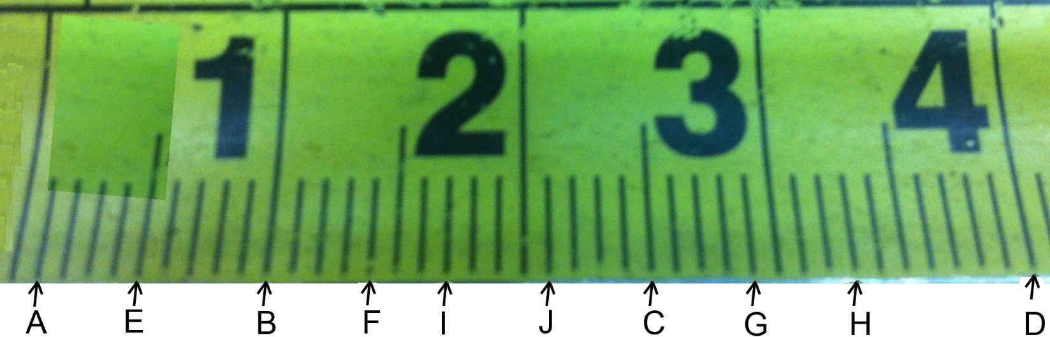
- Using Figure 2 write the measurement shown by each marking in the blank beside the letter.

A._____mm B._____mm C. _____mm D. _____mm E. _____mm

F._____mm G._____mm H. _____mm I. _____mm J. _____mm

Figure 3
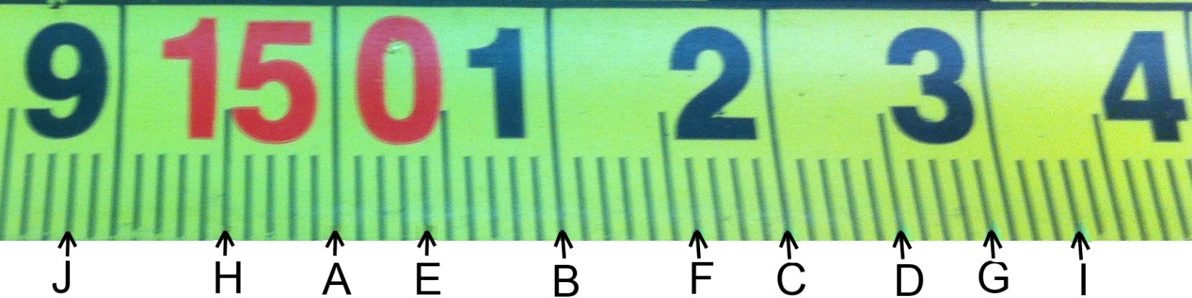
- Using Figure 3 write the measurement shown by each marking in the blank beside the letter.

A._____mm B._____mm C. _____mm D. _____mm E. _____mm

F._____mm G._____mm H. _____mm I. _____mm J. _____mm
4) Convert measurements A-E from question 3 into cm.
A._____cm B._____cm C. _____cm D. _____cm E. _____cm
5) Convert measurements F-J from question 3 into m.
F._____m G._____m H. _____m I. _____m J. _____m
Figure 4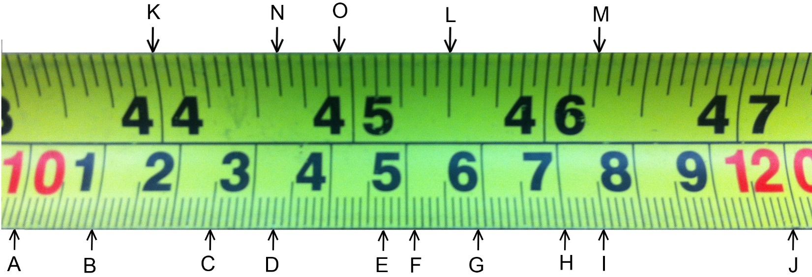
- Using Figure 4 write the measurement shown by each marking in the blank beside the letter.
NOTE: Watch carefully for the measuring unit the question asks for.

A._____mm B._____cm C. _____m D. _____mm E. _____cm

F._____cm G._____mm H. _____m I. _____m J. _____mm

K._____” L._____” M. _____” N. _____” O. _____”

