Self-regulation: “I am in control of my own actions, words, and feelings. I am in control of the organization of my own things.”

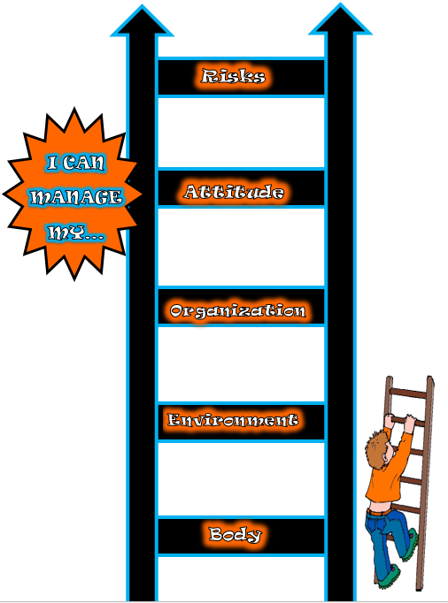
In Grade 3/4, we have begun to learn about self-regulating our bodies. This is the first step in self-regulation. Once the students can show they can self-regulate their bodies independently they can move up the ladder (a resource from Buckley’s Secret Skills). We have been focusing on making sure we are always in control of our actions and words. Also, we have been learning about selecting the best places to learn and how to do our best learning. We understand that everyone needs different things to learn (fidgets, hokki stool, desk, noise cancelling headphones, etc.) and will be learning in their own way. It’s okay to be different and that is something we value in our classroom.

Common language:
- Best learning
- Self-regulate
- I am in control of my own body and learning
- Calming corner
- Active zone
- Body scan

Our Rubric:
As a class we have come up with a rubric together so we can understand where we are at with self-regulating our bodies and what we need to do to get to a 3 (Yes! I can do it on my own!).

5  WOW | 4  Yes, and | 3  Yes | 2 Getting There | 1  Not YET
-can self-regulate all by myself  -can do everything in 3 and 4 plus teach it to a class or someone else  -focus and self-regulate the whole time all the time | -always listens to others  -can do everything in 3 and explain it | -control my body (actions and words)  -focus the whole time all the time  -look at the speaker  -self-regulate on my own  -do body scans  -listen to my body  -doing my job and listen to others all the time  -use the scales  -using fidgets | -sometimes a bit hyper or sleepy and don’t know what to do  -talking lots  -sometimes have eye contact  -listening only some of the time  -fidgety and don’t know how to self-regulate it  -ask lots of questions about self-regulation and what I need to do  -teacher helps me and reminds me  -trying or starting to self-regulate | -do not have eyes on speaker  -do not have control of body yet  -talking all the time  -not focusing  -sleeping or hyper and do not do anything to self-regulate  -never use scales or do body scans  -teacher has to always move me or self-regulate me

Last year, Mrs. Lutz and I created two different scales to help students identify their levels of energy and emotions. It is a visual tool to help students make the connection of what they need to do to be at a level where they can do their best learning.

Energy scale:
First, we do a body scan to check in with our bodies and then we identify on the scale if we have low amounts of energy or high amounts of energy. If we are a 4 or 5 we need to go to the calming corner to bring our energy down. We have learned different breathing activities, stretches, and other ways to bring down our energy. If we are a 1 or 2, we need to bring up our energy, so we go to the active zone and do an activity like jumping jacks or something that gets us moving. If we are a 3, we are ready to do our best learning.

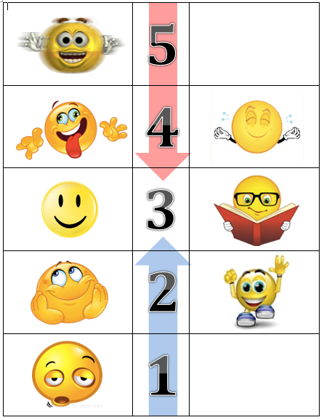
Emotion scale:
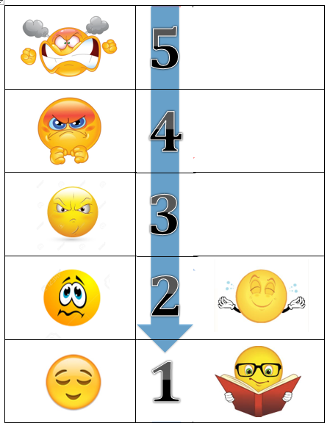
First, we need to do a body scan and identify which emotion we are feeling and how it is making our body react. We have done a few lessons to learn about different emotions as well as that our feelings/emotions often drive our actions. We have learned that we need to know what emotion we are feeling, that it is okay to feel that emotion, and how to calm ourselves before we react. On the scale, if you are anything other than a one, we need to go to the calming corner or do something to help calm our emotions down before we can do our best learning or have the best actions.

We use self-regulation in all areas of our lives and it is a skill our students will use for the rest of their lives. As the students become better at self-regulating their bodies, it will become more automatic and they can learn to self-regulate the other areas of their lives. Once students are ready we will create a rubric and learn about the next step of our ladder, which is self-regulating our environment and the organization of our things.

Created by: Nicole Francoeur

