Middle Years Genius Hour & Inquiry
Resources & Mini-lessons

Ilearn 2018
Jill Drews, Elrose Composite School
jill.drews@sunwestsd.ca

Brainstorming & forming ‘good’ questions
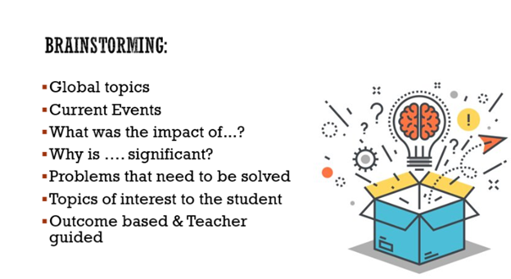
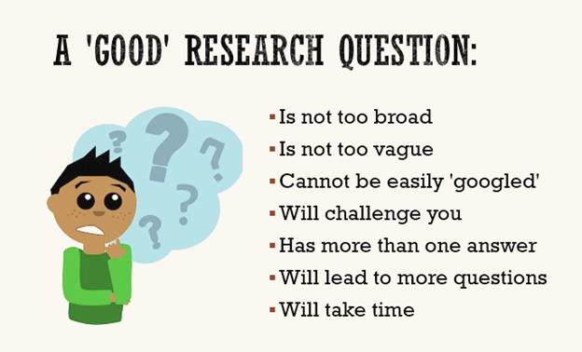

Resources: Getting Started
Steely Library NKU:  Developing a Research Question  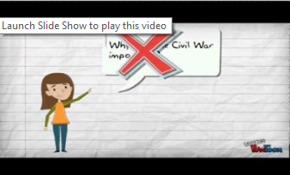  https://www.youtube.com/watch?v=LWLYCYeCFak | Libncsu:  Picking Your Topic IS Research!  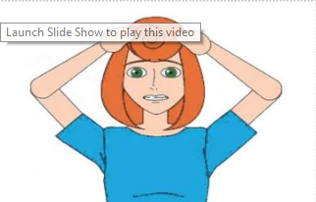  https://www.youtube.com/watch?v=Q0B3Gjlu-1o
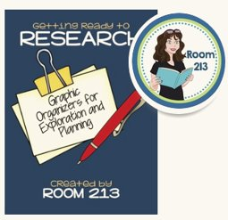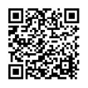  FREE: 5 page packet of resources to help your students organize their thoughts and get ready to research their topic!  Getting Ready to Research by Room 213 on Teachers Pay Teachers. | Brooklyn Connections: Crafting a Research Question Lesson Plan  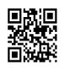  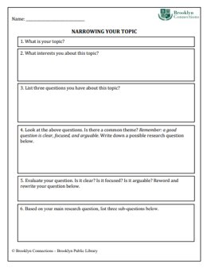  Parts of this resource packet are very helpful in assisting students to narrow their topic.  https://www.bklynlibrary.org/sites/default/files/documents/brooklyn-collection/connections/7_14_16_Research%20Question%20Lesson%20Plan.pdf
Research Questions - The Critical Thinking Consortium  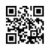  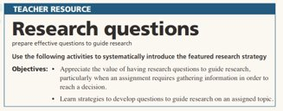  Full lesson plan to develop research and guiding questions.  https://tc2.ca/uploads/sections/thinking_about_history/Research_questions_Tutorial.pdf | Research Question Worksheet & Mindmap  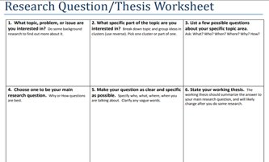  https://library.wlu.ca/sites/default/files/pdfs/tutorials/researchquestionworksheet.pdf

Resources: Skimming & Scanning
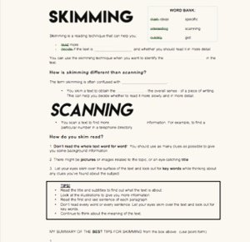  English- Reading Skills- Skim & Scan from Dream on Cue on Teachers Pay Teachers  Introduces students to skimming and scanning as well as reading for detail.  $2.00 download | 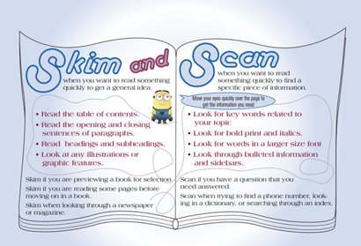  Free: Skim & Scan Poster from Leaders 4 Literacy on Teachers Pay Teachers  Highlights the difference between skimming and scanning and gives students tips for when and how to use these skills.
Read Write Think: Research Building Blocks: Skim, Scan, and Scroll  Appropriate for grades 3 to 5. This is a great resource for middle years students with low reading comprehension.  http://www.readwritethink.org/classroom-resources/lesson-plans/research-building-blocks-skim-155.html?tab=3#tabs | Read Write Think: Developing Searching, Skimming, and Scanning Skills with Internet Bingo.  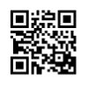  Geared to grades 4 to 8. Students play a game to help improve searching, skimming, and scanning skills.  http://www.readwritethink.org/classroom-resources/lesson-plans/developing-searching-skimming-scanning-1052.html?tab=3#tabs

Resources: Online Research Skills
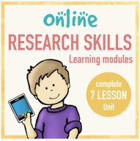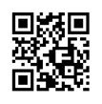  Online Research Skills complete 7 Lesson Unit by Brittany Washburn on Teachers Pay Teachers  This is a great packet to get your class started if you lack other resources. It leads students through modules on GCF Learn Free. We put the lessons into Onenote for our middle years students to work through independently.  $9.50 download | 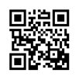  GCF Learn Free is a website that contains modules for 21st Century skills including how to use search engines correctly, as well as information about copyright, and evaluating websites.
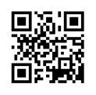  Helpful tips for teachers, could also be used in a “we do” lesson where students build their own search tip anchor chart, handout, or poster.  https://www.lifehack.org/articles/technology/20-tips-use-google-search-efficiently.html | Sunwest DLC: Middle Years ELA Inquiry Unit  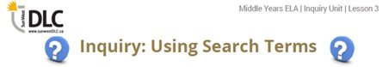  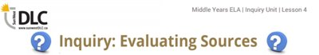  These lessons lead students through how to search online using keywords and evaluate sources. These resources are available through your PeBL Mentor (they can access the shared onenote) or the DLC.

Resources: Research Skills
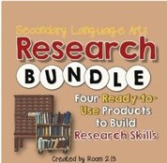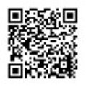  Research Skills Bundle (MLA) from Room 213 on Teachers Pay Teachers  This is an excellent resource with ready made lessons that cover a variety of research skills (paraphrasing, plagiarism, quotations, in-text citations, works cited etc). A combination of group lessons as well as independent task cards.  Under $20.00 download | Note Taking & Paraphrasing Videos:  Watchwellcast: How to take Great Notes  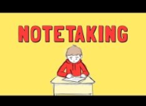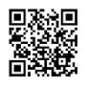  Justin Bolivar: How to Paraphrase  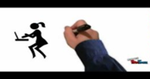
Student Note Taking & Paraphrasing Practice Handout: See attached (if you would like an electronic copy, please email Jill Drews)  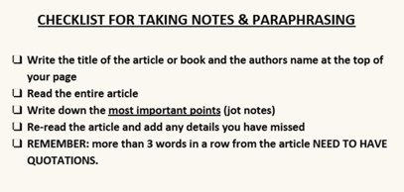  Suggested paraphrase practice resources:  - National Geographic Kids (an easy one to start with)  - Current Events & News articles  - Non-fiction Reading Passages  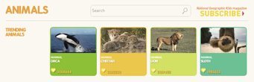 | Using Direct Quotations: Practice Stations  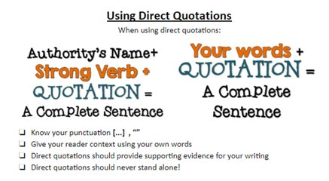  Growth Mindset themed quotes by various celebrities or noteworthy people. These can be used to help students practice using direct quotations in their writing. PeBL mentors will have access to this resource or feel free to email Jill Drews if you would like a copy.  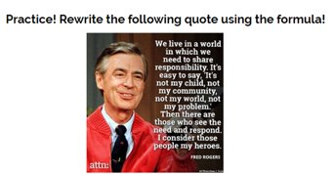
TAKING NOTES & PARAPHRASING Student Handout
- Write the title of the article and the authors name at the top of your page
- Read the entire article
- Write down the most important points (jot notes)
- Re-read the article and add any details you have missed
- Put away article and write your own paragraph using your notes
- REMEMBER: more than 3 words in a row from the article NEED TO HAVE QUOTATIONS.

Time to practice:
Assigned article:____________________________________________

My notes:

My paragraph:

Resources: In-text Citations & Works Cited
Sunwest DLC: Middle Years ELA Inquiry Unit  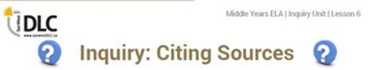  This lesson leads students through how to cite sources (both in-text citations & works cited). This resource is available through your PeBL Mentor (they can access the shared onenote) or the DLC. | Easybib contains loads of student friendly guides and resources for in-text citations and works cited page formatting in MLA, APA, and Chicago style.
The Purdue OWL: Research and Citation tab contains straightforward information for students for in-text citations and works cited pages in MLA, APA, and Chicago style.  Tip for sharing Purdue OWL & Easybib with students  Find the specific page or resource you are wanting students to use and use a QR code creator or URL shortener to make it easy to access. Turn into posters to hang up at stations or research skills bulletin board. | 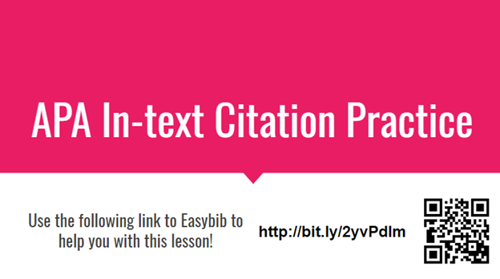  In-text Citation & Works Cited Practice Stations  Introduction to formatting for MLA, APA, & Chicago style  Suggestions for use:  - Set up as stations (go through as small groups or independently)  - Provide students with a list of websites and books for practice  - Have students find their own sites & books for practice  - Whole group teaching  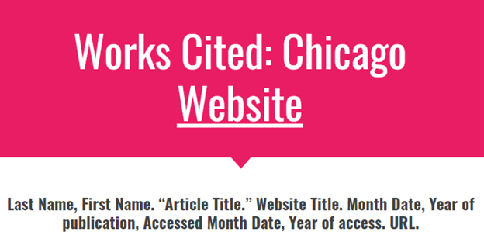  PeBL mentors have access to these materials if you are interested or email Jill Drews.

