Reader’s Theatre – Grade 2 Social Studies
The Signing of Treaty Six
This Reader’s Theatre script has been written to address the following outcome and indicator of the renewed Saskatchewan curriculum (2012).
Dynamic Relations 2.4 - Describe the influence of Treaty and First Nations people on the local community.
- b. Investigate the relationship of traditional First Nations to the land.
- c. Identify on a map the Treaty territory within which the local community is situated. (Treaty Map – available at the OTC website)
- d. Describe the reasons for Treaty from the perspective of the First Nations and the government.
- f. Present oral, visual, or other interpretation or representation of historical understanding gained through oral history.

Options for presenting:
You could connect this lesson to Arts Ed by having students create props for the Reader’s Theatre (visual arts) or add basic costumes for the various people (drama).
- Props –union jack flag, peace pipe, treaty medallion
- Costumes – jackets, hats, blankets

This Reader’s Theatre is based on the information provided at http://treaty6education.lskysd.ca
The script has been divided into four scenes, each taking place at a different location. To help students make sense of the locations, here is an outline map of Canada with capital cities.
I have listed the readers in each scene to allow you the opportunity to include all class members in the Reader’s Theatre experience.
New words and locations are identified by an asterisk * to give teachers an opportunity to stop the reading to discuss the term.
Photographs of the people involved in the Treaty process are included at the end of the script.
Scene 1 – Prime Minister of Canada’s Office in Ottawa
Scene 1 Readers
- Narrator 1 -
- Sir John A. Macdonald – Prime Minister of Canada
- Prime Minister’s Secretary -

Narrator 1 – Canada’s Prime Minister*, Sir John Macdonald sits as his desk. He is in his office in Ottawa*, the capital city of Canada. The year is 1871.
Sir John A. Macdonald – It is a very nice evening. I sure wish I could go outside and enjoy the weather.
Prime Minister’s Secretary – Why don’t you go for a quick walk, sir?
Sir John A. Macdonald – I have too much to do tonight. We have much work to do in the west now that British Columbia is part of Canada.
Prime Minister’s Secretary – That place seems so far away from here.
Sir John A. Macdonald – It is! That is why it is important to build a railroad across the country. We need to be able to move people to British Columbia soon!
Prime Minister’s Secretary – Why are you in such a hurry?
Sir John A. Macdonald – The Americans want to take over some of the land between Manitoba and British Columbia. Canada does not want to lose the land. We need it.
Prime Minister’s Secretary – Why does Canada need it? Why is the land so important?
Sir John A. Macdonald – Well, we have people coming from Europe* and they want to farm. We have promised these newcomers* cheap land. They want to come and farm in Canada. And we need the land to feed all of the people of Canada.
Prime Minister’s Secretary – What about the people who live on the land now? The First Nations people like the Cree*, the Assiniboine* and the Salteaux*? What will happen to them?
Sir John A. Macdonald –I am sending Governor Morris to meet with the First Nations Chiefs*. The government will work to make a plan. We hope that the Chiefs will give up their lands peacefully. We want to make agreements* with them so everyone can work together.
Prime Minister’s Secretary – Why would the First Nations people want to give up their land to farmers? Isn’t the land their home? Isn’t that how they feed their families? Don’t they need the land?
Sir John A. Macdonald – Yes, of course. And we do not want to take away their homes. We plan to still give land to the First Nations people to live. But the buffalo are disappearing on the land. The food is running out. This is why it is important to meet and make peaceful agreements. We do not want to fight. We want to talk.
Prime Minister’s Secretary – Is it true that many First Nations people have died because of illness brought by the newcomers?
Sir John A. Macdonald – Yes, sadly. It is true. Many of Canada’s new settlers have brought smallpox* to the lands of the First Nations. It is a terrible disease. Many First Nations people died. So it is important to meet with the Chiefs and make plans to keep everyone healthy.
Prime Minister’s Secretary – I hope the agreements work.
Sir John A. Macdonald – Me too.
Narrator 1 – Over the next few years, Sir John Macdonald would work with people of the Canadian government to come up with a plan for these agreements. These agreements soon came to be known as Treaties.

Discussion Questions:
- What is an agreement? What is a treaty?
- Who are the newcomers?
- What are three reasons why the Prime Minister wants to gets the Treaties signed?
  - Cross-Canada railroad
  - Threat of American expansion into the west
  - European immigration expanding to the west to begin farming
- What are two reasons the First Nations people might want to sign the Treaties?
  - People are starving; loss of animals
  - People are dying of smallpox; they hope to receive help from the government
- Why do you think the animals are disappearing?
  - Loss due to newcomers killing the buffalo for hides to sell; slaughtering animals without using all of the animal like the First Nations people
- Why do you think Sir John Macdonald is worried about having peaceful meetings?
Scene 2 – Fort Garry (present day Winnipeg)
Scene 2 Readers
- Narrator 2 –
- Governor Alexander Morris – Governor of Manitoba and the North-West Territories (later Saskatchewan and Alberta)
- William Christie – Treaty Commissioner
- James McKay – Treaty Commissioner
- Mr. Jackes – Treaty Secretary

Narrator 2 – On July 27, 1876, Governor Morris and his team were getting ready to leave Fort Garry*. These men are part of Sir John Macdonald’s plan for treaty talks and are part of the Government of Canada. These men are planning to meet First Nations Chiefs in the area that later would be called Saskatchewan. Their first meeting will take place at Fort Carleton*.
Mr. Jackes – Good morning Governor Morris. Mr. Christie from the Hudson’s Bay Company* wanted to make sure you had read the letter he received from Chief Sweetgrass. Do you have the letter?
Governor Morris – I have the letter right here. Did you have all have a chance to read it too?
William Christie – Yes, Governor Morris. Chief Sweetgrass is very worried about his people. He says he has heard rumours that we are selling the land without the First Nations’ permission.
Governor Morris – But that is not true. We have been making agreements with other First Nations people in Canada, but we are not stealing their land. Oh, I sure hope we can make him understand that we want to talk in a peaceful way.
James McKay – His letter invites us to visit and he says “let us be friendly”. I am sure he will be ready to talk.
William Christie – Chief Sweetgrass is also worried about his people starving. He tells us that the animals are disappearing and many people starved to death last winter.
Mr. Jackes – And the smallpox disease killed many more. Chief Sweetgrass is hoping that the Government of Canada will be able to help the First Nations people.
James McKay – I have heard that Big Bear, one of the Chiefs, is not happy with Canada’s plan for the First Nations people. He stopped some of the newcomers from coming on his land when they were planning the railroad. I sure hope we get a chance to talk to him.
Governor Morris – Mr. Crozier travelled by horseback to invite Big Bear to meet with us at Fort Carleton. I am sure he will meet with us so that we can talk.
James McKay – Mr. Crozier said that Big Bear is worried about the disappearing buffalo. Big Bear wants the government to make rules about hunting the buffalo for the newcomers.
Mr. Jackes – He is not happy that the newcomers are killing the buffalo to sell the hides. Many times, the animals are being left to rot. No one is using the meat.
Governor Morris – That is a worry, for sure. We need to make sure the First Nations people are looked after and have enough to eat.
William Christie – And Big Bear is worried about putting the First Nations people on reserves*. He wonders if this will be good for his people.
Governor Morris – Well, that is the plan that the Government has decided is the best. Other government people have already made treaty agreements with the First Nations people.
James McKay – Yes, Treaty 4* has already been signed.
Governor Morris – And now we are travelling to talk about Treaty 6*. So, it is important that we get to Fort Carleton as soon as we can. We need to work together to find a peaceful solution. We need to sign Treaty 6*.
Mr. Jackes – I will make sure the horses and wagons are ready to go. It is going to be a long journey.

Discussion Questions:
- Why is Chief Sweetgrass worried about his people?
- Heard the government is selling the land
- His people are starving
- Is Chief Sweetgrass hoping to have a peaceful talk? How do you know?
- What is a reserve?
- A block of land given to First Nations people to live on as part of the treaty agreements
- Why is Big Bear worried about the government’s plan?
- Losing food (buffalo) because the newcomers are killing animals for their hides
- Wonders if the First Nations people can survive on small blocks of land (reserves)
- So far, who has been involved in making a plan for the land?
- The government has developed the plan.
- The government is now going to talk to the First Nations people about the plan.
- If you were a First Nations person in Canada at this time, how would you feel about the treaties?
- If you were a government person, why is signing the treaties important?

Scene 3 – just outside of Fort Carleton
Scene 3 Readers
- Narrator 3 –
- Governor Alexander Morris – Governor of Manitoba and the North-West Territories (later Saskatchewan and Alberta)
- Chief Beardy – spiritual leader
- William Christie – Treaty Commissioner
- James McKay – Treaty Commissioner
- Mr. Jackes – Treaty Secretary
- Northwest Mounted Police Officer 1 –
- Cree Messenger –

Narrator 3 – The Government Treaty party travelled many days on their way to Fort Carleton. The weather was good and they reached Fort Carleton on August 15, 1876. Just outside of Fort Carleton, the men were met by a Cree messenger.
Cree Messenger – Hello and welcome to Gabriel’s crossing. Welcome to the land of the Cree.
Governor Morris – Thank you. Are we close to Fort Carleton?
Cree Messenger – We are very close. We will come to the Fort after we cross the river. Chief Beardy and I are here to escort you the rest of the way.
Chief Beardy – We want to make sure the rest of your journey is safe. Chief Yellowquill is unhappy with the Government people who came to talk about Treaty 4. He may try to cause trouble for you.
Mr. Jackes – Oh dear. Why is he unhappy?
Chief Beardy – Chief Yellowquill feels that the government was not fair to the First Nations people. He says the Government is not following up on the treaty promises.
Governor Morris – It will be good to get to Fort Carleton, so that we can talk with the Chiefs. Our hope is to make sure everyone is happy with the plan for the land.
William Christie – Are Big Bear and Chief Sweetgrass at the Fort? They both have many concerns. We want to make sure they are here to talk.
Chief Beardy – Neither Big or Chief Sweetgrass are there yet. We are not sure where he is. But Chief Ahatahkakoop and Chief Mistawasis are there along with eleven other Chiefs.
William Christie – I sure hope he arrives soon. It is important that he is at the treaty meeting.
Cree Messenger – There are about 2,000 First Nations peoples waiting at Fort Carlton right now.
James McKay – That is amazing! It seems that everyone is eager to make a peaceful agreement.
Chief Beardy – Last night, I had a powerful dream* about this meeting. In my dream, I was guided to a high hill in the area near Fort Carleton. It is there that we should hold our meeting. I believe this location will help us make a good agreement. We can look over the land as we talk. Can we move the meeting to this spot?
Governor Morris – I don’t think that is a very good idea. The meeting has been set for fort Carlton, and I think it is important to stay with the plan.
James McKay – I think that we should head to Fort Carlton before it gets too dark.
Cree Messenger – Let me help you with the horses as we cross the river. We will be at Fort Carleton soon.

Discussion Questions:
- Why have the Government men been met by members of the Cree Nation?
- Why do you think Mr. Christie feels it is important for Big Bear to be at the treaty meeting?
- If you were Chief Beardy, how would you feel about Governor Morris’ refusal to move the treaty meeting?
- Chief Beardy was a spiritual leader known to have powers. By refusing to honour this vision, Governor Morris was being disrespectful to the cultural beliefs of the First Nations people. Because of this Chief Beardy left the group and did not attend the meetings.
- Why do you think governor Morris did not want to change the location of the meeting?
- Governor Morris most likely did not understand the importance of the dream in the First Nations culture. He felt that following the plan was important.

Scene 4 – Fort Carleton
Scene 4 Readers
- Narrator 4 –
- Governor Alexander Morris –
- William Christie – Treaty Commissioner
- James McKay – Treaty Commissioner
- Northwest Mounted Police Officer –
- Chief Ahatahkakoop – First Nations Chief
- Chief Mistawasis –
- Poundmaker -
- Cree Council member -
- Salteaux Council member –
- Assiniboine Council member –
- Sacred Stem Bearer – this person is responsible for the pipe during all ceremonies
- Peter Erasmus – Métis interpreter

Narrator 4 – Everyone gets settled in at Fort Carlton. There is much drumming, singing and dancing for the next few days. After a few days of waiting for everyone to arrive, the meeting begins at the Council tent. William Christie and James McKay raise the Union Jack*.
William Christie – I am worried that Big Bear and Chief Sweetgrass have not arrived. It is important that they have a chance to talk and share their worries.
James McKay – I wonder what happened to them. We are starting the meeting today.
William Christie – Maybe messengers will tell the Chiefs that the meeting is going to start. Let’s put this Union Jack up high so people all around can see it.
James McKay – The Union Jack is also a good reminder that the Government is here to meet in peace.
Northwest Mounted Police Officer – This flag will also show that the Northwest Mounted Police are part of the treaty meeting. Our job is to keep peace in Canada. We hope for a peaceful agreement as well.
Cree Council member – The drums of our Nation are also a reminder that the Cree members are also here to meet in peace.
Salteaux Council member – The singing and dancing that has taken place over the past few days is our way of welcoming you to our land.
Assiniboine Council member – And now we will begin with the “pipe stem” ceremony. It is a way to show honour to those in the treaty meeting.
Sacred Stem Bearer – In my hands is our sacred pipe. We begin our meetings by asking the Creator to be present as we talk and to help provide guidance when we need it.
Narrator 4 – The Stem Bearer walks around the semi-circle of people, raising the stem to the heavens. He turns to the four corners – the north, the east, the south, and the west – holding out the stem at each point.
Sacred Stem Bearer – For all who are here, the pipe stem is a symbol of trust and of truth. We must all promise to tell the truth during our treaty meeting. We must all agree to do what is best for all people here. This is our promise.
Narrator 4 – Each member of the meeting, both the Government men, and the Chiefs, each touch the pipe as a promise to tell the truth.
Governor Morris – Thank you everyone for agreeing to meet. Mr. Erasmus, will you be able to help translate my words so that all of the Chiefs can understand?
Peter Erasmus – Yes, sir. I have been an interpreter* for the Chiefs for many years. I will help as best I can.
Governor Morris – Thank you. Chiefs, I begin by telling you how concerned the Government is with the health of our Indian* brothers and sisters. We have spent much time thinking about a peaceful solution to our problem of the land.
Chief Ahatahkakoop – It is true that our people are dying of hunger and disease. There are fewer animals to feed our families.
Governor Morris – We will help you feed yourselves. The Government of Canada promises you that as long as the sun shines and the rivers flow, we will take care of the First Nations people.
Poundmaker – But we have been able to feed ourselves for thousands of years before the newcomers arrived here. This is our land. It is not a piece of pemmican* to be cut off and given out in little pieces. It is our land.
Governor Morris – But the buffalo are disappearing. Soon there will not be enough buffalo on the prairies to feed your people. Our plan will help you feed your families.
Chief Mistawasis – We are willing to listen to what you have to say. What is your plan?
Narrator – Over the next few days, the Chiefs listen to Mr. Morris, Mr. Christie and Mr. MaKay as they explain the Government’s plan. Mr. Erasmus is very busy as he translates the English words into Cree. Then, he translates the Cree words back to English. By the end of the meeting, he is very tired.
Governor Morris – The Government is going to set aside land for your people. We will reserve land for the First Nations people to live. The Government will look after these lands for you.
Chief Mistawasis – How much land will be given to our people to survive? Now, we have large areas for hunting and for survival. Will there be enough for our families to live? We do not want to starve.
William Christie – The Government promises to set aside one square mile for every family to live. But you will need to learn to farm to feed yourselves because there are too few buffalo now.
Poundmaker – But we are not farmers. We have no tools.
Chief Ahatahkakoop – We have no animals or fences or shelter.
Chief Mistawasis – We do not know how to farm. We are willing to learn, but who will help teach us.
Governor Morris – The Government will help you. We will help get you started with farming by giving you the tools that you need. We promise to give you one thousand dollars to help with buying the supplies you need to start your farms. We will do this in return for the lands you are giving to us.
Chief Ahatahkakoop – What about the diseases the newcomers have brought to our land? Our grandparents, our parents and our children are dying.
Chief Mistawasis – We need medicine to help our people stay strong and healthy.
Governor Morris – Even though this promise was not included in Treaty 4, Treaty 6 will promise to always provide you with medical care. We will also provide you with schools for your children. This is what we promise in return for your lands.
Poundmaker –Now that the buffalo are almost gone, there are not enough animals to hunt. I am not sure that the government will be able to do enough to make up for the loss of our way of life. I worry that we will still starve.
Governor Morris – We promise to provide you with food when you are in need. Please understand, this Treaty is a gift for the First Nations people. The Government wants you to have the same way of life as before.
Chief Ahatahkakoop – The government makes many good promises to our people. I believe in you will keep your promise. I will sign the Treaty.
Chief Mistawasis – I agree. But, what about the Métis people of our land? Will you look after them in the same way?
Governor Morris – If a Métis person joins you in living on the reserve lands*, they will be treated the same as you.
Chief Mistawasis – I trust that the Government of Canada will look after the First Nations people in return for our lands. We trust that we can always rely on the Government in times of need.
Governor Morris – We promise to look after you now and in the future.
Narrator 4 – That afternoon, Treaty 6 was signed by Chief Ahatahkakoop, Chief Mistawasis and 11 other chiefs, and 44 Headmen.
Governor Morris – As a sign of thanks from the Government, I would like to present you with these treaty medallions. We also have other gifts of flags and uniforms and tobacco. We look forward to helping you in your new way of life.
Narrator 4 – Later, Governor Morris and the Treaty Commissioners meet with Chief Beardy. After discussion, he signs the Treaty. Governor Morris discovers that neither Big Bear nor Chief Sweetgrass had gotten a message about the treaty meeting at Fort Carlton. The group travels to Fort Pitt* where they find Chief Sweetgrass who also signs the Treaty.
Just before leaving Fort Pitt, Big Bear arrives. He is upset that he did not know about the treaty meeting at Fort Carlton. He refuses to sign the Treaty at the time, but later, many of his people were starving. Six years later, he signs the Treaty.

Discussion Questions
- What problems might have arisen from not understanding each other’s language? How do the meeting participants try to overcome that problem?
- Make a list of the promises that Governor Morris makes on behalf of the Government of Canada.
- Do you think Treaty 6 was a “gift” for the First Nations people?
- Currently, has the Government of Canada kept their promises to the First Nations people?
- Were the Métis people treated the same as the First Nations people?
- Why do you think Big Bear refused to sign the Treaty when he was at Fort Pitt?

Name
Student Assessment
Understanding Treaties

- Our community is located in Treaty Number ___.
  - 4
  - 7
  - 2
  - 6.

- A treaty is like
  - an argument.
  - an agreement.
  - a celebration.
  - an animal.

- What are some reasons that the First Nations people wanted a treaty?

- What are some reasons the government wanted a treaty?

Treaty Understandings
- understands that a treaty is like an agreement
- identifies the treaty where local community is located
- provides reasons why people wanted treaties

5  Wow | Shows insightful understanding of all concepts
4  Yes | Has solid understanding of most concepts
3  Yes, but | Has basic understanding of most concepts
2  Not Yet | Shows limited understanding of some concepts
1  No | Does not show understanding of any concept

For more information:
Historical Biographies are found at the Office of the Treaty Commissioner
http://www.otc.ca/LEARNING_RESOURCES/Historical_Biographies/

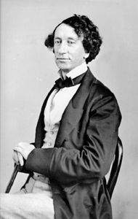

Sir John A. Macdonald, Canada's First Prime Minister
photo by William Notman, 1863, courtesy McCord Museum

Alexander Morris
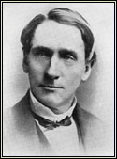
Alexander Morris was born in Perth, Upper Canada in 1826 and died in Toronto in 1889. Jean Friesen wrote that Morris was “born to privilege, privilege which he used to expand the fortunes of his family and his country.” His father was a politician and Morris studied Law in addition to taking degrees from McGill College in Montreal. In 1861, Mr. Morris entered political life as a Liberal-Conservative in Western Canada. Unfortunately, political life had its negative sides effects, due to his health concerns and financial constraints and in 1872, Mr Morris took an a appointment as a Judge in Manitoba. Morris was also Lieutenant-Governor of the North-West Territories from 1872-1876.
Alexander Morris was the main Treaty Commissioner for the Treaties signed in Saskatchewan. He was commissioner for Treaties 3, 4, 5 and 6 and helped negotiate Treaties 1 and 2.
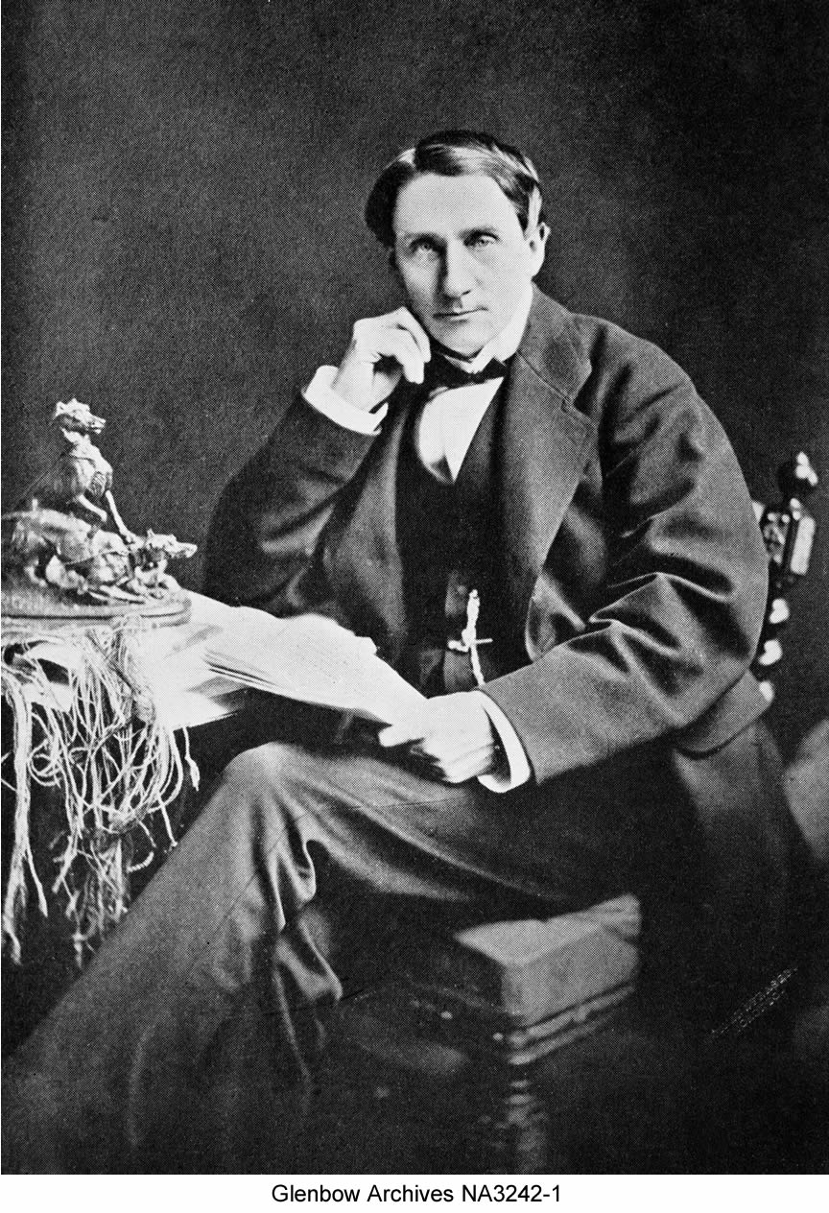
As Lieutenant-Governor, Morris was in charge of Indian Affairs and responsible for singing Treaties to open areas for settlement. Morris argued that Treaties should be signed before settlement took place and further argued for annuities along with education and assistance in farming. He focused on education to “train the new generation in the arts of civilization” and also emphasized assimilation and his need to “advance” the First Nations as part of his Christian duty.
- From the OTC site

Ahtakahkoop (Star Blanket)
Ahtahkahkoop (Star Blanket) was born around 1815-16 and was an influential Cree chief in the Fort Carlton area. In his early days, Ahtahkahkoop provided buffalo meat to the Hudson Bay Company traders at Fort Carlton and he also worked on York boats, taking supplies and furs to York Factory.
Ahtahkahkoop and his people settled at Sandy Lake, where they began to farm in 1875. In the summer of 1875, Ahtahkahkoop and Mistawasis sent a group of telegraphers back east stating that they needed permission to be on Cree land. As a result of this incident, the government decided to negotiate with the Cree of modern day Saskatchewan.
When the Treaty 6 negotiations took place at Fort Carlton, Ahtahkahkoop was one of the strongest proponents of the Treaty, as long as the Treaty provided assurances that the Cree would be able to make a living. Ahtahkahkoop believed that the Treaties would provide his children with the necessary tools by which to make the transition from buffalo hunting to a sedentary, farming life. Ahtahkahkoop agreed to Treaty 6 on August 23, 1876. Even though Ahtahkahkoop believed in the Treaties, he still participated in a Cree council that was held at Duck Lake in 1884 to draw up a petition of Cree grievances in relation to the Treaty.
In 1886, Ahtahkahkoop, along with Mistawasis, was invited to Ottawa in order to meet Prime Minister John A. Macdonald, as well as to participate in the unveiling of a monument that honored the great Mohawk chief Joseph Brant. Ahtahkahkoop died on December 4, 1896.
Sources - Deanna Christensen. Ahtahkahkoop: The Epic Account of a Plains Cree Head Chief, His People and Their Struggle for Survival, 1816-1896. Shell Lake: Ahtahkahkoop Publishing, 2000.

- From the OTC site

Pitikwahanapiwiyin (Poundmaker)
Pitikwahanapiwiyin (Poundmaker) was born in 1842 in present day central Saskatchewan to a Stoney father, Sikakwayen (Skunk Skin) and a mother of mixed blood ancestry. Poundmaker’s Uncle was Mistawasis (Big Child), a leading Plains Cree chief in the Eagle Hill, Alberta area.
In 1873, Poundmaker was adopted by the Blackfoot chief Crowfoot because he reminded Crowfoot’s wife of one of their dead sons. Poundmaker went to live with Crowfoot and he was given the name Mayoki-yoh-kin (Wolf Thin Legs).
Poundmaker attended the Treaty 6 negotiations at Fort Carlton as a minor chief of Pihew-kamihkosit (Red Pheasant). At the negotiations, Poundmaker was elected to talk on behalf of some of the younger Cree chiefs who disagreed with the terms of the Treaty. Poundmaker claimed the Treaty did not provide for future generations, nor did it provide the Cree with enough assistance by which to learn how to farm. As a result of Poundmaker’s request, Alexander Morris, the Treaty Commissioner, agreed to give the Cree more farming implements, agricultural supplies and he also put in a disaster relief clause.
Poundmaker signed Treaty 6 on August 23, 1876 and he settled on a reserve in 1879 where the Battle River and Cut Knife Creek join, some 40 miles west of Battleford. In 1881, Poundmaker was chosen to accompany the Marquess of Lorne during his trip of the western prairies. The two developed a deep respect for each other and Poundmaker was so impressed by Lorne, that he urged his people to keep the peace with the European settlers.
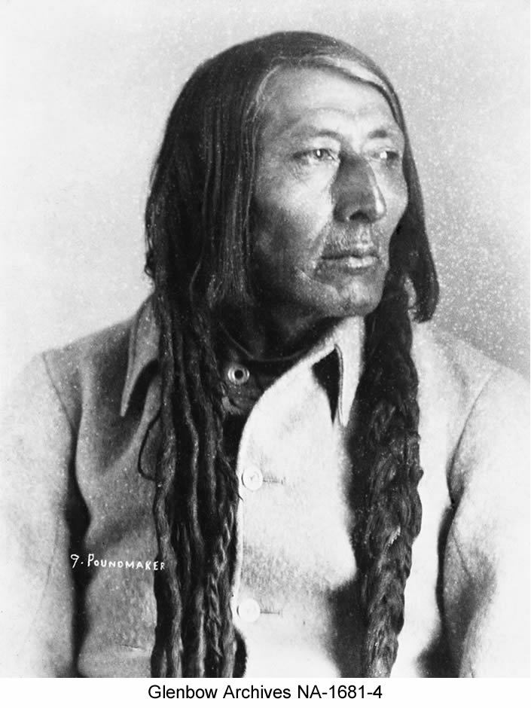
- From the OTC site

Mistawasis (Big Child)
Mistawasis (Big Child) was born around 1813 and was a life long friend of Ahtahkahkoop (Star Blanket). Mistawasis was one of the chiefs of the Fort People, a group of Cree that lived around Fort Carlton and his people eventually settled at Snake Plain.
In his early years, Mistawasis supplied the Hudson Bay Company traders with buffalo for pemmican. Mistawasis was also a strong opponent of the alcohol that was being traded amongst the Cree in the 1860s and 1870s. Mistawasis' son was stabbed during a drinking binge and as a result, he sent a letter to the federal government asking them to ban the sale of alcohol in the North-West Territories. Mistawasis' petition, along with many others the government received from the North-West, convinced the federal government to create the North West Mounted Police and send them west to eradicate the whisky trade.
In the summer of 1875, Mistawasis and Ahtahkahkoop sent a group of telegraphers back east stating that they needed permission to be on Cree land. As a result of this incident, the government decided to negotiate Treaty 6 with the Cree of modern day central Saskatchewan.
Mistawasis was one of the most influential Cree chiefs in the Fort Carlton area and he used his position to speak out in favor of negotiating Treaty 6 when the Treaty Commissioner arrived in 1876. Mistawasis believed that the Queen would protect his people, so he agreed to Treaty 6 on August 23, 1876. Even though Mistawasis believed in the Treaty, he still participated in a Cree council that was held at Duck Lake in 1884 to draw up a petition of Cree grievances in relation to the Treaty.
In 1886, Mistawasis, along with Ahtahkahkoop, was invited to Ottawa in order to meet Prime Minister John A. Macdonald, as well as to participate in the unveiling of a monument that honored the great Mohawk chief Joseph Brant. Mistawasis died in August of 1896.
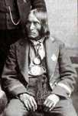
Sources - Deanna Christensen. Ahtahkahkoop: The Epic Account of a Plains Cree Head Chief, His People and Their Struggle for Survival, 1816-1896. Shell Lake: Ahtahkahkoop Publishing, 2000.
- From the OTC site
- Image from The Encyclopedia of Saskatchewan

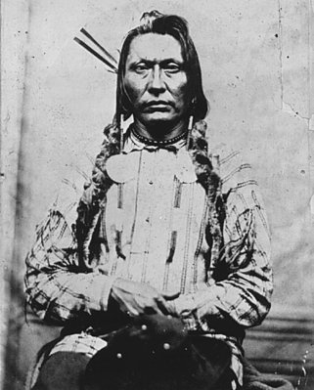
Mistahimaskwa (Big Bear)
Mistahimaskwa (Big Bear) was born near Jackfish Lake around 1825. Big Bear was a famed and well respected leader of a group of Plains Cree that camped near Fort Pitt and he rose to prominence over his attempts to get Cree grievances over the Treaties met.
In 1875, when the Rev. George McDougall came to inform the Cree that the federal government wanted to talk with them about Treaties, Big Bear refused the presents McDougall offered him stating that they would not accept the governments trap - Big Bear wanted face-to-face meetings with government representatives. When the Indian Commissioner Alexander Morris came to Fort Pitt to negotiate Treaty 6, Big Bear did not arrive until September 13; one day after the Treaty was negotiated. Big Bear wanted assurances from the government that they would enact legislation to protect the buffalo and that the Cree would not be susceptible to Canadian law. Big Bear was not satisfied with what Morris offered him and as a result he did not take Treaty in 1876. Big Bear continued to follow and hunt the buffalo, until it stopped migrating north to Canada in the winter of 1878-79.
The remainder of Big Bear's life was dedicated to unifying the Cree's voice and their reserves so that the government would have no choice but to alter the Treaties and give the First Nations better terms. Big Bear refused Treaty until 1882 and as a result, he lost many of his followers who went to camp with other chiefs, such as Little Pine and Thunderchild, who had taken Treaty when headmen of Big Bear's Band. Finally, with his people starving and the buffalo gone from the prairies, Big Bear adhered to Treaty 6 at Fort Walsh on December 8, 1882.
Sources - Dictionary of Canadian Biography, Volume XI, pp. 597-600.

Information From the OTC site
Image from Chief Big Bear

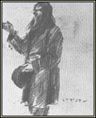
Kamayistowesit (Beardy)
Beardy was born around 1828, and was chief of the Willow band of Plains Cree. Known as a strong spiritual person Beardy welcomed news of the Treaty Six commissioners, but was angry when they ignored his request to meet at Duck Lake. Beardy had a vision as to where the Treaty council should take place, but Alexander Morris and the Treaty commissioners had committed the negotiations to Fort Carlton.
Morris traveled to Duck Lake after the Carlton negotiations and offered Beardy the same Treaty terms. Beardy felt the terms were inadequate He requested assistance in times of famine, and he wanted protection for the remaining buffalo, but he also realized his people had few other options. Beardy signed the Treaty and spend the next ten years fighting the Canadian government for implementation on the Treaty promises. He expressed his dissatisfaction with the Canadian government by hosting a meeting of Plains Cree chiefs in 1884 to organize opposition to the Treaty. The opposition suffered greatly by the rebellion of 1885. When a number of Beardy's warriors fought alongside the Metis, his band was suspended from Treaty. Beardy died in April of 1889.
Sources: Dictionary of Canadian Biography, Volume XI, pp. 458-459.

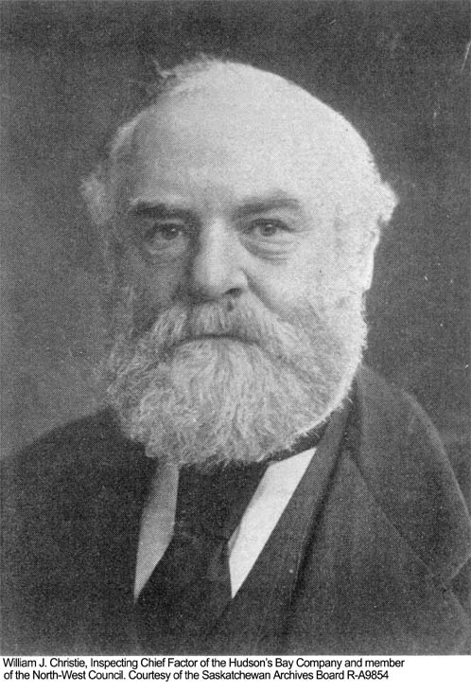
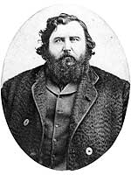

James McKay William Christie

James McKay - http://www.mhs.mb.ca/docs/people/mckay_j.shtml

Peter Erasmus
Peter Erasmus was a Metis traveller, guide, buffalo hunter, translator, farmer, Indian Agent, and mission worker. He was born in 1833, and died in 1931. Erasmus was instrumental as the translator at the Treaty Six negotiations, and witnessed the change from buffalo hunting, to settlements and Reserves. At the age of 87, Erasmus told his life story to Henry Thompson (also a Metis person, and a journalist at the time) who wrote it down. The manuscript found its way to the Glenbow Museum and Archives and was published as Buffalo Days and Nights in 1976.
Erasmus' Buffalo Days and Nights contains one of the few documentations of Treaty negotiations with his reminiscences of Treaty Six. Erasmus highlighted the authority of Mistawasis and Atahkakoop as Treaty Six Chiefs, and the resistance to treaty by Poundmaker and The Badger. Erasmus also revealed that he was in favor of treaty and the transition to farming, and was very critical of the Hudson's Bay Company.
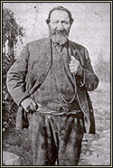
Source: Buffalo Days and Nights, Peter Erasmus

- From the OTC site

PLEASE NOTE:
All liberties and omissions are strictly the responsibility of the author.
- Jade Ballek, Learning Coach, 2012

