Grade 1- Viewing, Listening, Speaking Choice Board
Name:___________

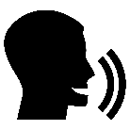
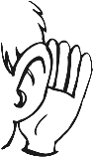
MUST DO:
I understand what is happening in pictures and drawings and what the feelings are.  CR1.2 | I understanding what a diagram and icon is telling me.  CR1.2 | I understanding what a pictograph and graph is telling me.  CR1.2
I can listen to a read aloud and retell it. I know the who, what, where, when, why, and how.  CR1.3 | I can listen to a person speaking and retell what they say.  CR1.3 | I can listen to directions and retell them in order.  CR1.3
I can ask questions clearly.  CC1.3 | I can speak clearly in a good order about:  -things I have done  -ideas  -what I like  CC1.3 | I can speak clearly using expression and drama.  CC1.3

Grade 1- Representing and Writing Choice Board
Name:___________

MUST DO:
Act it Out  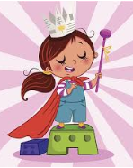  CC1.1, CC1.2 | Pictures  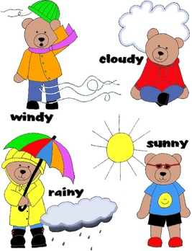  CC1.1, CC1.2 | Sounds  CC1.1, CC1.2
Physical Movement  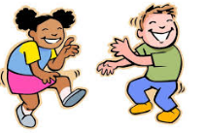  CC1.1, CC1.2 | Charts  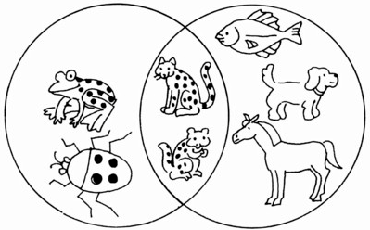  CC1.1, CC1.2 | Build it  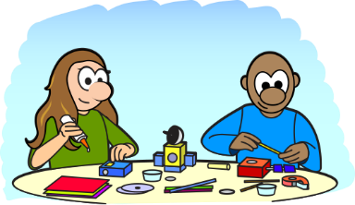  CC1.1, CC1.2
Drawings

CC1.1, CC1.2

CC1.2: I can show the main ideas and events in order with detail.

