Grade 2- Arts Ed. Choice Board
Name:___________

MUST DO:
I can create dances using ideas about my community.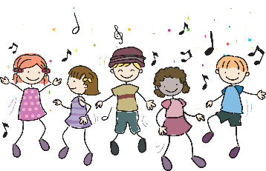  CP2.1 | I can create and connect dance phrases using actions, spacing, my body, working with others.  CP2.2 | I can share my ideas and create a skit. I can take on a role in drama and work with others in role.  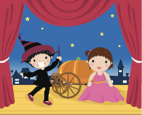  CP2.3, CP2.4
I can create music using communities as inspiration.  CP2.5 | I can create and perform music that demonstrates understanding of the parts of music.  CP2.6 | I can create visual art that shows my observations and ideas about my community.  CP2.7
I can create visual art using different types of materials.
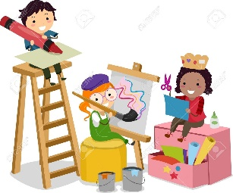

CP2.8

