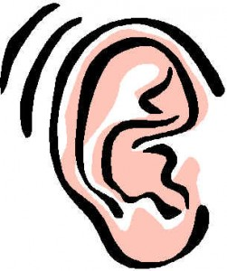
Study Tips for Auditory Learners

Auditory learners learn best by hearing or listening. They prefer talking about a situation and learn best through verbal (spoken) instruction. If you are an auditory learner, the following study tips may be helpful:

1. Read the material aloud. Concentrate. Read slowly. Enunciate (say the words) clearly.

2. Discuss it. Tell someone about what you've learned.

3. When preparing for a test, tape record review sheets and important notes and listen to the tape 2 to 3 times.

4. Verbalize (say) things you want to remember such as dates, key terms, quotes and important events. Use study cards.

5. Study with a friend so you can discuss and hear the information. If you can verbalize the information, you increase the probability of understanding it. Have your friends ask you questions and vice versa. Verbally review facts and terms that must be memorized.

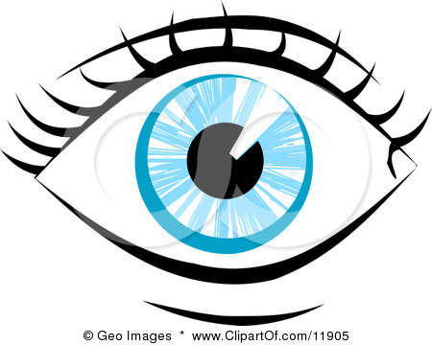
Study Tips for Visual Learners

Visual learners learn best by seeing. They prefer watching demonstrations and have the ability to visually imagine information. If you are a visual learner, the following study tips may be helpful:

1. Read the material aloud to yourself. Concentrate. Read slowly.

2. Make study notes - use graphs, study cards, pictures, charts, etc. Practice visualizing (seeing) or picturing important information.

3. Write things down. Taking notes in class will help you in remembering details. These notes can then be used in studying for tests.

4. Use a highlighter for main ideas in your notes.
5 . Pay attention to graphs, pictures and charts in your textbooks,
6. Learning by listening is not easy for visual learners. When listening, always look at the speaker to help you maintain your attention. Summarize important concepts but don't try to write down everything the teacher is saying word for word.

7. Sit close to the front of the room and away from distractions such as your close friends, doors, or windows.

8. Study in a quiet place with no interruptions, preferably alone, rather than with a friend.

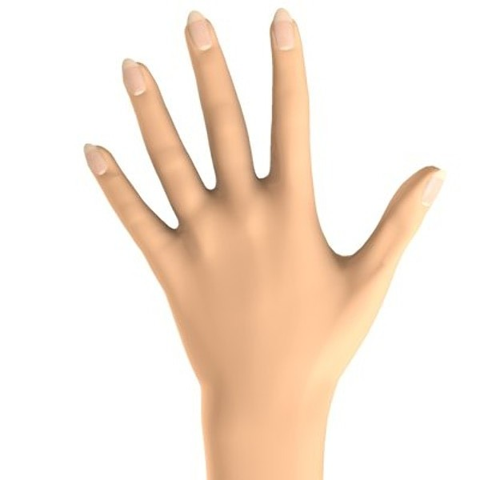
Study Tips for Tactile/Kinesthetic Learners

Tactile/Kinesthetic learners learn best by doing. They remember best by doing something, not seeing or hearing it. If you are a kinesthetic learner, the following study tips may be helpful:

1. While in class, experiment with ways of moving without disturbing the class. For example, roll a pencil between your fingers.

2. Walk around while reviewing or studying.

3. Take frequent notes or write important facts several times while studying.

4. Whenever possible, use graphic note-taking methods such as mapping or time lines.

5. Use a highlighter for main ideas and important facts in your notes.

6. Take frequent, short breaks and do something that involves light activity such as getting a drink of water.

7. Whenever possible, experiment and "do" your assignments, experiments, and projects in an active way.

