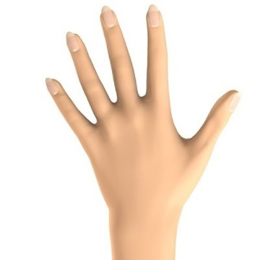
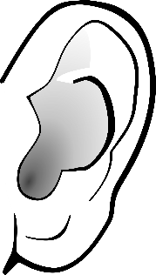

Learning Styles
In your groups discuss (ALL students must be prepared to share your discussion)
- Why do you think people learn in different ways?
- Do you think one learning style is better than another? Why?
- Are you the learning style you expected to be?
- Did you learn anything new about your learning style today?
- What will you do differently when learning now you know your learning style?

Answer these questions below. You will be asked to share with the class!

Type of style _________________________________________

- How we learn:

- What teachers should know about us as learners to help us:

- What other students should know about how we learn to help us:

