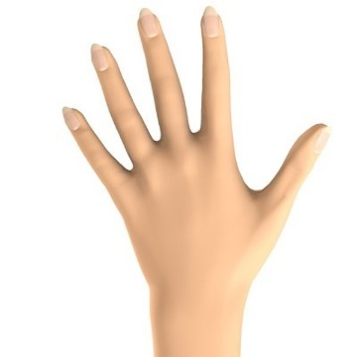

Learning Styles
In your groups discuss (ALL students must be prepared to share your discussion)
Answer these questions below. You will be asked to share with the class!

Type of style _________________________________________

- How we learn:

- What teachers should know about us as learners to help us:

- What other students should know about how we learn to help us:

