Grade 1- Arts Ed. Choice Board
Name:___________

MUST DO:
I can move my body in different ways and patterns.  CP1.1, CP1.4 | I can create a dance.  CP1.2, CP1.4 | I can use my imagination during a play.  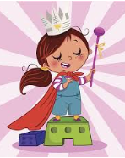  CP1.3, CP1.4
I can make music. I can talk about the music I hear.  CP1.4, CP1.5, CP1.6 | I can find patterns in music. I can pick out different parts in music.  CP1.6 | I can see patterns in art.  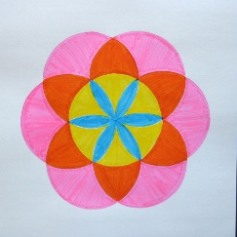  CP1.7
I can make art.

CP1.4, CP1.8

CP1.4: I can use my words, body, sounds, or pictures to show my ideas.

