Finished Image:
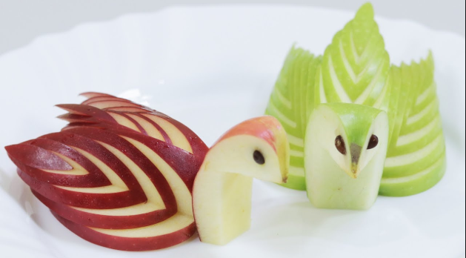

How to video link:
https://www.youtube.com/watch?v=f2JRzxODc0s

Materials Needed:
- Knife
- Apple
- Wooden Chopsticks

Any additional information:

Save in the Mrs. Long - PAA Folder – under Garnishes with your name

