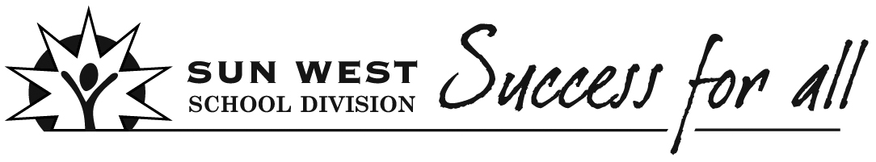
Lesson Planning
Teacher(s) | Subject(s) | Grade |  | Learning Experience/Unit/Theme |  | Date
Consider the Transfer of Responsibility (The movement back and forth between I do, We do, You do)
I do | We do | You do
The “I do” phase of a lesson involves you telling students what they need to know and showing them how to do the things that they need to be able to do.  (Marzano) | The “We” do phase involves doing tasks together. You can help students use the steps they need to follow and complete particular tasks.  (Marzano) | The “You do” phase involves students practicing what you have already taught them by themselves. Such practice helps student retain what they may have learned and to become fluent with what they must be able to do.  (Marzano)

Big Ideas/Key Questions/Essential Understandings

Outcome(s)  Indicators |  |  | I Can Statements
Assessment Plan
Pre-Assessment Plan | Formative Assessment Plan |  |  |  | Summative Assessment Plan
Motivational Set
Instructional Strategies/Activities (Before/During/After)

Ways to differentiate to meet individual student's needs

Opportunities for Personalization

Materials/Resources/FNMI

7 C’s  Consider how to incorporate:  - Creativity, Innovation and Entrepreneurship  - Critical Thinking  - Collaboration  - Communication  - Character  - Cultural and Ethical Citizenship  - Computer and Digital Technologies (Learning Tools)  Details |  | REORDER  Consider how to incorporate:  - Relationships  - Environment  - Opportunities  - Resources  - Distribution of Leadership  - Evaluation  - Recognition  Details
Reflection

