Citizenship

Strong | Weak

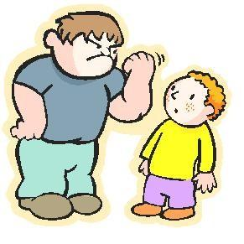
 | 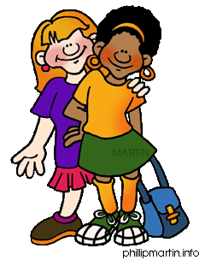
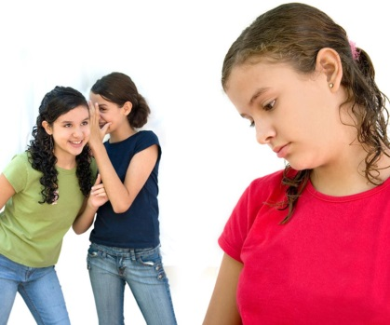
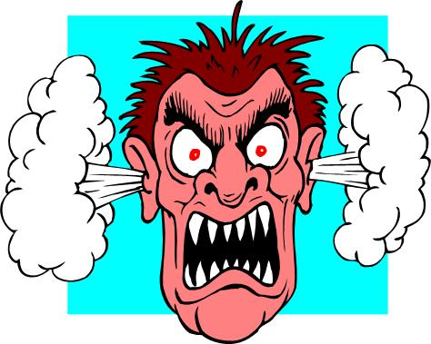 | 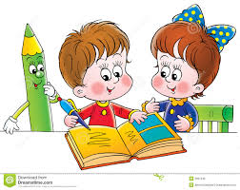
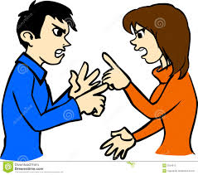 | 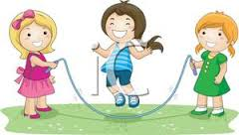
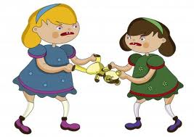 | 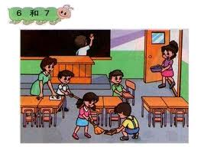
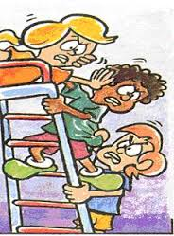 | 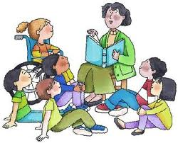
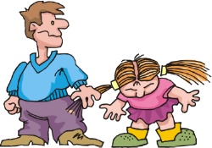 | 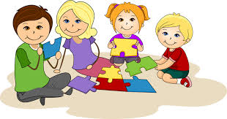

Strong Citizen

Weak Citizen

The purpose of this activity is to have students look at the pictures and decide if the students in the pictures are acting as strong citizens or weak citizens. After students have discussed and told why they chose which type of citizen the picture shows they will place it on the correct chart. This activity is aligned with CCSS K-4.1 Identify qualities of good citizenship, including honesty, courage, determination, individual responsibility, and patriotism and K-4.2 Demonstrate good citizenship in classroom behaviors, including taking personal responsibility, cooperation and respecting others, taking turns and sharing, and working with others to solve problems.

Works Cited
http://bestclipartblog.com/clipart-pics/friendship-clip-art-6.gif
https://encrypted-tbn3.gstatic.com/images?q=tbn:ANd9GcTmQHVp1lhTq1t7sU7jgZct2R_uSnlqWhk3os_ij8jdi5hm1C5fIw
http://upload.wikimedia.org/wikipedia/en/a/a1/Jimmy_and_Gary.png
http://blog.timesunion.com/kristi/files/2012/05/bully.jpg
http://4.bp.blogspot.com/-PQLSfap5qjs/UO_j8ZOKVeI/AAAAAAAAMkE/A9_7k1zszQQ/s1600/bully-bravado.jpg
http://www.brainpowerlearning.com/adult%20bully.jpg
https://encrypted-tbn2.gstatic.com/images?q=tbn:ANd9GcSinTv89_AxWembQwPRDLjrcz1Yjzu-GMLwSdvNemCEMAK6gHqCRw
https://encrypted-tbn2.gstatic.com/images?q=tbn:ANd9GcQwC8G38ldExkKFDZ-Xt6BBDjhVt1Pjiu1l5GOt2upkAeI_bRCMxg
https://encrypted-tbn2.gstatic.com/images?q=tbn:ANd9GcQOqoAbZoEyr6rU1Qsto4YKw2sa0ifFVax8qSmYHOddnDfh1_8z
https://encrypted-tbn0.gstatic.com/images?q=tbn:ANd9GcSkJ-15ExvCO0ILYwncJ_vkDqCC-i0LaSCYUQUVKqlhJSJnsaOghQ
http://www.specialops.org/resource/resmgr/children_photos/bully_clipart.jpg
https://encrypted-tbn2.gstatic.com/images?q=tbn:ANd9GcQ08NBuSpIxrtILdFa0txbKDefbFd7C1PAbnSwhP263bdi8Wc5Zrg
https://encrypted-tbn2.gstatic.com/images?q=tbn:ANd9GcR7RGLl4miqiH0vjsZr35eDKGVFg8jtsuMB9YQ72oswQdgtT5WeFA
https://encrypted-tbn2.gstatic.com/images?q=tbn:ANd9GcToe2-W-oQuSDhvfj984J3IkjHxSqLJ_q7-TLeCquFnlNgvtq2Fmg
https://encrypted-tbn3.gstatic.com/images?q=tbn:ANd9GcSY4MZ2CATJ6RT-ehZJ5Uh52MrxxiNJIFIXqhKyoMo8o_xIsqRj
https://encrypted-tbn2.gstatic.com/images?q=tbn:ANd9GcTMrK4sDkgdvAHop66J3O3g7vSfwNcmS-GzLqbPD3PrH9Onv5yy0A

