 | Form 210-23
 | Additional Student Programming and Classroom Supports
 | Box 700, Rosetown, Sask., S0L 2V0  Phone: (306) 882-2677 Fax: (306) 882-3366  Toll Free: 1(866) 375-2677, www.sunwestsd.ca | Reference | AP 210 Services for Students with Diverse Needs
 |  | Revised | April 18, 2018
 |  | Level | Division
 |  | Submit to | Student Support Services Consultant
 |  | When | As Required

School Name |  | Date

Please list students requiring continuous supports (intensive, high needs students requiring supports for safety, personal care, etc.). These students require an eIIP.

Name | Grade | Diagnoses (if any) | Key Areas of Development

Please list students requiring frequent supports. These students require an eIIP.
Name | Grade | Diagnoses (if any) | Key Areas of Development

Student Programming Support:

Name | Grade(s) | What is the programming need?

Facilities: Do you anticipate any changes to facilities related to Student Support?

The following chart illustrates which member of the Triad will take the lead when considering the following additional student programming and classroom supports. The classroom teacher is integrated throughout however; the role of the Triad is to consider who takes the lead in supporting students and teachers.
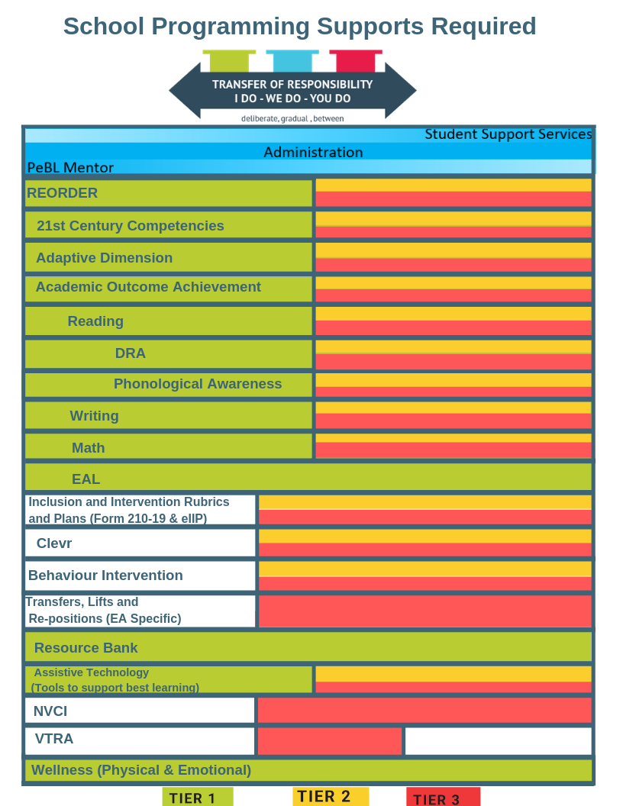

What supports do you need to help you take the lead in the areas above?
List and explain in the box below.

