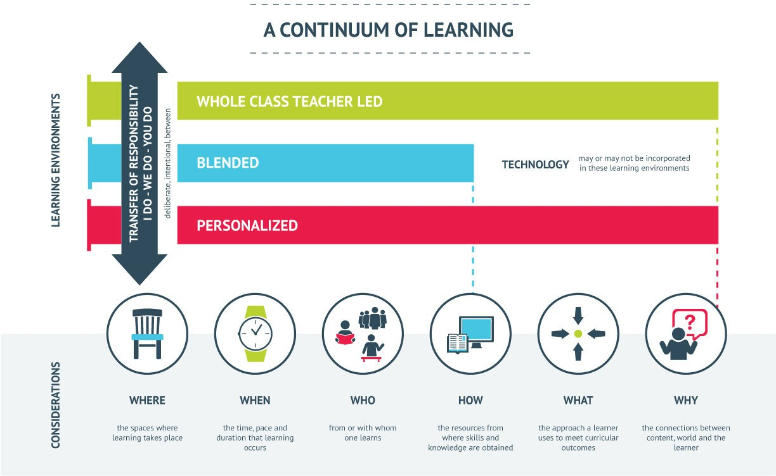

Sun West Continuum of Learning Key Messages
Each student is unique
Learning/teaching may look different in every school/class
Transfer of Responsibility is gradual, essential, and goes back and forth between educator and student as needed
Learning environments that are open to change Culture, Character and Skills & Knowledge prepare students to take on more responsibility
Great teaching practices and strategies are used to support the transfer responsibility between student(s) and teacher
Where & when learning occurs can look different in each learning environment and for each student
We use a variety of resources (including people) to learn skills & knowledge Technology may or may not be used to best support a student’s learning needs Student learning can be approached and assessed using a variety of methods such as,
exploring a topic/outcome, problem solving researching, building, assignments, projects and tests
Students are encouraged to make connections between themselves, the content and world Educators play critical role in determining student readiness, co-creating learning environments and providing support.
I Do (teacher makes decisions, whole class teacher-led instruction, any grade appropriate) We Do (blended environment with shared decisions, learners choose where, when, how, with whom),
You Do (fully personalized, student driven, Voice & Choice – what and why) Not every situation is best for personalized learning & not at all times Technology is a tool or support, NOT a strategy
As a result of the above, students become fully engaged in their education

Sun West Continuum of Learning Discussion Guide
Can you identify examples of the 6W's (Where, When, Who, How, What & Why) happening in your school?
There are a variety of key messages in this video. Discuss what they mean to you. Jot your notes here.

How does this video clear up any misunderstandings your school community may have about PeBL.

How might you collaboratively, with your school administration team, lead a discussion regarding this video with your SCC?
Link to video: https://youtu.be/zrlMkP3hJ3A
How might you engage your parent community in
discussing this video and experiencing PeBL for themselves?

