Co-teaching Readiness Assessment Checklist

- Co-teacher Interest

- Administrator supports by providing time and resources

- Co-teacher Collaborative & Flexible Mindset

- REORDER Culture evident in both classrooms

- Risk Taking & Safe Environment (Trust)

- Co-teachers/Students in both classes have similar understanding of 21 CC’s

- Most students are able to self-regulate

- Schedules are flexible and align

SBA Role in Co-teaching
- Co-teaching walk through
- Time for collaboration and planning (flexible use of time)
- Transfer of responsibility
- Sharing and involvement with the outcomes/I cans
- Students have voice and choice in the planning
- PeBL Planning Template (Resource Bank)(including 21 CC’s)
- Ensure that the co-teaching has a larger impact than what they would do if they were not co-teaching
- Accountability
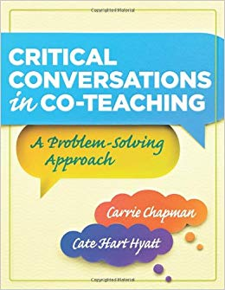
The Co-Teaching Process
Critical Conversations
Throughout the process:
- What do we want our kids to know?
- How do we know if they know it?
- What do we do if they don’t learn it?
- What do we do if they already know it?

Readiness Assessments
Available at Indigo & Amazon
1. Engage Partners (Collective Responsibility, Relationships & Distribution of Leadership )
Ask: Are we ready and committed to co-teach?
What might our shared vision be?

Planning Instruction
2. Enhance Instruction (Opportunities, Resources, Distribution of Leadership, Recognition)
Ask: What are you going to do together that is better than what you could have done individually?

Planning Assessment
3. Examine Data: (Evaluation; Resources, Opportunities)
Ask: How will we use data in our co-teaching to improve instruction and learning?

Reflection
4. Expand Impact (Relationships, Environment, Opportunities, Resources, Distribution of Leadership, Evaluation, Recognition)
Ask: What might add value to our instruction and co-teaching implementation? (Where do we go from here?)

