Make Writing by Angela Stockman PD Take Aways
Hack 1 – Make writing physically and collaboratively
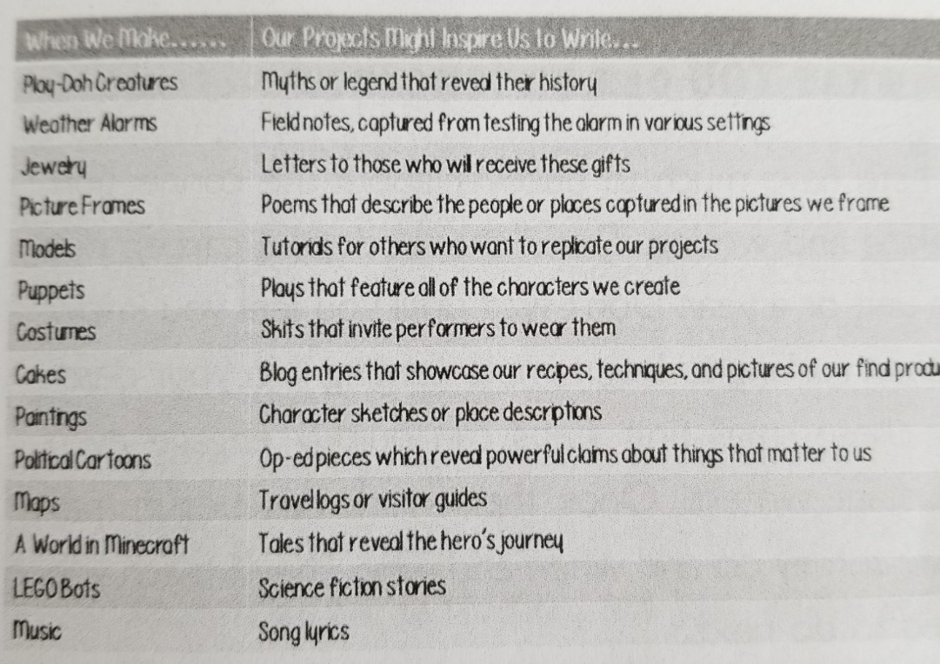
Live in the We-Do for awhile​
My Notes & Ideas:

Make Writing, p.19

Hack 2 – Design the classroom with making in mind
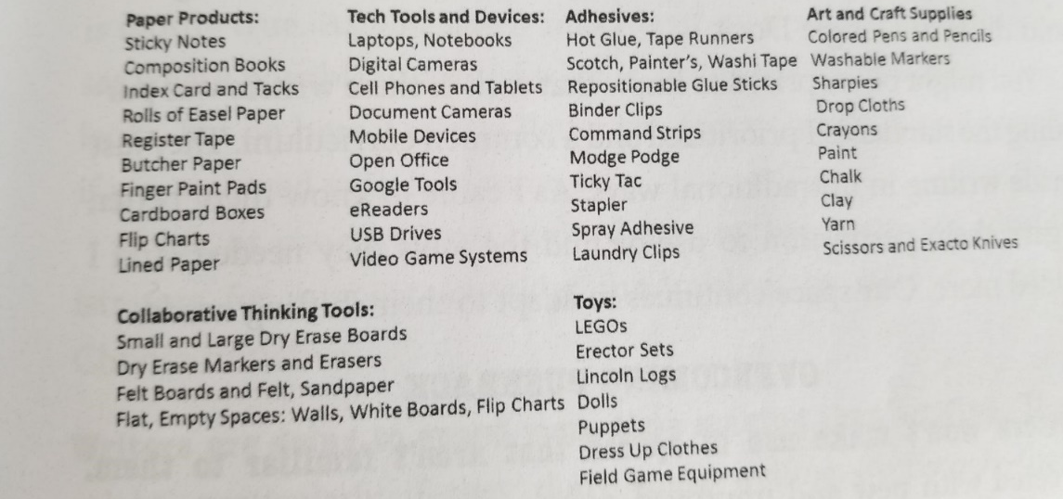
My Notes & Ideas:

Make Writng, p. 43

Hack 3 – Teach them to Tinker
Model Notes & Ideas:

Routine 1 Notes & Ideas:

Routine 2 Notes & Ideas:
My Notes & Ideas:

Implementation: (Use mini-lessons & Modelling throughout)
*Explore many models and mentor texts​
​*Teach how to commit ethical Creative theft​
*Set up a spot for writers to share their work​
​*Use your walls as tools​
​*Make an inspiration board​

Hack 4 – Keep it real (audiences) My Notes & Ideas:
*Help kids choose topics that matter​
​*Teach to engage audiences they want to influence​
​*Teach to seek feedback​
​*Carve out time for exibition at all stages

Hack 5 – Hack your curriculum My Notes & Ideas:
*Define your purpose​
​*Share your vision with stakeholders ​
​*Outcomes are the guide not the commander​
​*Voice, CHoice & Tra remain key​
​*Track growth & outcomes​
*reach way beyond ELA – Writing should be happening everywhere

