_________________’s
Now What??
Grade 6 Math Choice List…
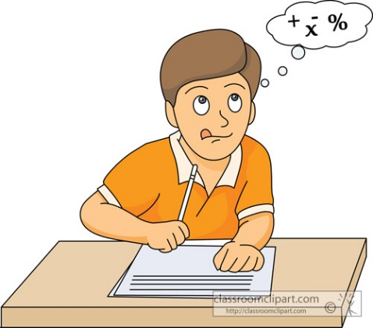

Mrs. Siroski & Miss Brown

- You must complete ALL Must Do List from each of the 6 categories:
3-4-5
  - Bump It Up
  - Gritty Fighting 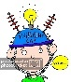
  - Technology & Games
  - Garbage Can Or Filing Cabinet 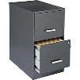
  - Level Up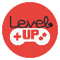
  - Ready, Set, Speed…Math Fluency 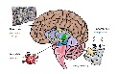
- You can do the Must Do Items in any order.
- Then once all the must do’s items are done, you can go back and pick additional topics to work on.
- Use the chart below when you need help and put in my hand in box, if I am busy and didn’t get around to answering the question you needed.
Teacher… I need your help with…  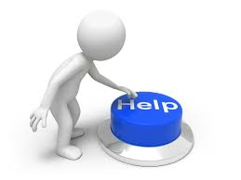 | Date | Teacher Comment/Initial

Teacher Check In Dates & Comments

You can Bump It Up
3-4-5

Must Do | Optional
- Choose 1 outcome from Numeracy and create a 4 minute video using the iPAD. Use the planning template in this document  - Date Started:  - Date Completed:  - Teacher Initial: | - Create another video for 1 outcome from any of the strands.
- Choose 1 outcome from Shapes & Space and create a math game. Use the planning template in this document  - Date Started:  - Date Completed:  - Teacher Initial: | - Create another math game for 1 outcome from any of the strands.
- Choose 1 outcome from Stats & Probability and make a survey that students can use as part of their assignment. Use the planning template in this document  - Date Started:  - Date Completed:  - Teacher Initial: | - Create another class math problem solving activity for 1 outcome from any of the strands.  - Make a template for a foldable math vocabulary book for students using important words from 1 outcome.
- Choose 1 outcome from Patterns and create an anchor chart for the wall. Use the planning template in this document  - Date Started:  - Date Completed:  - Teacher Initial: | - Create another anchor chart for 1 outcome from any of the strands.

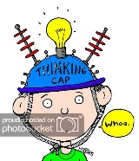
Let’s do this… Gritty Fighting…
Must Do | Optional
- Choose 1 activity from the Problem Solving Binder. Complete the activity individually & list what Math Outcomes are connected  - Date Started:  - Date Completed:  - Teacher Initial: | - Choose 1 activity from the Problem Solving Binder. Complete the activity individually & list what Math Outcomes are connected
- Choose 1 activity from the Problem Solving Binder. Complete the activity with a partner or a group & list what Math Outcomes are connected  - Date Started:  - Date Completed:  - Teacher Initial: | - Choose 1 activity from the Problem Solving Binder. Complete the activity with a partner or a group & list what Math Outcomes are connected

Math is in Technology & Games?
Must Do | Optional
- Choose 1 STEAM card & complete individually  - Date Started:  - Date Completed:  - Teacher Initial: | - Choose 1 STEAM card & complete individually
- Choose 1 STEAM card & complete with a partner/group  - Date Started:  - Date Completed:  - Teacher Initial: | - Choose 1 STEAM card & complete with a partner/group

I still got it… Garbage Can or Filing Cabinet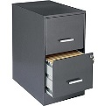
Must Do | Optional
- Complete the Numeracy review assessment
  - Date Started:

  - Date Completed:

  - Teacher Initial:
- Complete the Shapes & Space review assessment
  - Date Started:

  - Date Completed:

  - Teacher Initial:
- Complete the Stats & Probability review assessment
  - Date Started:

  - Date Completed:

  - Teacher Initial:
- Complete the Numeracy review assessment
  - Date Started:

  - Date Completed:

  - Teacher Initial:

I’m ready coach… Level Up
Must Do | Optional
- Choose 1 outcome from Grade 7 Numeracy and get an Outcome Plan  N7.1 - I know and can use the divisibility rules for 2, 3, 4, 5, 8, 9 and 10  N7.2 - I can add, subtract, multiply and divide decimals.  N7.3 - I can relate fractions to decimals and Whole Numbers to each other (including mixed numbers, proper fractions and improper fractions).  N7.4 - I can show fractions for percents between 1-100  N7.5 - I can add and subtract Fractions and Mixed Numbers  N7.6 - I can add and subtract Integers  - Date Started:  - Date Completed:  - Teacher Initial: | - Choose another Grade 7 Numeracy Outcome.
- Choose 1 outcome from Grade 7 Stats & Probability and get an Outcome Plan  SP7.1 -I Understanding and finding Mean, Median, Mode  SP7.2 - I Understanding Circle Graphs and sum of % to 100.  SP7.3 - Understanding probability for two independent events (Sample space less than 36) expressed as a fraction, a decimal and a percent.  - Date Started:  - Date Completed:  - Teacher Initial: | - Choose another Grade 7 Numeracy Outcome.
- Choose 1 outcome from Grade 7 Shapes & Space and get an Outcome Plan  SS7.1 – I understanding circles and circumference and central angles.  SS7.2 – I can use formulas to determine areas of triangles, parallelograms and circles  SS7.3 - I uunderstand the relationship between lines and angles  SS7.4 - I understanding Cartesian Plane and ordered pairs with Integral Coordinates  SS7.5 - I understanding transformations of 2D shapes in 4 quadrants of the Cartesian Plane  - Date Started:  - Date Completed:  - Teacher Initial: | - Choose another Grade 7 Shapes & Space Outcome.
- Choose 1 outcome from Grade 7 Patterns & Relations and get an Outcome Plan  P7.1 - I uunderstand and graph input and output machines  P7.2 - I can understand algebraic equations and expressions  P7.3 I can solve algebraic equations using whole numbers  P7.4 - I can solve algebraic equations using integers  - Date Started:  - Date Completed:  - Teacher Initial: | - Choose another Grade 7 Patterns & Relations Outcome.

Ready, Set, Speed…Math Fluency
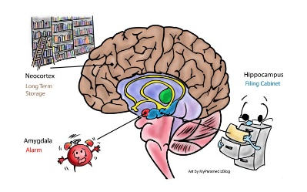
Must Do | Optional
- Multiplication Math Facts 1-12 | - BEDMAS Mental Math
- Division Math Facts 1-12

- Addition Math Facts

- Subtraction Math Facts

You can Bump It Up
3-4-5

Planning Templates

Video Planning Template
Start Planning Date:
End Date:
Outcome:
I can…
App Your Using to Create the video:
Easy Example:
Vocabulary words to review:
Important things to say or remember
(think a script)
Sample Question:
Sample Question:
Word Problem:
Where are you saving the video (which Ipad #)

BUT FIRST, LET ME TAKE A #SELFIE
Rate each category on the following scale:
- Very blurry! I need to do better next time.
- Out of focus! I could be more detailed.
- Needs a filter! I could do even more.
- Picture Perfect! I did this very well.
- Award Winning Work!
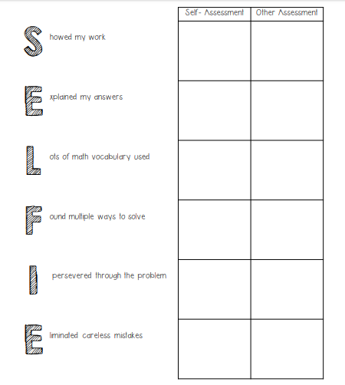

Math Game Planning Template
Start Planning Date:
End Date:
Outcome:
I can…
My Idea:
Game it is similar too:
Things I need to include:
(Think pieces, rules, games, cards, answer key, etc)
Materials Needed:

BUT FIRST, LET ME TAKE A #SELFIE
Rate each category on the following scale:
- Very blurry! I need to do better next time.
- Out of focus! I could be more detailed.
- Needs a filter! I could do even more.
- Picture Perfect! I did this very well.
- Award Winning Work!

Classroom Activity Planning Template
Start Planning Date:
End Date:
Outcome:
I can…
My Idea:
Materials Needed:
How will I know if the student’s learned something?

BUT FIRST, LET ME TAKE A #SELFIE
Rate each category on the following scale:
- Very blurry! I need to do better next time.
- Out of focus! I could be more detailed.
- Needs a filter! I could do even more.
- Picture Perfect! I did this very well.
- Award Winning Work!

Anchor Chart Planning Template
Start Planning Date:
End Date:
Outcome:
I can…
What is an anchor chart?? | 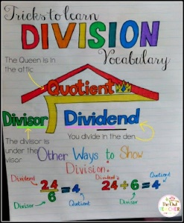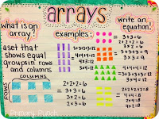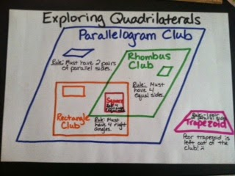
Draw a sample of anchor chart
(Think wisely about colors, size of words, hints, etc)

