**Date:\_\_\_\_\_\_\_\_\_\_\_\_\_\_ Name: \_\_\_\_\_\_\_\_\_\_\_\_\_\_\_\_\_\_\_**

**Grade 6 Summative Assessment**

**N6.1** I can label place value of numbers one million & one thousandth- \_\_\_\_\_\_\_\_\_\_\_

**N6.2** I can identify factors and multiples & prime/composite- \_\_\_\_\_\_\_\_\_\_

**N6.3** I can explain the standardized order of operations -\_\_\_\_\_\_\_\_\_\_\_\_

**N6.4** I can multiply & divide a decimal number- \_\_\_\_\_\_\_\_\_\_\_\_

**N6.5** I can understand percent-\_\_\_\_\_\_\_\_\_\_\_

**N6.6** I can understand integers - \_\_\_\_\_\_\_\_\_\_\_\_

**N6.7** I can understand improper fractions and mixed numbers- \_\_\_\_\_\_\_\_

**N6.8** I can show that I understand ratios- \_\_\_\_\_\_\_\_\_\_\_

**N6.9** I can share how First Nations & Métis people use numbers -\_\_\_\_\_\_\_

**SS6.1** I can identify acute, obtuse, right, straight and reflex angles-\_\_\_\_\_\_

**SS6.2** I can explain perimeter, area, volume- \_\_\_\_\_\_

**SS 6.3** I can classify any triangle & polygons- \_\_\_\_\_\_

**SS 6.4** I can plot an ordered pair on the first quadrant-\_\_\_\_\_\_\_\_

**SS 6.5** I can identify, draw 2 – D transformations-\_\_\_\_\_\_\_\_

**PR 6.1** I can understand the PR in a table of values and graphs- \_\_\_\_\_\_

**PR 6.2** I can show understanding of preservation of equality-\_\_\_\_\_\_\_

**PR 6.3** I can use expressions and equations involving variables-\_\_\_\_\_\_

**SP 6.1** I can find & use values in, on and around a line on a graph-\_\_\_\_\_\_

**SP 6.2** I can list the different outcomes that can happen for events and predict likelihood of future events & define and calculate experimental and theoretical probability-\_\_\_\_\_\_\_

**Number Strand**

**N6.1**

* **I can label place value of numbers greater than one million.**
* **I can label place value of numbers less than one thousandth.**
* **I can solve problems involving numbers greater than one million and less than one thousandth using a calculator or computer.**

1. Write each number in standard form.

a) 60 000 000 + 7 000 000 + 400 000 + 3000 + 20 + 2 \_\_\_\_\_\_\_\_\_\_\_\_\_\_\_\_\_\_\_\_

b) 3 billion 48 million 7 thousand 124 \_\_\_\_\_\_\_\_\_\_\_\_\_\_\_\_\_\_\_\_\_\_\_\_

1. Write each number in expanded form.

a) 23 086 021

\_\_\_\_\_\_\_\_\_\_\_\_\_\_\_\_\_\_\_\_\_\_\_\_\_\_\_\_\_\_\_\_\_\_\_\_\_\_\_\_\_\_\_\_\_\_\_\_\_\_\_\_\_\_\_\_\_\_\_\_\_\_

b) 4 326 180 501

\_\_\_\_\_\_\_\_\_\_\_\_\_\_\_\_\_\_\_\_\_\_\_\_\_\_\_\_\_\_\_\_\_\_\_\_\_\_\_\_\_\_\_\_\_\_\_\_\_\_\_\_\_\_\_\_\_\_\_\_\_\_

1. Write each number in standard form.

a) 2 and 5 thousandths: \_\_\_\_\_\_\_\_\_\_\_\_\_\_\_\_\_\_\_\_\_\_\_\_\_\_\_

b) 125 millionths: \_\_\_\_\_\_\_\_\_\_\_\_\_\_\_\_\_\_\_\_\_\_\_\_\_\_\_

c) 17 hundred-thousandths: \_\_\_\_\_\_\_\_\_\_\_\_\_\_\_\_\_\_\_\_\_\_\_\_\_\_\_

d) 1 and 34 ten-thousandths: \_\_\_\_\_\_\_\_\_\_\_\_\_\_\_\_\_\_\_\_\_\_\_\_\_\_\_

**N6.2**

* **I can identify factors and multiples of numbers less than 100.**
* **I can compare multiples to multiplication and division.**
* **I can compare prime and composite numbers.**

1. Use these numbers: 83, 77, 47, 56, 81, 126, 63, 108, 29  
   Which numbers are:

a) multiples of 7? b) multiples of 9?

\_\_\_\_\_\_\_\_\_\_\_\_\_\_\_\_\_\_\_\_\_ \_\_\_\_\_\_\_\_\_\_\_\_\_\_\_\_\_\_\_\_\_

c) prime numbers? d) composite numbers?

\_\_\_\_\_\_\_\_\_\_\_\_\_\_\_\_\_\_\_\_\_ \_\_\_\_\_\_\_\_\_\_\_\_\_\_\_\_\_\_\_\_\_

1. Find the first 3 common multiples of each set of numbers.

a) 4, 5, and 10 b) 3, 6, and 8 c) 2, 6, and 9

\_\_\_\_\_\_\_\_\_\_\_\_\_ \_\_\_\_\_\_\_\_\_\_\_\_\_ \_\_\_\_\_\_\_\_\_\_\_\_\_

1. List all the factors of each number. Circle the factors that are prime numbers.

a) 24 b) 64

\_\_\_\_\_\_\_\_\_\_\_\_\_\_\_\_\_\_\_\_\_ \_\_\_\_\_\_\_\_\_\_\_\_\_\_\_\_\_\_\_\_\_

c) 40 d) 78

\_\_\_\_\_\_\_\_\_\_\_\_\_\_\_\_\_\_\_\_\_ \_\_\_\_\_\_\_\_\_\_\_\_\_\_\_\_\_\_\_\_\_

1. Draw a factor tree for each number.  
   a) 30 b) 84 c) 48

**N6.3 I can explain the standardized order of operations.**

1. Evaluate each expression.  
   a) 48 ÷ (17 – 9) b) 26 + 2 × 3 c) 50 × (6 ÷ 3)

\_\_\_\_\_\_\_\_\_\_\_\_ \_\_\_\_\_\_\_\_\_\_\_\_ \_\_\_\_\_\_\_\_\_\_\_\_

1. Use a calculator to evaluate each expression.  
   a) (526 – 302) ÷ 28 b) 385 × 48 ÷ 12 c) 726 × 142 ÷ (16 ÷ 4)

\_\_\_\_\_\_\_\_\_\_\_\_ \_\_\_\_\_\_\_\_\_\_\_\_ \_\_\_\_\_\_\_\_\_\_\_\_

1. The warehouse workers packed 475 boxes of dictionaries.   
   Each box held 24 dictionaries. They also packed 589 boxes of spelling books.   
   Each box held 36 books. How many books did the workers pack altogether?
2. Each bus holds 56 people.  
   How many buses are needed to take 427 students, 17 teachers, and   
   53 parent volunteers to the track-and-field meet? Show your work
3. Enrique’s crew planted 258 rows of tomatoes. Each row had 175 plants.   
   How many tomatoes did Enrique’s crew plant?
4. You may use a calculator.  
   The product of a 2-digit number and a 4-digit number is about 500 000.  
   What might the 2 numbers be? Give as many answers as you can

**N6.4**

* **I can multiply a decimal number by a one digit whole number and by a one digit natural number.**
* **I can divide a decimal number by a one digit whole number and by a one digit natural number.**

1. Estimate each product or quotient using the given strategies.  
   Tell if the estimate is an overestimate or an underestimate.

a) 5.78 × 4

Front-end estimation: \_\_\_\_\_\_\_\_\_\_\_\_\_\_\_\_\_\_\_\_\_\_\_\_\_\_\_

Decimal benchmarks: \_\_\_\_\_\_\_\_\_\_\_\_\_\_\_\_\_\_\_\_\_\_\_\_\_\_\_

b) 976.4 ÷ 2

Front-end estimation: \_\_\_\_\_\_\_\_\_\_\_\_\_\_\_\_\_\_\_\_\_\_\_\_\_\_\_

Compatible numbers: \_\_\_\_\_\_\_\_\_\_\_\_\_\_\_\_\_\_\_\_\_\_\_\_\_\_\_

1. Estimate to replace each with > or <.  
   How did you decide which symbol to use?

a) 4 × 2.12 10.68

b) 3 × 0.97 29.1

c) 6 × 5.215 30

1. Estimate to place the decimal point in each product.

a) 3.4 × 8 = 272 b) 2.813 × 6 = 16878

c) 6.003 × 9 = 54027 d) 11.64 × 3 = 3492

1. Multiply.

a) 0.57 × 4 b) 3.78 L × 9

1. Divide.

a) 14.6 ÷ 4 b) $2.57 ÷ 9

1. Draw a square with perimeter 12.8 cm. Label the side length. (SS6.2)
2. Divide.

a) 0.18 ÷ 2 b) 0.048 ÷ 6 c) 0.0028 ÷ 4

1. One kilogram of cherries cost $4.29. Sam bought 4 kg.   
   The clerk charged Sam $19.96.

a) How did Sam immediately know that the clerk had made a mistake?

b) How much did the clerk charge Sam for each kilogram?  
Show your work.

c) How much should the clerk have charged Sam for the cherries?  
Show your work.

1. You know that 150 × 3 = 450 and 15 × 3 = 45.  
   Use these multiplication facts and patterns to write 4 multiplication   
   facts that involve decimals.  
   Describe the strategies you used.

**N6.5 I can understand percent.**

1. Write a fraction, a decimal, and a percent to name the shaded part of each grid.

|  |  |  |  |
| --- | --- | --- | --- |
| a) | u05_m22-t07 | b) | u05_m22-t08 |
|  |

1. Write each fraction as a percent and as a decimal.

a)  \_\_\_\_\_\_\_\_\_\_\_\_ b)  \_\_\_\_\_\_\_\_\_\_\_\_\_ c)  \_\_\_\_\_\_\_\_\_\_\_\_\_

d)  \_\_\_\_\_\_\_\_\_\_\_\_\_\_ e) \_\_\_\_\_\_\_\_\_\_\_\_\_

1. Use the grids in question 1.  
   Write a fraction, a decimal, and a percent to describe the unshaded part of each grid.

a) \_\_\_\_\_\_\_\_\_\_\_\_\_\_\_\_\_\_\_\_\_\_\_\_\_\_\_\_\_\_\_\_\_\_\_\_\_\_\_\_\_\_\_\_\_\_\_\_\_\_\_\_\_\_\_\_\_\_\_\_\_\_

b) \_\_\_\_\_\_\_\_\_\_\_\_\_\_\_\_\_\_\_\_\_\_\_\_\_\_\_\_\_\_\_\_\_\_\_\_\_\_\_\_\_\_\_\_\_\_\_\_\_\_\_\_\_\_\_\_\_\_\_\_\_\_

1. Is each fraction or decimal greater or less than 25%? Explain how you know.

a) 0.17 \_\_\_\_\_\_\_\_\_\_\_\_\_\_\_\_\_\_\_\_\_\_\_\_\_\_\_\_\_\_\_\_\_\_\_\_\_\_\_\_\_\_\_\_\_\_\_\_\_\_\_\_\_\_\_\_\_\_

b)  \_\_\_\_\_\_\_\_\_\_\_\_\_\_\_\_\_\_\_\_\_\_\_\_\_\_\_\_\_\_\_\_\_\_\_\_\_\_\_\_\_\_\_\_\_\_\_\_\_\_\_\_\_\_\_\_\_\_\_

c)  \_\_\_\_\_\_\_\_\_\_\_\_\_\_\_\_\_\_\_\_\_\_\_\_\_\_\_\_\_\_\_\_\_\_\_\_\_\_\_\_\_\_\_\_\_\_\_\_\_\_\_\_\_\_\_\_\_\_\_\_

d) 0.4 \_\_\_\_\_\_\_\_\_\_\_\_\_\_\_\_\_\_\_\_\_\_\_\_\_\_\_\_\_\_\_\_\_\_\_\_\_\_\_\_\_\_\_\_\_\_\_\_\_\_\_\_\_\_\_\_\_\_\_

1. Saul got 19 out of 25 on a test. Cindy got 79% on the same test.   
   Which student got the higher mark? Explain.
2. Write a percent that represents:

a) about  of something \_\_\_\_\_\_\_\_\_\_\_\_

b) between 0.15 and 0.25 of something \_\_\_\_\_\_\_\_\_\_\_\_

c) a little less than  of something \_\_\_\_\_\_\_\_\_\_\_\_

1. Explain what 75% means. Show and describe it in as many ways as you can.

**N6.6 I can understand integers and show my understanding concretely, pictorially and symbolically**

1. Look at these integers.  
   +1, –8, +9, –2, +8, –4, –1, +3, –7, +6, 0

List the integers that are:

a) less than 0 b) between –5 and +5

\_\_\_\_\_\_\_\_\_\_\_\_\_\_\_\_\_\_\_\_\_\_\_ \_\_\_\_\_\_\_\_\_\_\_\_\_\_\_\_\_\_\_\_\_\_\_\_

1. Order these integers from least to greatest.

+15, +3, –18, –7, 0, –12, +7

\_\_\_\_\_\_\_\_\_\_\_\_\_\_\_\_\_\_\_\_\_\_\_\_\_\_\_\_\_\_\_\_\_\_\_\_\_\_

**N6.7 I can understand fractions, improper fractions and mixed numbers.**

1. Write each mixed number as an improper fraction.

a)  \_\_\_\_\_\_\_\_\_\_\_\_\_\_\_\_\_\_\_\_\_\_ b)  \_\_\_\_\_\_\_\_\_\_\_\_\_\_\_\_\_\_\_\_\_\_

c)  \_\_\_\_\_\_\_\_\_\_\_\_\_\_\_\_\_\_\_\_\_\_ d)  \_\_\_\_\_\_\_\_\_\_\_\_\_\_\_\_\_\_\_\_\_\_

1. Write each improper fraction as a mixed number.

a)  \_\_\_\_\_\_\_\_\_\_\_\_\_\_\_\_\_\_\_\_\_\_ b)  \_\_\_\_\_\_\_\_\_\_\_\_\_\_\_\_\_\_\_\_\_\_

c)  \_\_\_\_\_\_\_\_\_\_\_\_\_\_\_\_\_\_\_\_\_\_ d)  \_\_\_\_\_\_\_\_\_\_\_\_\_\_\_\_\_\_\_\_\_\_

1. Place the numbers in each set on the number line.  
   a) , , 



b) , , 



1. Order the numbers in each set from least to greatest. Show your work.

a) , ,  \_\_\_\_\_\_\_\_\_\_\_\_\_\_\_\_\_\_\_\_\_\_\_\_\_\_\_\_\_\_\_\_\_\_\_\_\_\_\_\_\_\_\_\_\_\_\_\_\_\_\_\_\_

b) , ,  \_\_\_\_\_\_\_\_\_\_\_\_\_\_\_\_\_\_\_\_\_\_\_\_\_\_\_\_\_\_\_\_\_\_\_\_\_\_\_\_\_\_\_\_\_\_\_\_\_\_\_\_\_

**N6.8 I can show that I understand ratios concretely, pictorially and symbolically.**

1. Write a ratio to show the number of:

a) circles to squares \_\_\_\_\_\_\_\_\_ b) triangles to circles \_\_\_\_\_\_\_\_\_\_

c) squares to triangles \_\_\_\_\_\_\_\_\_ d) circles to all shapes \_\_\_\_\_\_\_\_\_

|  |
| --- |
| u05_m22-t09 |

1. Write 3 equivalent ratios for each ratio.

a) 3 : 5 \_\_\_\_\_\_\_\_\_\_\_\_\_\_\_\_\_\_\_\_\_\_\_\_\_\_\_\_\_\_\_\_\_\_\_\_\_\_\_\_\_\_\_\_\_\_\_\_\_\_\_\_\_\_\_\_\_

b) 90 : 30 \_\_\_\_\_\_\_\_\_\_\_\_\_\_\_\_\_\_\_\_\_\_\_\_\_\_\_\_\_\_\_\_\_\_\_\_\_\_\_\_\_\_\_\_\_\_\_\_\_\_\_\_\_\_

1. Find all ratios that are equivalent to 5 : 9 and have a first term that is less than 40.
2. Kwasi uses 3 parts of olive oil for every 2 parts of vinegar to make a salad dressing. Suppose Kwasi uses 15 parts of olive oil. How many parts of vinegar will he use?

N6.9 I can share how First Nations and Métis people use numbers in their lives.

**Shape and Space Strand**

**SS6.1**

* **I can identify acute, obtuse, right, straight and reflex angles in the real world.**
* **I can classify angles as acute, obtuse, right, straight and reflex.**
* **I can estimate the measure of an angle because I know what a 45°, 90°, and 180° angle looks like.**
* **I can draw angles between 0° and 360°.**
* **I can explain the relationship between the 3 angles in a triangle.**
* **I can explain the relationship between the 4 angles in a quadrilateral.**

1. Estimate the size of each angle.  
Use a protractor to measure the angle.  
Name the angle as acute, obtuse, right, or straight.  
a) b) c) d)

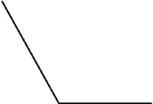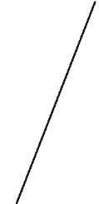  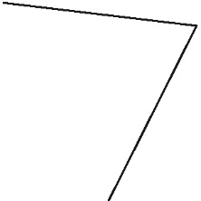

\_\_\_\_\_\_\_\_\_\_\_\_\_ \_\_\_\_\_\_\_\_\_\_\_\_\_ \_\_\_\_\_\_\_\_\_\_\_\_\_ \_\_\_\_\_\_\_\_\_\_\_\_

\_\_\_\_\_\_\_\_\_\_\_\_\_ \_\_\_\_\_\_\_\_\_\_\_\_\_ \_\_\_\_\_\_\_\_\_\_\_\_\_ \_\_\_\_\_\_\_\_\_\_\_\_\_

\_\_\_\_\_\_\_\_\_\_\_\_\_ \_\_\_\_\_\_\_\_\_\_\_\_\_ \_\_\_\_\_\_\_\_\_\_\_\_\_ \_\_\_\_\_\_\_\_\_\_\_\_\_

2. Use a ruler to draw an angle between 45° and 90°.  
Use a protractor to measure the angle you drew.  
Label the angle with its measure.

3. Use a ruler and a protractor.   
Draw and label an angle with each measure.

a)140° b) 240°

c)340° d) 40°

4. a) Use a protractor. Draw and label a 70° angle.

b)Do not use a protractor. Draw and label an angle that is 90° greater   
than your angle in part a.

c)Use a protractor to check your angle from part b.   
How close was your angle?

5. Draw a quadrilateral that has:

a) Exactly 2 right angles b) Exactly 3 acute angles

6. A triangle has angle measures of 35° and 55°.   
What is the measure of the third angle?  
Explain how you know.

7. A quadrilateral has three angles that measure 70°, 125°, and 35°.  
A student says the measure of the fourth angle is 120°.  
Is the student correct? Explain how you know.

8. Suppose you have 2 copies of this triangle. You combine the triangles to form as many different triangles and quadrilaterals as you can.

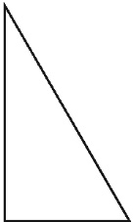

a) Sketch the shapes that have right angles.

b) Sketch the shapes that have acute angles.

c) Sketch the shapes that have obtuse angles.

d) Sketch the shapes that have straight angles.

e) Choose one quadrilateral and one triangle from parts a to d.   
Each shape is made from the same 2 triangles. Explain why the sum of the interior angles of one shape is 180° and the sum of the interior angles of the other shape is 360°.

**SS6.2**

* **I can explain how the area of a right rectangular prism relates to volume.**
* **I can show how perimeter compares to area in rectangles.**
* **I can show how area compares to volume in a right rectangular prism.**
* **I can use formulas for finding perimeter of polygons, areas of rectangles and volume of right rectangular prisms.**
* **I can explain how the area and volume of a shape are affected by orientation of the shape.**
* **I can solve word problems involving perimeter, area and volume.**

1. Write a rule to find the perimeter of this shape.

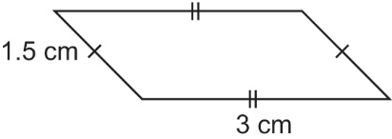

Write the rule as a formula.

What is the perimeter?

1. Complete the table below.

|  |  |  |  |
| --- | --- | --- | --- |
| Rectangle | Length (cm) | Width (cm) | Area (cm2) |
| A | 14 | 6 |  |
| B | 25 |  | 300 |
| C |  | 8 | 128 |
| D | 11.8 | 9 |  |

1. Sandar needs a box in the shape of a rectangular prism with volume 300 cm3.   
   He wants the box to hold a gift he bought for his mother.

a) Make a sketch of a box Sandar might use.  
Label its dimensions.

b) What might the gift be that Sandar bought?

**SS 6.3**

* I can classify any triangle as scalene, isosceles, equilateral, right, obtuse and acute.
* I can classify any polygon as regular or irregular.
* I can explain the relationship between side lengths in a regular polygon.
* I can explain the relationship between angles in a regular polygon.
* I can identify whether or not 2 polygons are congruent.

1. Name each triangle in 2 different ways.

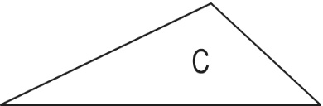\_\_\_\_\_\_\_\_\_\_\_\_\_\_\_ \_\_\_\_\_\_\_\_\_\_\_\_\_\_\_

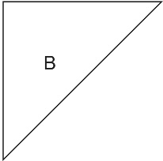 \_\_\_\_\_\_\_\_\_\_\_\_\_\_\_ \_\_\_\_\_\_\_\_\_\_\_\_\_\_\_

 \_\_\_\_\_\_\_\_\_\_\_\_\_\_\_ \_\_\_\_\_\_\_\_\_\_\_\_\_\_\_

1. Use a ruler and protractor.

|  |  |
| --- | --- |
| a) Draw triangle ABC. The measure of ∠B is 30°. The length of side AB is 5 cm. The length of side BC is 3 cm. | b) Draw triangle XYZ. The measure of ∠X is 60°. The measure of ∠Y is 50°. The length of side XY is 5 cm. |
|  |  |

1. Suppose triangle LMN has these measures:  
   ∠M = 60° ∠N = 60° Side LM = 6 cm  
   a) What is the measure of ∠L? \_\_\_\_\_\_\_\_\_\_  
   b) What is the measure of side LN? \_\_\_\_\_\_\_\_\_\_  
   c) What is the measure of side MN? \_\_\_\_\_\_\_\_\_\_  
   d) What kind of triangle is ∆LMN? \_\_\_\_\_\_\_\_\_\_\_\_\_\_\_\_\_\_\_\_\_\_\_\_\_\_\_\_\_  
   e) How many lines of symmetry does it have? \_\_\_\_\_\_\_\_\_\_
2. Which pairs of polygons are congruent? How did you decide?

\_\_\_\_\_\_\_\_\_\_\_\_\_\_\_\_\_\_\_\_\_\_\_\_\_\_\_\_\_\_\_\_\_\_\_\_\_\_\_\_\_\_\_\_\_\_\_\_\_\_\_\_\_\_\_\_\_\_\_\_\_\_\_\_

\_\_\_\_\_\_\_\_\_\_\_\_\_\_\_\_\_\_\_\_\_\_\_\_\_\_\_\_\_\_\_\_\_\_\_\_\_\_\_\_\_\_\_\_\_\_\_\_\_\_\_\_\_\_\_\_\_\_\_\_\_\_\_\_

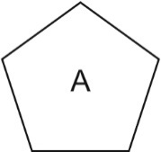 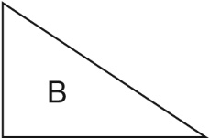 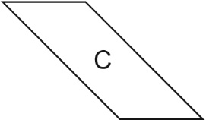 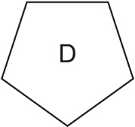

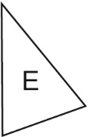 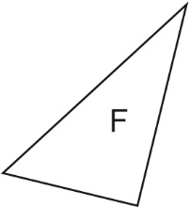 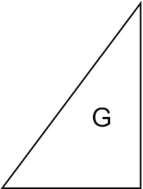 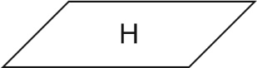

1. a) Sort the polygons into sets of regular and irregular polygons.  
   Record your sorting in a table.

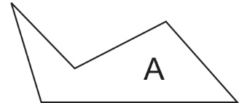 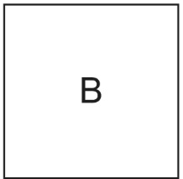 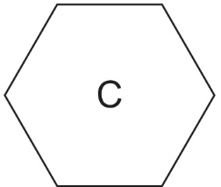

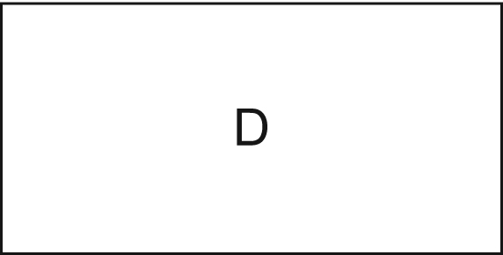

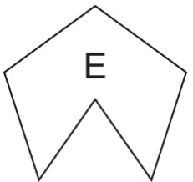 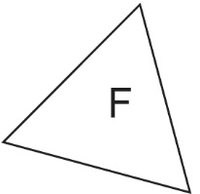 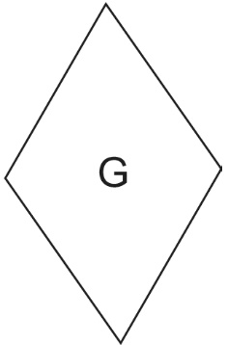

b) Sort the polygons into sets of convex and concave polygons.  
Record your sorting in a table.

**SS 6.4 I can plot an ordered pair on the first quadrant of the Cartesian Plane.**

1. Write the coordinates of each point on the coordinate grid.

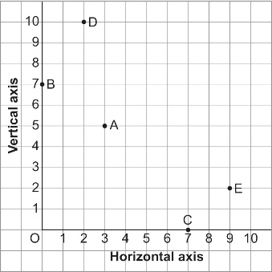

A: \_\_\_\_\_\_\_\_, B: \_\_\_\_\_\_\_\_, C: \_\_\_\_\_\_\_\_, D: \_\_\_\_\_\_\_\_, E: \_\_\_\_\_\_\_\_

1. 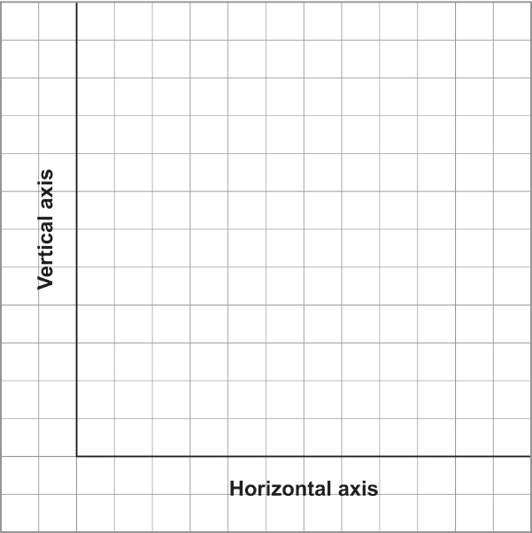a) Plot each point on the grid.  
   What scale will you use?  
   Explain your choice.   
   A(6, 8) B(6, 16) C(10, 16) D(10, 8)  
   \_\_\_\_\_\_\_\_\_\_\_\_\_\_\_\_\_\_\_\_\_\_\_\_\_\_\_\_\_\_\_\_\_\_\_\_  
   \_\_\_\_\_\_\_\_\_\_\_\_\_\_\_\_\_\_\_\_\_\_\_\_\_\_\_\_\_\_\_\_\_\_\_\_  
   \_\_\_\_\_\_\_\_\_\_\_\_\_\_\_\_\_\_\_\_\_\_\_\_\_\_\_\_\_\_\_\_\_\_\_\_

b) Join the points in order.  
Then join D to A.  
Describe the shape you have drawn.  
\_\_\_\_\_\_\_\_\_\_\_\_\_\_\_\_\_\_\_\_\_\_\_\_\_\_\_\_\_\_\_\_\_\_\_\_

c) Find the length of BC and CD.   
Show your work. (SS6.3)

**SS 6.5**

* **I can identify 2 – D transformations**
* **I can explain how a 2 – D transformation was done.**
* **I can draw a 2 – D transformation.**

1. 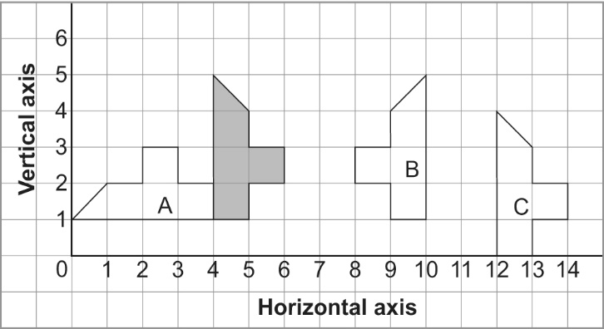This diagram shows a shape and its   
   image after 3 different transformations.  
   Identify each transformation.  
   Explain how you know.

a) the shape to Image A  
\_\_\_\_\_\_\_\_\_\_\_\_\_\_\_\_\_\_\_\_\_\_\_\_\_  
\_\_\_\_\_\_\_\_\_\_\_\_\_\_\_\_\_\_\_\_\_\_\_\_\_  
\_\_\_\_\_\_\_\_\_\_\_\_\_\_\_\_\_\_\_\_\_\_\_\_\_  
\_\_\_\_\_\_\_\_\_\_\_\_\_\_\_\_\_\_\_\_\_\_\_\_\_

b) the shape to Image B  
\_\_\_\_\_\_\_\_\_\_\_\_\_\_\_\_\_\_\_\_\_\_\_\_\_\_\_\_\_\_\_\_\_\_\_\_\_\_\_\_\_\_\_\_\_\_\_\_\_\_\_\_\_\_\_\_\_\_\_\_\_\_\_\_\_  
\_\_\_\_\_\_\_\_\_\_\_\_\_\_\_\_\_\_\_\_\_\_\_\_\_\_\_\_\_\_\_\_\_\_\_\_\_\_\_\_\_\_\_\_\_\_\_\_\_\_\_\_\_\_\_\_\_\_\_\_\_\_\_\_\_

c) the shape to Image C  
\_\_\_\_\_\_\_\_\_\_\_\_\_\_\_\_\_\_\_\_\_\_\_\_\_\_\_\_\_\_\_\_\_\_\_\_\_\_\_\_\_\_\_\_\_\_\_\_\_\_\_\_\_\_\_\_\_\_\_\_\_\_\_\_\_  
\_\_\_\_\_\_\_\_\_\_\_\_\_\_\_\_\_\_\_\_\_\_\_\_\_\_\_\_\_\_\_\_\_\_\_\_\_\_\_\_\_\_\_\_\_\_\_\_\_\_\_\_\_\_\_\_\_\_\_\_\_\_\_\_\_

1. Use △PQR on the coordinate grid. For each transformation below:  
   • Draw the image after the transformation.  
   • Write the coordinates of the vertices of the image.  
   • Describe how the positions of the vertices of the triangle have changed.   
   a) a translation of 3 squares left and 1 square down  
   b) a reflection in the vertical line through the horizontal axis at 6  
   c) a 90° clockwise rotation about vertex P

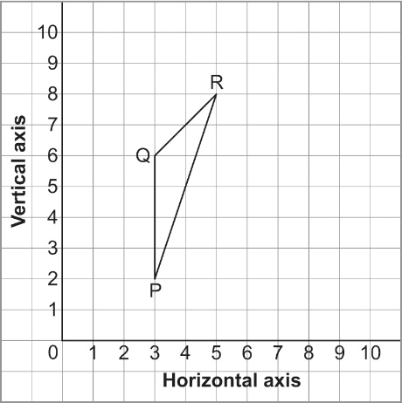

1. 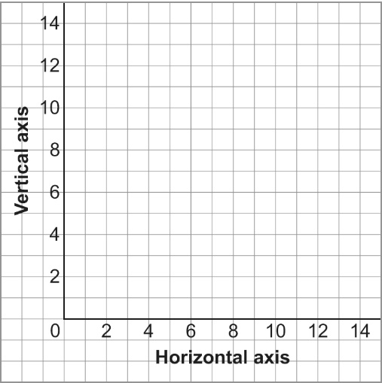a) Rectangle MNPQ has these vertices: (SS6.4)  
   M(1, 3), N(4, 6), P(6, 4), Q(3, 1)  
   – Draw MNPQ on the grid.  
   – Rotate MNPQ 180° about (4, 7).  
   – Then, reflect the rotation image   
    in a vertical line through the horizontal   
    axis at 7.  
   – Find the coordinates of the final image.  
    \_\_\_\_\_\_\_\_\_\_\_\_\_\_\_\_\_\_\_\_\_\_\_\_\_\_\_\_\_\_\_

b) What can you say about the rectangle   
and its final image? How can you check?

1. 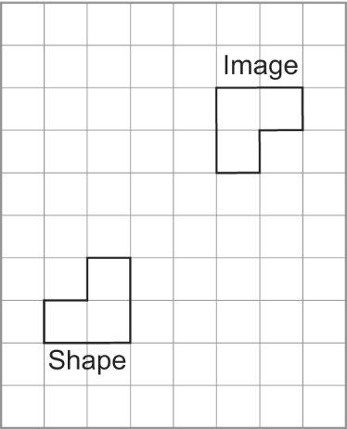Describe as many pairs of transformations as you can that move the shape   
   to its image.

\_\_\_\_\_\_\_\_\_\_\_\_\_\_\_\_\_\_\_\_\_\_\_\_\_\_\_\_\_\_\_\_\_\_\_\_\_

\_\_\_\_\_\_\_\_\_\_\_\_\_\_\_\_\_\_\_\_\_\_\_\_\_\_\_\_\_\_\_\_\_\_\_\_\_

\_\_\_\_\_\_\_\_\_\_\_\_\_\_\_\_\_\_\_\_\_\_\_\_\_\_\_\_\_\_\_\_\_\_\_\_\_

\_\_\_\_\_\_\_\_\_\_\_\_\_\_\_\_\_\_\_\_\_\_\_\_\_\_\_\_\_\_\_\_\_\_\_\_\_

**\_\_\_\_\_\_\_\_\_\_\_\_\_\_\_\_\_\_\_\_\_\_\_\_\_\_\_\_\_\_\_\_\_\_\_\_\_**

1. Use 2 shapes and transformations to make a design on the grid below.

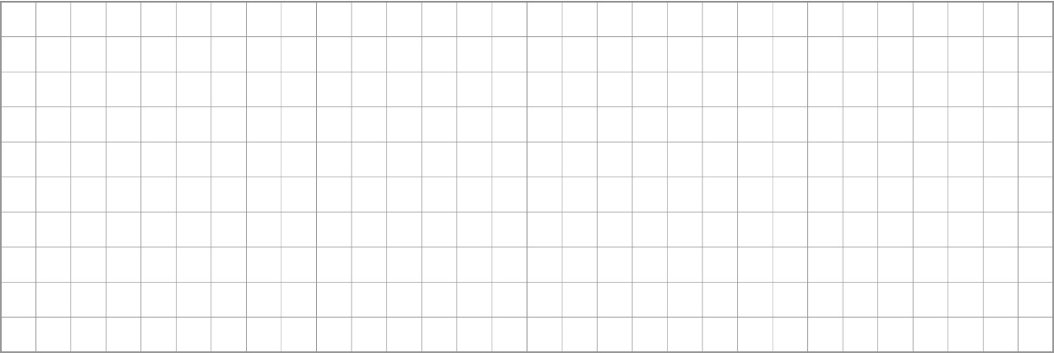

Describe some of the transformations you used to create the design.

\_\_\_\_\_\_\_\_\_\_\_\_\_\_\_\_\_\_\_\_\_\_\_\_\_\_\_\_\_\_\_\_\_\_\_\_\_\_\_\_\_\_\_\_\_\_\_\_\_\_\_\_\_\_\_\_\_\_\_\_\_\_\_\_\_\_\_

\_\_\_\_\_\_\_\_\_\_\_\_\_\_\_\_\_\_\_\_\_\_\_\_\_\_\_\_\_\_\_\_\_\_\_\_\_\_\_\_\_\_\_\_\_\_\_\_\_\_\_\_\_\_\_\_\_\_\_\_\_\_\_\_\_\_\_

\_\_\_\_\_\_\_\_\_\_\_\_\_\_\_\_\_\_\_\_\_\_\_\_\_\_\_\_\_\_\_\_\_\_\_\_\_\_\_\_\_\_\_\_\_\_\_\_\_\_\_\_\_\_\_\_\_\_\_\_\_\_\_\_\_\_\_

**Patterns and Relations Strand**

**PR 6.1 I can understand the patterns and relationships in a table of values and graphs.**

**1. a)** Here is an Input/Output table for this machine.  
Check the data in the table.  
Identify any output numbers that are incorrect.  
How do you know they are incorrect?

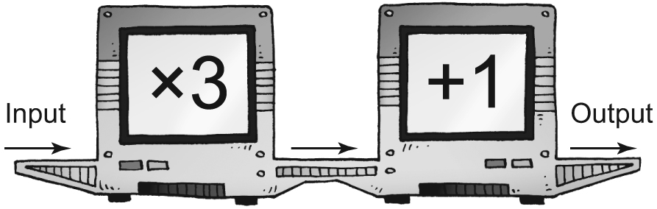

|  |  |
| --- | --- |
| **Input** | **Output** |
| 1 | 4 |
| 2 | 7 |
| 3 | 8 |
| 4 | 12 |
| 5 | 16 |
| 6 | 13 |

**b)** Write the pattern rule for the input: \_\_\_\_\_\_\_\_\_\_\_\_\_\_\_\_\_\_\_\_\_\_\_

**c)** Write the pattern rule for the corrected output: \_\_\_\_\_\_\_\_\_\_\_\_\_\_\_\_\_\_\_\_\_\_\_\_\_

2. This table shows the input and output from a machine with two operations.

|  |  |
| --- | --- |
| **Input** | **Output** |
| 1 | 2 |
| 2 | 7 |
| 3 | 12 |
| 4 | 17 |

**a)** Identify the numbers and operations in the machine.   
Draw the machine.

**b)** Write a pattern rule that relates the input to the output. (PR6.3)

\_\_\_\_\_\_\_\_\_\_\_\_\_\_\_\_\_\_\_\_\_\_\_\_\_\_\_\_\_\_\_\_\_\_\_\_\_\_\_\_\_\_\_\_\_\_\_\_\_\_\_\_\_\_\_\_\_

**c)** Write an expression to represent the pattern. (PR6.3)

**d)** Find the output when the input is 10. \_\_\_\_\_\_\_\_\_\_\_\_\_\_\_\_

What strategy did you use? \_\_\_\_\_\_\_\_\_\_\_\_\_\_\_\_\_\_\_\_\_\_\_\_\_\_\_\_\_\_\_\_\_\_\_

|  |  |
| --- | --- |
|  |  |
|  |  |
|  |  |
|  |  |
|  |  |
|  |  |

**3. a)** Record this pattern in the table.

u01_m19-t06

**b)** Use grid paper. Draw a graph to represent the pattern.  
Explain how the graph represents the pattern.

\_\_\_\_\_\_\_\_\_\_\_\_\_\_\_\_\_\_\_\_\_\_\_\_\_\_\_\_\_\_\_\_\_\_\_\_\_\_\_\_\_\_\_\_\_\_

\_\_\_\_\_\_\_\_\_\_\_\_\_\_\_\_\_\_\_\_\_\_\_\_\_\_\_\_\_\_\_\_\_\_\_\_\_\_\_\_\_\_\_\_\_\_

**c)** Write an expression to represent the pattern. \_\_\_\_\_\_\_\_\_\_\_\_\_\_\_\_\_\_\_\_\_\_\_\_ (PR6.3)

4. June is going to the amusement park with her friends.   
She will pay $8 for admission, plus $2 for each ride she goes on.

**a)** Make a table to show how much June will pay   
if she goes on 1, 2, 3, and 4 rides.

**b)** Write a pattern rule that relates the amount June pays   
to the number of rides she goes on.

|  |  |
| --- | --- |
|  |  |
|  |  |
|  |  |
|  |  |
|  |  |

\_\_\_\_\_\_\_\_\_\_\_\_\_\_\_\_\_\_\_\_\_\_\_\_\_\_\_\_\_\_\_\_\_\_\_\_\_\_\_

\_\_\_\_\_\_\_\_\_\_\_\_\_\_\_\_\_\_\_\_\_\_\_\_\_\_\_\_\_\_\_\_\_\_\_\_\_\_\_

**c)** Write an expression to represent the pattern. \_\_\_\_\_\_\_\_\_\_\_\_\_\_\_\_\_\_\_\_\_\_\_\_(PR6.3)

**d)** Suppose June goes on 8 rides. How much will she pay? \_\_\_\_\_\_\_\_\_\_\_\_\_\_\_

What strategy did you use to find out?

\_\_\_\_\_\_\_\_\_\_\_\_\_\_\_\_\_\_\_\_\_\_\_\_\_\_\_\_\_\_\_\_\_\_\_\_\_\_\_\_\_\_\_\_\_\_\_\_\_\_\_\_\_\_\_\_\_\_\_\_

**e)** Suppose June paid $30. How many rides did she go on? \_\_\_\_\_\_\_\_\_\_\_\_\_\_\_

How did you find out? \_\_\_\_\_\_\_\_\_\_\_\_\_\_\_\_\_\_\_\_\_\_\_\_\_\_\_\_\_\_\_\_\_\_\_\_\_\_\_\_\_\_\_

**PR 6.2 I can show understanding of preservation of equality concretely, pictorially and symbolically.**

1. Rewrite each expression using a commutative property.

**a)** 4 × 8 \_\_\_\_\_\_\_\_\_\_\_\_\_\_\_\_\_\_ **b)** 84 + 19 \_\_\_\_\_\_\_\_\_\_\_\_\_\_\_\_\_\_\_

1. Write an equivalent form of the equation *5c* = 30.

Tell how you know that equality has been preserved.

**PR 6.3 I can use expressions and equations involving variables to show understanding of patterns and relationships.**

1. Write an expression with a variable to represent each pattern rule.  
   Let n represent the input.

**a)** Multiply the input by 10, then add 4. \_\_\_\_\_\_\_\_\_\_\_\_\_\_\_\_\_\_\_\_\_\_\_\_\_\_

**b)** Divide the input by 3, then add 4. \_\_\_\_\_\_\_\_\_\_\_\_\_\_\_\_\_\_\_\_\_\_\_\_\_\_\_\_

**c)** Multiply the input by 7, then subtract 2. \_\_\_\_\_\_\_\_\_\_\_\_\_\_\_\_\_\_\_\_\_\_\_\_

2. Write an expression with 2 numbers and one operation to balance each equation.

**a)** 5 × 7 = \_\_\_\_\_\_\_\_\_\_ **b)** 18 – 9 = \_\_\_\_\_\_\_\_\_\_ c) 32 ÷ 8 = \_\_\_\_\_\_\_\_\_\_

**Statistics and Probability Strand**

**SP 6.1**

* **I can find and use values in, on and around a line on a graph.**
* **I can show information on questionnaires, databases and electronic media trends using trends and patterns to arrive at a meaning.**

1. Design a questionnaire to collect data to answer this question.  
   Who is the favourite author of students in your class?  
   Give at least 4 possible answers for your question.

1. Choose an appropriate method to collect data to answer each question below.

a) How do most children in Canada get to school?

b) How many times can you hop on 1 foot in 1 min?

|  |  |
| --- | --- |
| **Month** | **Mass (kg)** |
| 1 | 3 |
| 2 | 5 |
| 3 | 7 |
| 4 | 8 |
| 5 | 9 |
| 6 | 9.5 |
| 7 | 10 |
| 8 | 10 |

1. Molly weighs her new puppy at the end of each month   
   for 8 months.

a) Use 1-cm grid paper. Draw a line graph to show these data.

b) Explain how you chose the scale for the vertical axis.

c) What conclusions can you make from the graph?

1. Which type of graph would you use to display each set of data?   
   Justify your choice each time.

a) the favourite art materials of students in your class

b) the temperature in your classroom between 9 a.m. and 3 p.m.

c) the number of students in your school each year from 2003 to 2008

**SP 6.2**

* **I can list the different outcomes that can happen for events and predict likelihood of future events.**
* **I can define and calculate experimental and theoretical probability including a zero probability of an event.**

1. Arash places 2 yellow, 4 green, 1 blue, and 6 red tiles in a bag.   
   He picks one tile without looking.   
   What is the theoretical probability of drawing each colour?
2. Liam uses this spinner to choose a flavour of potato chips.

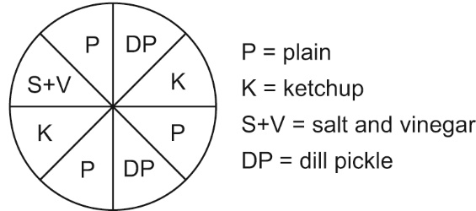

1. What is the theoretical probability that Liam will choose ketchup chips?

b) Which flavours have an equal chance of being chosen?

c) Liam spun the spinner 40 times. Here are his results:  
plain 17, dill pickle 8, ketchup 13, salt and vinegar 2

What is the experimental probability that Liam will choose ketchup chips?\_\_\_\_\_\_

How does this compare to the theoretical probability? Explain.

1. Suppose you are playing a game.  
   You have a 6-sided die with faces labelled: 1, 2, 2, 3, 3, 3  
   You have a regular octahedron with faces labelled: 1, 1, 2, 2, 2, 3, 3, 3  
   To win the game, you must roll an odd number.

a) Which die would you roll? Explain your choice.

1. Ian played the game 60 times with one of the dice. These are his results:  
   odd number: 42 even number: 18  
   Can you tell which die Ian used to play the game? Explain.