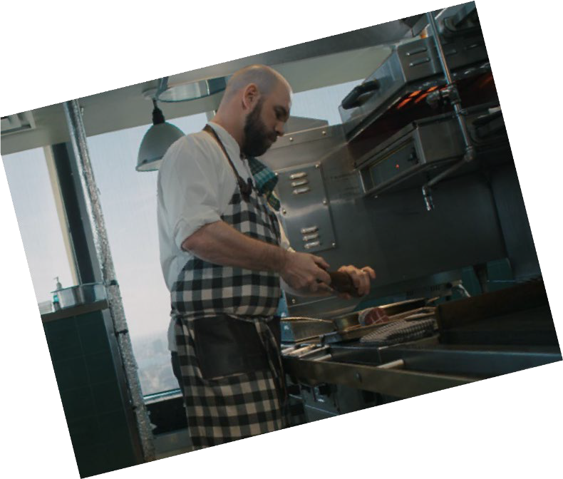
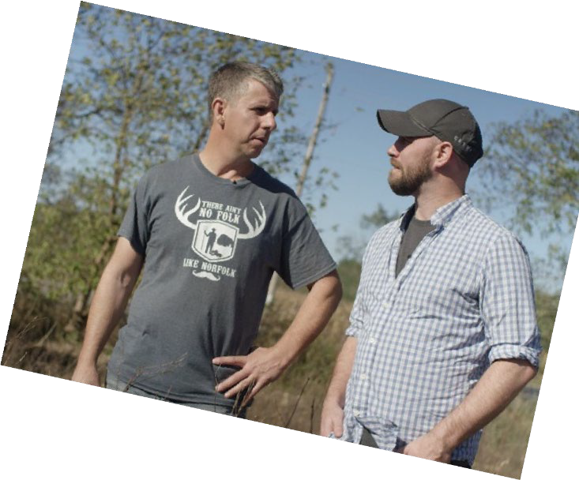
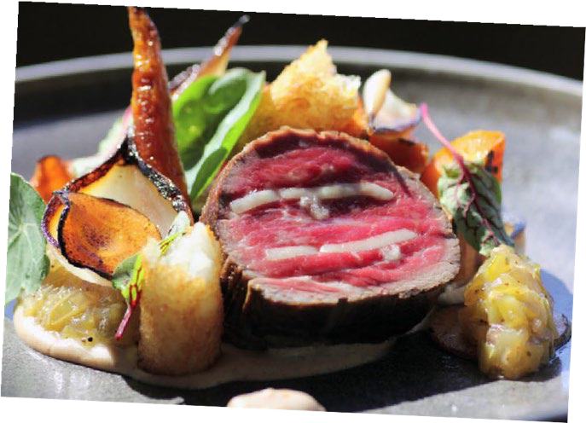

Before the Plate
Student Guide

Educational Resource for Grades 9-12

WWW.AITC-CANADA.CA

Documentary: Before the Plate

Pre-Viewing Questions
- We will be watching a documentary called Before the Plate. Based on the title, what do you predict this film will be about?

- When you sit down to eat a meal, where do you imagine your food comes from?

- Have you ever visited a farm? If so, what was it like?

- What would you like to learn about farmers and farming?

- Have you ever met a farmer? What were they like?

- What is your opinion of farmers? What level of education do you think most need to do their job well? What do you think their typical day is like?

- What is your knowledge and present opinion of organic food and non-organic food?

- What do you know about GMO foods? What is your present opinion of GMO foods?

Documentary: Before the Plate

Viewing Questions

Part A: Introduction

- What is Chef John’s goal in the film?

- Chef John says: “Farmers need to hear our voice, and we need to hear theirs.” Do you believe this is true? Why or why not?

- According to Chef John, what makes it easy for consumers to complain about price?

Part B: The Potato Farmer

- What is one of the challenges the potato farmer notes when it comes to selling his product?

- List two things you learned from the potato farmer about chemical use on farms.

Part C: The Cattle (Beef) Farmer

- List three things you learned about animal antibiotics from the beef farmer.

- List two things you learned about hormones in beef cattle.

- How are beef cattle killed, and why is this method used?

- In addition to beef, what else is the animal used for?

- Do you as a consumer of beef want to know how beef cattle are raised? Why or why not?

Part D: The Tomato Farmer

- List two things you learned about growing tomatoes in a greenhouse.

- What do you think are the challenges of growing tomatoes in a greenhouse?

- What do you think are the benefits of growing tomatoes in a greenhouse rather than in a field?

Part E: The Cash Crop Farmer

1. How is the cash crop farmer (who grows corn) connected to the tomato farmer?

Part F: The Vegetable Farmer (Carrots, Onion, Celery)
- How many truckloads of vegetables fill the farmer’s cooler each week?

- Why does the farmer like to harvest when the soil is cold, right before the first frost arrives?

- Dr. Clarence Swanton says consumers’ expectations for perfect looking food come at a cost to the environment and to the food production system. What does he mean by this?

- How were the onion plants planted? Why does the farmer choose to plant them this way?

- The vegetable farmer brought a helicopter in to spray his field because it was too wet to take vehicles in to do the spraying. What do you think is wrong with taking farm vehicles onto wet farmland?

- What does the vegetable farmer hope people will come to understand about modern farming?

- Research Ontario’s Holland Marsh. What is it known for? What makes it so special?

Part G: The Sunflower Farmer

- What does a sunflower have to look like in order to be harvested?

- The farmer produced his seed by taking plant genetics from two plants and creating a hybrid. When deciding on what seed to use to grow his plants, what factors does the farmer consider?

- What percentage of oil is each sunflower seed comprised of?

- How many months of the year does the sunflower farmer make sunflower oil?

- Why did the sunflower farmer decide to start growing sunflowers?

Part I: The Wheat Farmer

- When you buy a bag of wheat flour from the grocery store, is all that flour from one single farm? Explain.

- What did you learn about the planting, dormancy, and growing stages of wheat?

- The wheat farmers talk about how farming is a lifestyle and not a career. What do they mean by this?

Part J: The Honey Farmer

- Why does the farmer leave some honey behind on the cells?

- How much honey can one bee produce in its lifetime?

- Briefly explain how honey is made.

- List 3 bee health issues noted by the honey farmer

Miscellaneous Questions

- What is 100KM Foods Inc.?

- What did you learn about the food inspection system?

- What was the goal of this video?

- How can you contact a farmer?

- What did you learn about the adoption of new farming technologies?

Documentary: Before the Plate

Post-Viewing Reflection Questions
- How can you continue to educate yourself about where your food comes from?

- What impact do you think the consumer has on what grocery stores supply?

- Did your stance on Canadian agriculture (including organic and GMO foods) change? What was it before and how has it changed as a result of watching this video?

- Identify a food not mentioned in this video and identify where it is grown in Canada. Next, phone or email a farmer with your questions. Write down their answers.

- After watching this video, describe how you would explain Canadian agriculture to one of your friends who do not have an agricultural connection.

- Do you have any remaining questions about Canadian food production? What are they? What can farmers do to address them and make the answers more available and well known to the wider public?

- What makes this documentary a credible source of information on farming practices in Canada?

- Is it necessary to know where your food comes from? Why or why not? Why do chefs and farmers think it is important?

- A migrant worker from Jamaica was featured in the potato segment of Before the Plate. What types of farms do you think require migrant workers, and why? What do you think it is like for those migrant workers to be working so far away from home?

- Write a letter to the director with your remaining questions.

- Reflect on the title of the film, Before the Plate. Do you think this title is appropriate? Why or why not?

- A popular bumper sticker states: “Farmers Feed Cities”. After watching this video, what does this statement mean to you? What images come to mind?

