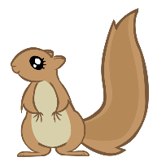
Self-Manager Squirrel

- well-behaved (good) kids
- working hard
- you keep trying
- you have everything you need

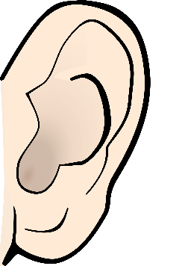
- quiet (but not a pin drop quiet)
- using nice words to each other
- kids figuring things out
- asking someone else for information

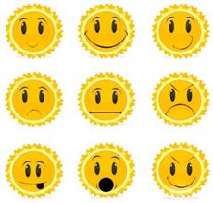
- happy because we’re learning new things
- awesome because we learn our own things

