Creative Cat
- Seeing lots of detail
- Kids being unique
- Kids discovering

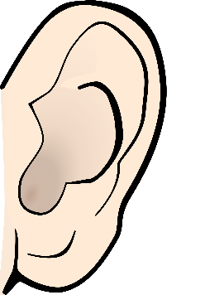
- Hearing “I’ll try that!”
- Kids asking questions to get information
- Kids making connections

- Feeling happy because you are trying new things
- Not feeling scared to take a risk
- Feeling proud and confident

