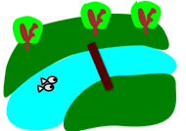
Reflective River

- Kids making things better.
- Seeing kids understanding feedback.
- Kids showing what they have learned.

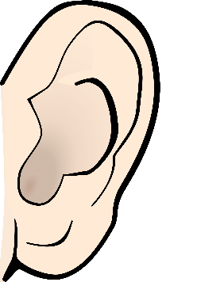
- Kids saying “Oops, I better look it over.”
      - Kids saying “This is what I want to get done today.”
      - Kids saying “I’m not giving up on this today!”

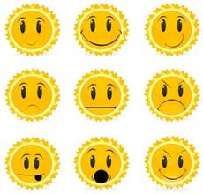
      - Kids feeling proud that they reached a goal.
      - Kids feeling happy that they found a way around a problem.
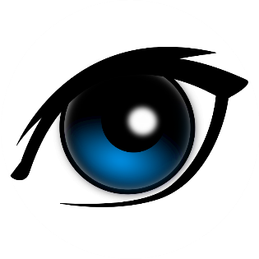
      - Kids feeling positive that they shared something special!

