Eager Elephant

- kids helping other kids
- kids doing their best
- kids solving problems

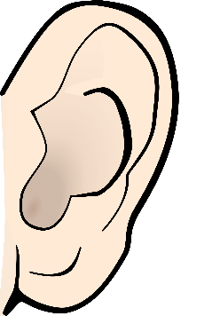
- “Can I help you?”
- you hear answers to a problem
- “Thanks for your help!”
- “Can we get working?”

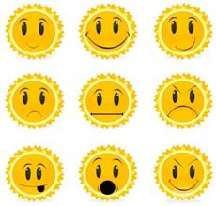
- Kids excited to get to work on their project.
- Feeling proud that you helped someone
- Feeling happy that friends are helping friends

