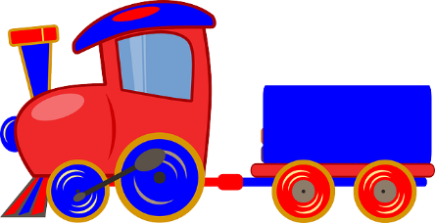
Team Work Train
- Kids helping each other
- No one is left out!
- Kids sharing jobs
- Kids doing teamwork!

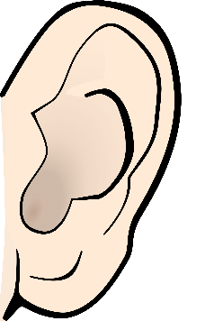
      - Kids saying “I’ll help you!”
      - Kids saying “I’ll work with you!”
      - Kids saying “The job is done!”

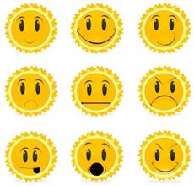
- Kids feeling proud that they helped people.
- Kids feeling amazing that they shared jobs.
      - Kids feeling perfect because they were responsible.

