Exam Preparation & Overcoming Test Anxiety
A Crash Course

Setting Priorities:
Prioritize the following in order from MOST (1) important to LEAST (6) important on an average weeknight:

- ____________ Watch TV​
- ____________ Organize my backpack for tomorrow​
- ____________ Watch youtube videos​
- ____________ Study for a test next friday​
- ____________ Complete math homework due tomorrow​
- ____________ Text with friends

In order to be a successful student, you must make your assignments, as well as studying for tests and exams a priority over entertainment.

Internal & External Barriers to Studying:

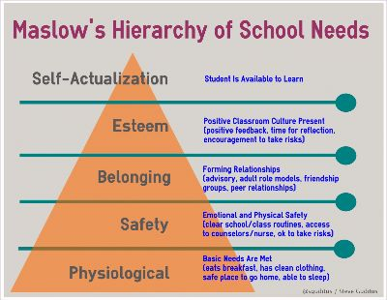

There are many factors that influence how you learn and study. These can be internal (your own thoughts and feelings) or external (distractions and problems in your environment).

My own internal & external barriers to studying:

My internal barriers (my thoughts, feelings, attitude): | My external barriers (my environment, my habits, other distractions)

Knowing when to study:

- Studying has shown to be most effective in chunks or short repeated sessions. (you should be studying for several days or weeks before your test or exam)​
- Study at specific times, make it a part of your routine. (ie: after dinner every day)​
- Try the pomodoro technique. This is a technique proven to boost productivity. Using a timer study for 25 minutes (an undistracted/ focused 25 minutes), then take a 5 minute break.​
- After four "pomodoros" have passed (100 minutes with 4 breaks), you take a 15 minute break. ​
- The pomodoro technique keeps your brain fresh and focused. ​

The time I study best is:
- Early in the morning
- Right after school
- After dinner
- Other_____________________________

The reason I choose this time:____________________________________________

Study Environment:

- Create a dedicated or sacred spot​
- Your environment should be comfortable and free from distractions​
- Have all of your materials on hand before starting your session​
- Some research shows that varying your study environment can help you study​
- Some research shows that studying in the same place you will help you with recall​
- Certain classical music has been shown to help but studies have shown that students using a quiet environment have better recall of content.

The place I study best is:
- My bedroom
- The library
- The kitchen
- The diningroom
- Other __________________________________

The reason I choose this place:_________________________________________

Five items I need in my study environment to be an effective learner:
1____________________________________
2____________________________________
3____________________________________
4____________________________________
5____________________________________

Knowing when and where to study are two important factors in test and exam success. Studying in short chunks in a comfortable, distraction free environment have been proven to be successful study techniques.

Classical Study Playlists:

Classical Music for Reading
https://www.youtube.com/watch?v=mIYzp5rcTvU

Calm Music 24/7
https://www.youtube.com/watch?v=rLMHGjoxJdQ

Beautiful Relaxing Music
https://www.youtube.com/watch?v=hlWiI4xVXKY

Studying based on your learning style:

- Auditory Learner
- Visual Learner
- Kinesthetic Learner

Auditory Learner Study Tips:
- Auditory learners solidify their learning by hearing the information​
- Avoid the visuals of videos (listen don’t watch)​
- Have a friend or relative verbally quiz you
- Find audio sources with information you are studying​
- Verbalize what you are studying​
- Read your textbook out loud

Visual Learner Study Tips:
- Visual learners take in information with their eyes​
- Take detailed notes you can review later​
- Consider using mind maps to sort your information​
- Write a practice test
- Use flash cards while studying​
- Watch a video on the topic

Kinesthetic Learner Study Tips:
- Kinesthetic learners learn best through physical activity​
- Time your study sessions using the pomodoro technique, do a body break during your five minute break​
- Find ways to make your session active​ (such as a friend quizzing you while you do a physical activity)
- Keep your hands busy using a stress ball or fidget​
- Use flash cards spread throughout the room to get moving

My dominant learning style is _________________________________________

Two study tips I will try based on my learning style:
1.________________________________________________
2.________________________________________________

General Study Tips:

- Study based on how you learn best
- Notes can be overwhelming for many, flash cards are excellent tools
- Have a specific goal or plan for each study session (use the learning plan template to help with planning study sessions)
- Study as if you have to teach it to someone else, your brain will organize information more logically
- Eliminate distractions such as the television, or phone
- Find a study buddy with similar habits to yours
- Do a practice test
- Take care of yourself, get enough sleep and eat well
- Don’t cram, study over many days in smaller sessions
Knowing what learning style you are can help you to determine what study techniques can work best for you. Remember that everyone is a combination of three styles so a combination of techniques may be what you need.

Overcoming Test Anxiety:

Before:
- Get at least 8 hours of sleep prior to an exam (and in the week leading up to your exam or test)
- Eat a balanced diet during the week and a fiber and carbohydrate rich breakfast the day of the exam to fuel your brain.
- Avoid “high stress” foods such as caffeine, sugary foods and snacks, and fried foods.
- Avoid cramming just before the test, be sure to prepare well in advance
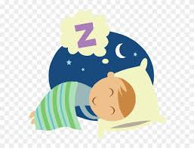
- Strive for a relaxed state of concentration. Avoid speaking with any fellow students who have not prepared, who express negativity, who will distract your preparation
- Approach the exam with confidence, positive self talk can help put you into the right mindset
- Keep your expectations realistic. Do not expect 100% on any exam.
- Bring a water bottle to keep hydrated and a small snack to eat during the exam
- Arrive early so you have time to get settled.

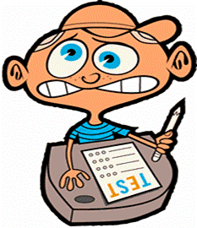
During:
- Read directions carefully
- Change positions or stretch to help you relax
- Concentrate on your breathing, slow, deep breaths can help you relax
- Take your time
- Don't think about the fear
- Write down any formulas or important information in the margins of your exam as soon as you are allowed to begin
- Use positive visualization and self talk, you’ve got this! You are doing your best!
- Skip difficult questions and come back to them
- Don’t panic or rush when other students begin to hand in their papers
- Expect to have some anxiety, acknowledge it but do not let it take control.

After:
- Think about the techniques you used and what worked
- Look for ways to improve
- Celebrate your accomplishments
- Treat yourself (vent to friends, watch a movie, go for a walk)

List three techniques or strategies you are going to use to help with test anxiety:
1______________________________________________________
2______________________________________________________
3______________________________________________________

