Collaborative Story Writing

Teana Hayes – Eatonia Colony School

Summary
After reading several books from the My Weird School Series by Dan Gutman, my classroom decided that it would be fun to create our own weird school story. We had decided from the beginning that the main character of our story would be our colony supervisor, Mrs. Barclay. Since all titles in the Weird School Series rhyme, we thought it was only appropriate to also have a title that rhymed and so the class created Mrs. Barclay is Sparkly.
This project was a collaborative effort. We knew that we wanted each grade to have their own chapter in the story. Each group of students was responsible for brainstorming ideas for their chapter. I then helped them develop their ideas into a chapter. Each grade was also responsible for providing the illustrations for their chapters.
I have included pictures of us creating the book as well as the cover, table of contents and one chapter from our finished product! I have also included my lesson plan and assessment rubric.

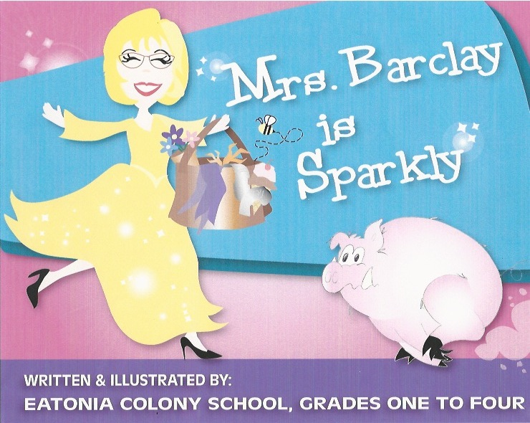

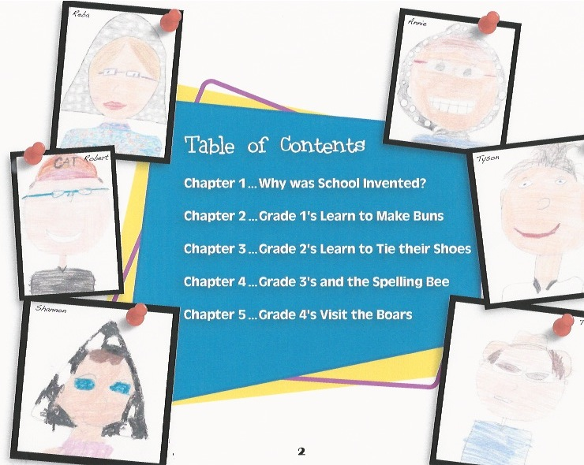

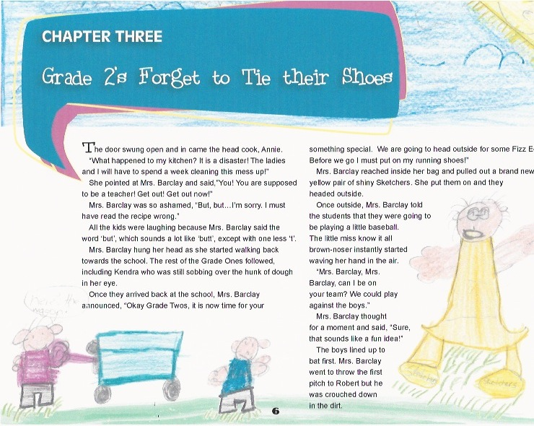

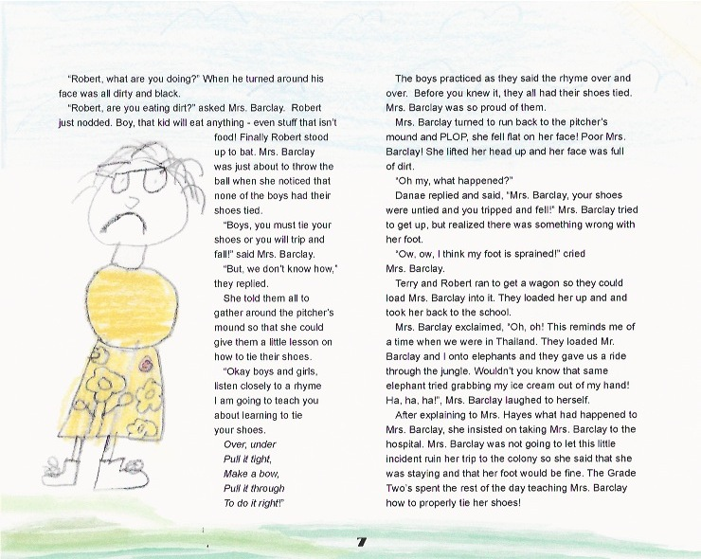
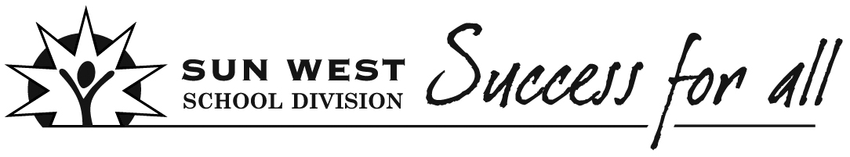Lesson Plan – Collaborative Story Writing
Teacher  Teana Hayes | Subject  ELA - Writing |  | Grade  1-4 | Unit /Theme  Compose and Create |  | Topic  Collaborative Story Writing | Date  Jan-May 2014
 |  |  |  |  |  |  | Duration
Big Ideas/Key Questions
Collaborative Story Writing
What is collaboration?
What are the steps to the writing process?
Outcome(s)  CC2.4 Write stories, poems, friendly letters, reports, and observations using appropriate and relevant details in clear and complete sentences and paragraphs of at least six sentences.  CC3.4 Write to communicate ideas, information, and experiences pertaining to a topic by creating easy-to-follow writing (including a short report, a procedure, a letter, a story, a short script, and a poem) with a clear purpose, correct paragraph structure, and interesting detail. |  |  |  |  | Student Friendly Outcome(s)  I can collaboratively write a story with my classmates using the writing process.
Indicator(s)  -Employ a writing process (e.g., planning, drafting, and “fixing up”).  -Write stories, poems, songs, friendly letters, reports, and observations using techniques observed in reading texts  -Create characters and events from outside students’ personal environment.  -Write descriptions that use concrete sensory details.  -Begin to use excitement, humour, suspense, and other creative devices. |  |  |  |  | Student Friendly Indicator(s)  Students will collaboratively write a story following the writing process.  Students will create characters and write descriptions using sensory details.  Students will begin to use excitement and humor in their story.
Assessment Strategy  - Pre-Assessment  - Formative Assessment  X Summative Assessment |  | - Students will complete a self-assessment when the story is complete.
Motivational Set
- We have read numerous novels from the “My Weird School Series”. Explain to students that we will be now writing our own story based on the “My Weird School Series”.
Instructional Strategies/Activities (Before/During/After)

Before – Write the word collaboration on the board. Have discussion on what collaboration means. Tell students that we will be working the writing process to collaboratively create our own “My Weird School” story.
During - Brainstorm the title and main character of our book. Once decided on, complete a graphic organizer describing the character’s traits. Discussion around each grade being responsible for determining the title of their chapter and the events that will take place in their chapter. The students will do this process using chart paper and sticky notes to organize their ideas. Once ideas are generated Mrs. Hayes will assist with putting ideas together on paper. While Mrs. Hayes works with one group the EA will assist other groups with their brainstorming. The students will also be responsible for drawing illustrations for their chapters.
After – once rough draft of story is completed, go through with students and read book aloud. Make any necessary changes. Book will then be published into a hard copy version for the classroom.
Students will complete self-assessment rubric. Mrs. Hayes will also complete for each student.

Differentiated Strategies
- Choice to brainstorm ideas individually or in a group.
- Choice to orally express ideas or write them on sticky notes.
- Choice of drawing ideas rather than writing them.

Materials/Resources

Graphic Organizers
Chart Paper and markers
My Weird School novels
Self-Assessment Rubric

Reflection
Super excited about this project. It turned out better than expected. I was having a difficult time getting the students to generate ideas in the first chapter but after going through the process together in the first chapter, they seemed to catch on and became very excited about the rest of the chapters. So great to see the entire class of grades 1-4’s come together to produce such a wonderful product!
