Social Studies 6: Immigration Unit
Ms. Forrester

Coming to Canada
A variety of ways to be welcomed!

Immigration

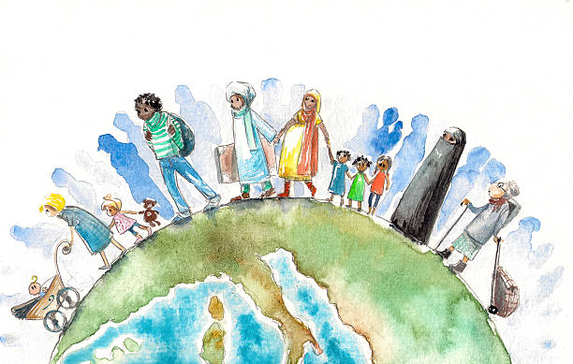
Who is an immigrant?
An immigrant is someone who makes a conscious decision to leave their home and move to a foreign country with the intention of settling there. It is a long process and many become lawful permanent residences and eventually Canadian citizens.

How do you become an immigrant?
You can immigrate to Canada by applying to the Canadian Government. There are a variety of different routes someone can take to apply to immigrate to Canada.

Express Entry
Immigrate as a high skilled worker. Someone who is well educated or trained in a specific field (medicine, law, trades, etc) can apply for express entry. It is a large amount of paperwork to prove English proficiency tests, academic transcripts, and degrees.

Start Up Visa
Immigrate by starting a business and creating jobs. To qualify for this program you have a qualifying business, get a letter of support from a designated organization, meet the language requirements, and bring enough money to settle.
Family Sponsorship
Sponsor your family including your spouse, partner, children, grandparents, in-laws and other to immigrate. You can sponsor your relatives to come to Canada by being at least 18 years old, and a Canadian citizen or permanent resident of Canada.
Caregivers
Immigrate by providing care for children, the elderly or those with medical needs, or work as a live-in caregiver
Self Employed
Immigrate as a self-employed person in cultural or athletic activities. You must have relevant experience and make a significant contribution to the cultural or athletic life in Canada.
Provincial Nominees
Immigrate by being nominated by a Canadian province or territory. For workers who have the skills, education and work experience to contribute to the economy of a specific province or territory.

Who is a migrant?
A migrant is someone who is moving place to place (either within their own country or across borders) usually for economic reasons such as seasonal work. Similar to immigrants, they were not forced to leave their home countries and left because of job opportunities.

Asylum
Someone who travels across borders into another country, usually short notice or unexpected. They do not have paperwork being processed ahead of time. They can first claim ‘asylum’ in the country and then apply for refugee status and start the paperwork process. This will apply to people who need to flee their home country in a hurry or without warning.

Social Studies 6: Immigration Unit
Refugee

Who is a refugee?
A refugee is someone who has been forced to flee their home because of war, violence or persecution often without warning. They are unable to return home unless and until conditions in their native lands are safe for them to return again.
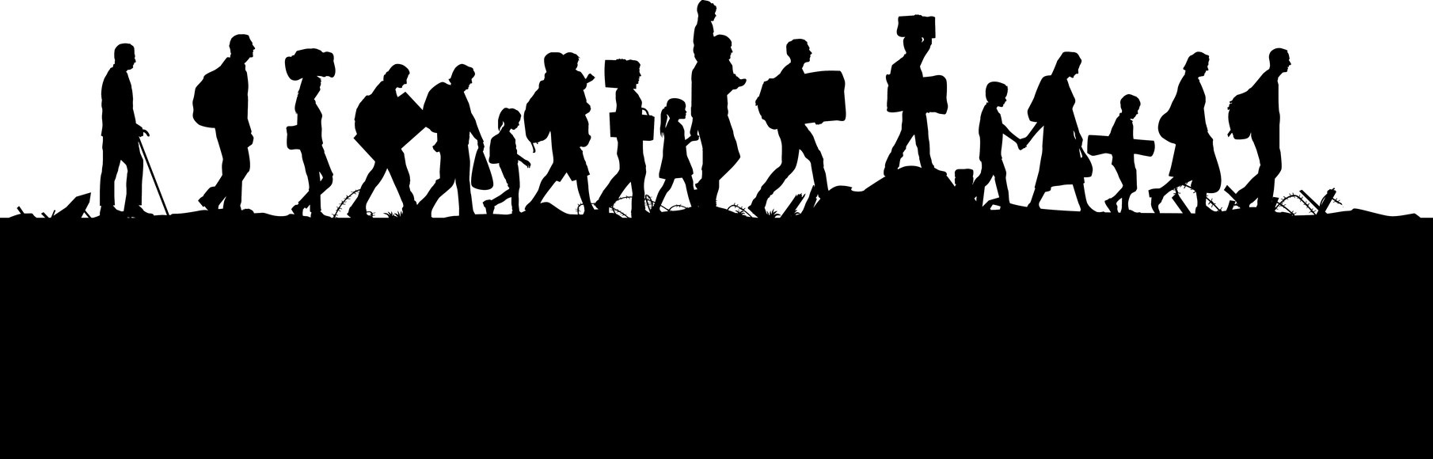

United Nations Refugee Agency
Canada as part of the United Nations, offers refugee protection to people in Canada who fear persecution or who would be in danger if they had to leave. Some dangers they may face include:
- torture
- a risk to their life, or
- a risk of cruel and unusual treatment or punishment.

Currently, there are 68.5 million men, women and children escaping war, persecution and political turbulence.

Government-assisted refugees (GARs)
GARs are permanent residents who are selected abroad for resettlement in Canada, either as 'Convention refugees' as defined under the Immigration and Refugee protection act or as members of the ‘Convention refugees abroad class’. They receive resettlement assistance from the federal government.

Privately sponsored refugees
Sponsored refugees are permanent residents selected abroad for resettlement in Canada. They are sponsored by organizations, individuals or groups of individuals. They receive no government sponsorship. Your sponsorship group will:
- help you find a place to live
- give you financial support
- give you social and emotional support
- give you food and clothing

Refugees landed in Canada
These permanent residents have had their refugee claims accepted and have subsequently applied for and been granted permanent resident status in Canada. These people are otherwise known as “Protected persons in Canada”.

Refugee dependents
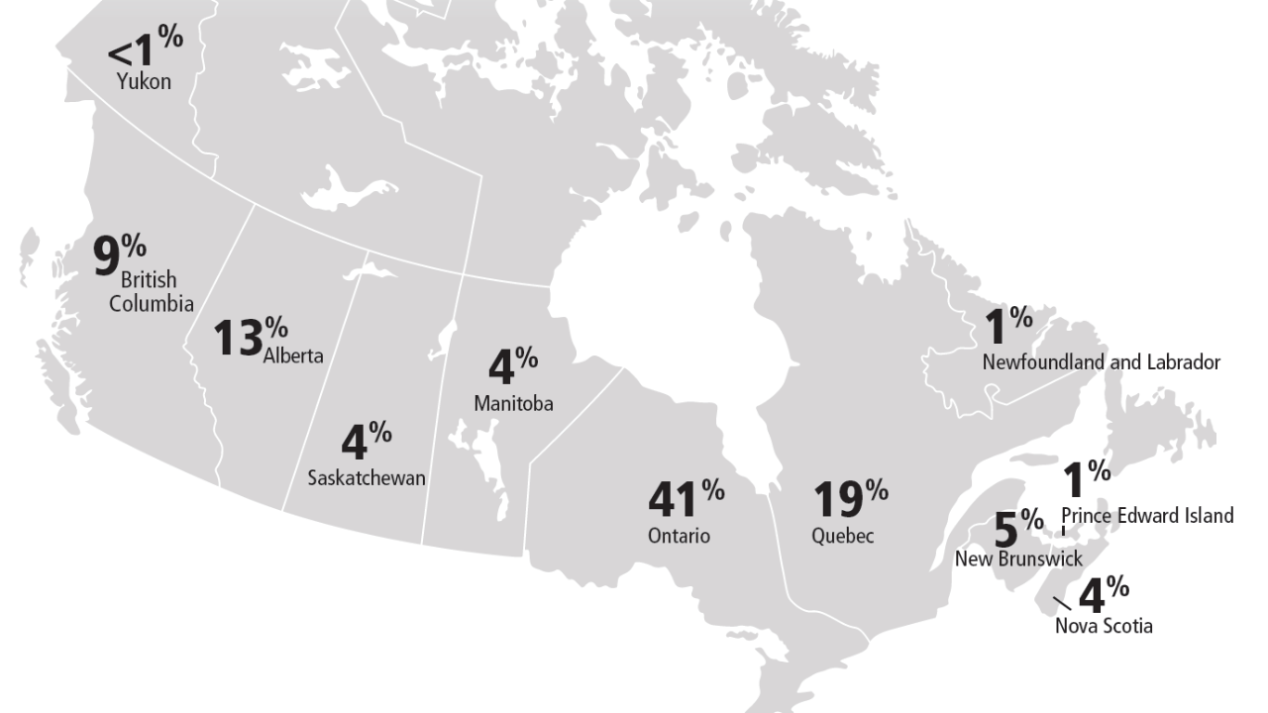
Refugee dependents are also permanent residents. They are family members of a refugee landed in Canada who were either living abroad or in Canada at the time of application.

