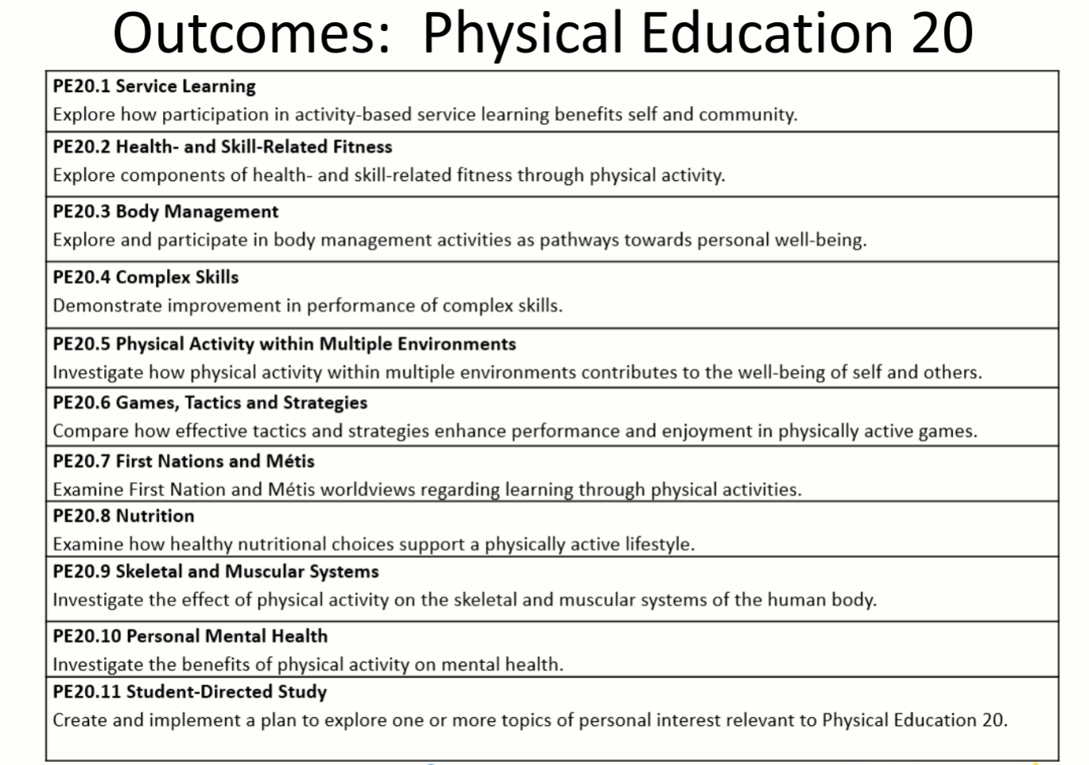

Notes:
- Service Learning - while Wellness 10 is more wide open and provides students opportunities to do other activities not related to physical activity, PE 20 and PE 30 Service Learning concentrates on fitness related volunteering like coaching, rodeo, and cultural events.

- Health & Skill Related Fitness - students concentrate on improving their personal fitness both in physical health and in skill development;​ identifying how to develop fitness; then analyze what they did to try to improve on what they just did; and self reflection.​

- Body Management - students will develop body movement and learn how it is transferred between skills. ​In this curriculum, there is a First Nations and Métis outcome. First Nations and Métis content is included as an indicator in most outcomes in this course. Societal trends are discussed and students learn to recognize them and their benefits as well as the use of technology in gathering data.

- Complex Skills - are broken down into individual parts and students identify which parts to change to improve the overall complex skill. Students analyze the feedback they use to show if improvement happened or not.​
- Physical Activity within Multiple Enviros - multiple environments refers to locations inside and outside of the gym. Students participate in physical activities in a variety of environments to create a well rounded experience. ​Note: Air refers to being in the air as part of a skill like vaulting in gymnastics. ​Students explore where else they can participate in physical activities.​

- Games, Tactics & Strategies - this is a more traditional physical education outcome where students play games but are expected to also participate in other activities like First Nations and Métis games that they may not have experienced. ​Using games from other cultures is a way to create interest and engage students in learning. ​Creating their own games can help students with understanding basic game tactics and strategies. ​

- First Nations and Métis - elders have indicated that certain protocols are required in teaching First Nations and Métis games. Resources will be available through the implementation process (for example, SPEA is exploring the development of support materials for this outcome). ​

- ​Nutrition - Canada Food Guide has changed as of January 2019. Food groups are now gone as are quantities. Nutrition trends and major topics commonly found online are covered with a focus on how nutrition relates to physical activity.​

- Skeletal & Muscular Systems - students investigate the connection between training (possibly over-training) and how it can affect the muscular and skeletal systems of the human body.​ Causes and treatment of common injuries and the effects of a sedentary lifestyle are also covered. ​

- Personal & Mental Health - mental health was discussed during the early portion of the writing process. This outcome looks at the relationship between physical activity and mental health. ​Students learn what resources are in place or being developed to help treat mental health issues.​

- Student Directed Study - students are given topic ideas but are free to choose one of their own. Students are required to create a tool to show others what they have learned.​

