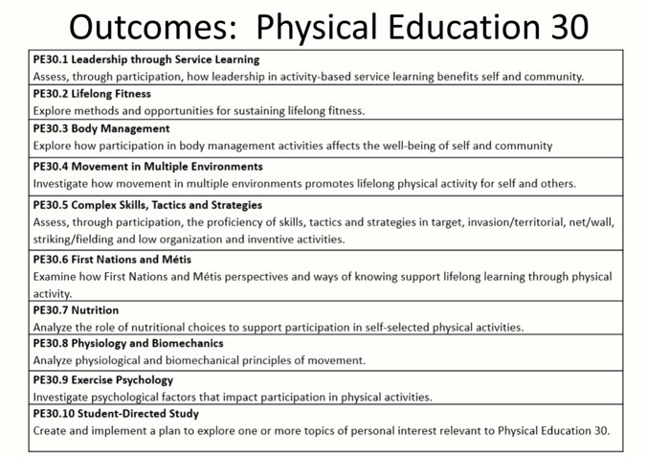

Notes:
- Leadership through Service Learning - students are still involved in service learning in physical activities but take more of a leadership role within the activities.​
- Lifelong Fitness - students learn about lifelong fitness goals beyond high school, post-secondary education or training and into adulthood. ​Students have an opportunity to use technology and community resources to improve fitness. ​
- Body Management - this outcome has the same activities as PE 20 but asks students to take a community leadership role. Teaching a walking class to seniors at a seniors centre satisfies a need in the community while learning how to lead others. ​
- Movement in Multiple Environments - PE 30 asks students to look at what they can do for physical activity outside of the community and leading to lifelong fitness. ​
- Complex Skills, Tactics, Strategies - PE 20 focused on students improving their own abilities while the focus of PE 30 is to have students teach other students how to improve their abilities in a complex skill and knowledge of game tactics and strategies. ​

- Students are expected to help teach others First Nations and Métis perspectives and games and develop leadership skills. This outcome can be combined with other outcomes.​
- Nutrition - PE 30 is an extension of PE 20 as the focus is on assessing what topics in nutrition affect performing an activity. Topics include nutritional choices, fad diets, supplements, calorie counting and nutrient timing. ​
- Physiology and Biomechanics - students will select complex skills and take a look at the biomechanics of the motion: what are muscles and joints doing. Specific techniques are identified like weight training movements (bench press) and looking at how the body should be moving to execute the motion. Students help analyze their own and others’ movements to help improve them. ​Long term effects of training are identified as well as the role of recovery. ​
- Exercise Physiology - students identify how activity directly relates to areas of mental health like visualization, goal setting and motivation. The focus is on improving their own physical activity and not from a competition perspective. Teachers can use differentiation to support all students. For instance, teachers can differentiate instruction to extend learning to meet the strengths of an elite athlete or adapt the learning environment to reduce barriers for a student. ​
- Student Directed Study - like PE 20, students select a topic related to the course but look at it from a leadership or lifelong perspective. ​

