21st Century Competencies – The Artifact
Kevin Mastel – Eston School

Summary:

Critical Thinking is integrated into every unit I teach. In Math and Science when trying to solve any problem you need to stop and think about the types of strategies and what information you are given.

Collaboration is integrated throughout the courses I teach as well. Students work together in discussing ideas and different ways possible to solve a problem.

The specific artifact I am using is the making of first nation tipis to scale in Workplace and Apprenticeship 20 (grade 11 students)
The curriculum outcomes are:
WA20.5 Extend and apply understanding of 3-D objects including: top, bottom, and side views, exploded views, component parts, and scale diagrams.
[CN, R, T, V]
WA20.10 Extend and apply proportional thinking to solve problems that involve unit analysis and scale. [C,CN,PS,R,T,V]
Lesson Plan:
I would first like to say this was part of a team taught unit with Krista Dmytryshyn. As a class discuss what you know about the tipi. Then teach about scale calculations and the different style of drawings (see WA20.5). We had each member of the class go to www.tipi.com where they could then learn all about actual tipis as well as go and design their own tipi. Using this website students were able to come up with an actual design and understanding of what the symbols represented. Students could now use their scale knowledge to draw out their own tipi. We then built the tipis and created the various types of drawings.

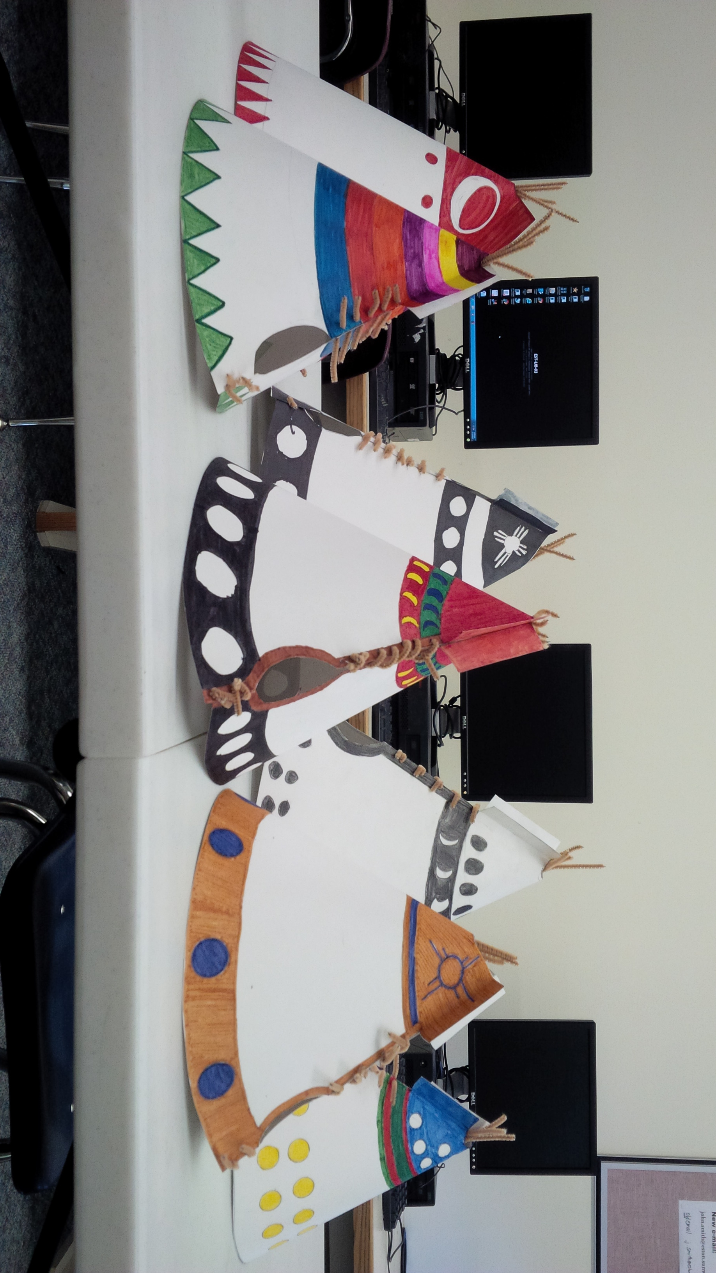

References:
www.tipi.com
Math Works 11 textbook

