How to Run Fitness Testing

Beep Test (levels)

Purpose: The 20m multistage fitness test (MSFT) is a commonly used maximal running aerobic fitness test. It is also known as the 20 meter shuttle run test, beep or bleep test among other names.

Equipment required: beep test audio, music player, recording sheets

https://www.youtube.com/watch?v=cz2m1PJ0gj4&t=451s

Pre-test: Explain the test procedures to the students (many beep test audios have an explanation at the start of the recording). The course is the far gray badminton line to the far gray badminton line. Ensure that the students are adequately warmed-up.

Procedure: This test involves continuous running between two lines 20m apart in time to recorded beeps. The students stand behind one of the lines facing the second line and begin running when instructed by the recording. The speed at the start is quite slow. The student continues running between the two lines, turning when signaled by the recorded beeps. After about one minute, a sound indicates an increase in speed, and the beeps will be closer together. This continues each minute (level). If the line is reached before the beep sounds, the student must wait until the beep sounds before continuing. If the line is not reached before the beep sounds, the student is given a warning and must continue to run to the line, then turn and try to catch up with the pace within two more ‘beeps’. The student is given a warning the first time they fail to reach the line (within 2 meters) and eliminated after the second warning.
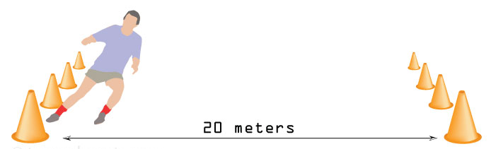

Scoring: The student's score is the level and number of shuttles (20m) reached before they were unable to keep up with the recording. Record the last level completed (not necessarily the level stopped at).

Sit and Reach (inches)
Purpose: The sit and reach test is a common measure of flexibility, and specifically measures the flexibility of the lower back and hamstring muscles. This test is important because tightness in this area is implicated in lumbar lordosis, forward pelvic tilt and lower back pain.

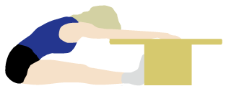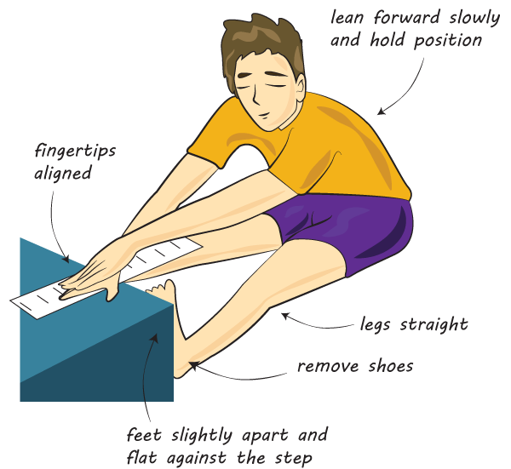
Equipment required: sit and reach box, recording sheets
Procedure: This test involves sitting on the floor with legs stretched out straight ahead. Shoes should be removed. The soles of the feet are placed flat against the box. Both knees should be locked and pressed flat to the floor - the teacher may assist by holding the knees down. With the palms facing downwards, and the hands on top of each other or side by side, the student reaches forward along the measuring line as far as possible. Ensure that the hands remain at the same level, not one reaching further forward than the other. After some practice reaches, the student reaches out and holds that position for one to two seconds while the distance is recorded. Make sure there are no jerky movements.
Scoring: The score is recorded to the nearest half inch as the distance reached by the hand.

Curl Ups
Purpose: The curl-up test measures abdominal strength and endurance, which is important in back support and core stability.
Equipment required: a flat, clean, cushioned surface, curl-up cadence track, recording sheets
https://www.youtube.com/watch?v=QQjxFyCPZLk
Procedure: The student begins by lying on their back, knees bent at approximately 140 degrees, feet flat on the floor, legs slightly apart, arms straight and parallel to the trunk with palms of hands resting on the thighs. The fingers are stretched out and the head is in contact with the mat. The feet cannot be held or rest against an object. Keeping heels in contact with the mat, the student curls up slowly, sliding their fingers up their thighs to touch their kneecaps, then curls back down until their head touches the mat. Movement should be smooth and at the cadence of the track recording.
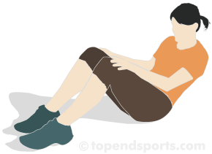
Scoring: Record the total number of curl ups, up to a maximum of 80. The test is continued until exhaustion (e.g. the subject cannot maintain the set rhythm), or until they complete 80 curl-ups. The test is also stopped if the student has two technique warnings - if the heels come off the floor, the head does not return to the mat, or the fingertips do not reach the kneecaps.

Push Ups

Purpose: The push-up fitness test (also called the press-up test) measures upper body strength and endurance.
Equipment required: push-up cadence track, recording sheets
https://www.youtube.com/watch?v=k33_2CHxnVw&t=75s
Procedure: A standard push-up begins with the hands and toes touching the floor, the body and legs in a straight line, feet slightly apart, the arms at shoulder width apart, extended and at a right angle to the body. Keeping the back and knees straight, the student lowers the body until there is a 90-degree angle at the elbows, then returns back to the starting position with the arms extended. This action is repeated, and the test continues until exhaustion, or until they can do no more in rhythm with the recording track or have reached the target number of push-ups.
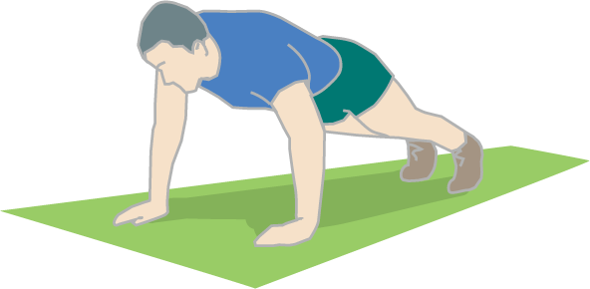
Scoring: Record the number of correctly completed push-ups.

Hand Grip Total (kg)
Purpose: The purpose of this test is to measure the maximum isometric strength of the hand and forearm muscles. Handgrip strength is important for any sport in which the hands are used for catching, throwing or lifting. Also, as a general rule people with strong hands tend to be strong elsewhere, so this test is often used as a general test of strength.
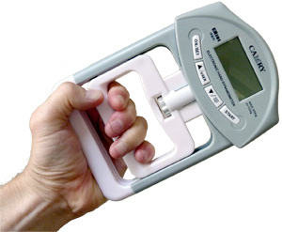
Equipment required: handgrip dynamometer, recording sheets
Procedure: Press the On/Set button. The gender and age do not matter, but make sure it is set to kilograms (kg). If it is set to pounds (lb), push the On/Set button again. The student holds the dynamometer in the hand to be tested, with the arm at right angles and the elbow by the side of the body. The base should rest on the first metacarpal (heel of palm), while the handle should rest on middle of the four fingers. When ready the student squeezes the dynamometer with maximum isometric effort, which is maintained for about 5 seconds. No other body movement is allowed. The student should be strongly encouraged to give a maximum effort. When the student releases their grip, write down the measurement in kilograms (kg). Press the Start button to reset the dynamometer to 0. Repeat with the other hand and record.
Scoring: Add the two recordings, one from each hand, together to reach the total in kilograms (kg).

Vertical Jump (inches)
Purpose: to measure the leg muscle power
Equipment required: vertical challenger jump tester, recording sheets
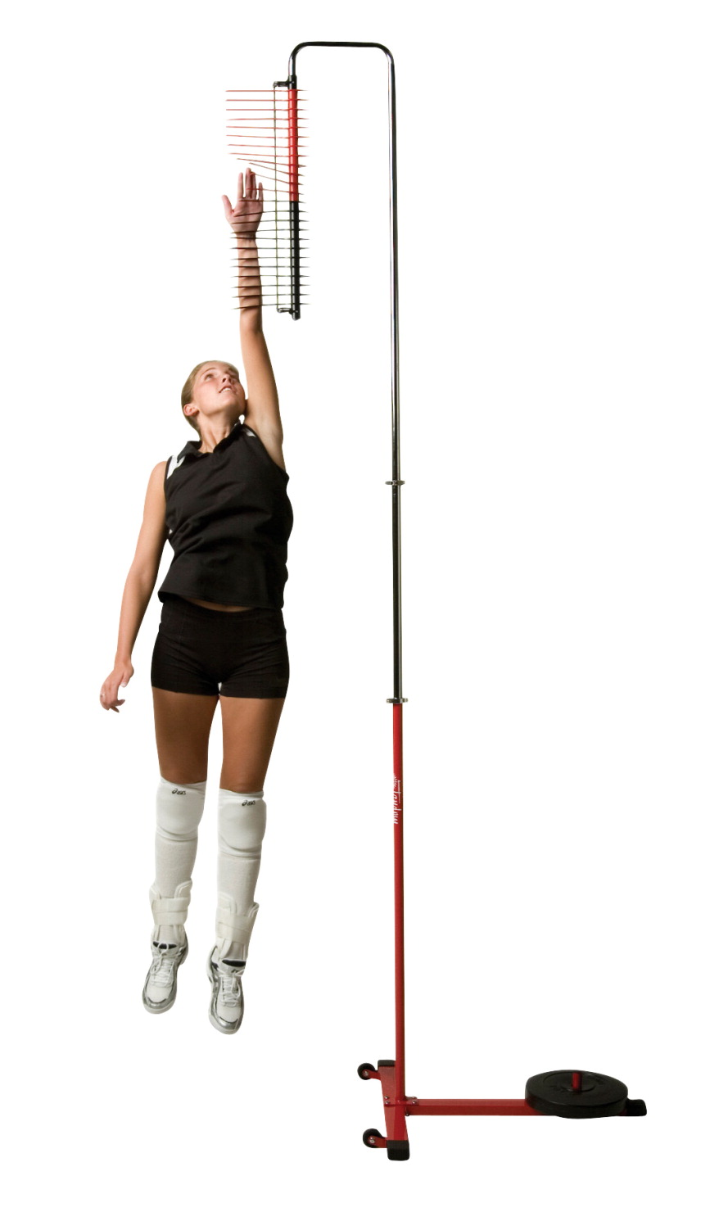
Procedure: The student stands under the tester and reaches up with one hand. Keeping the feet flat on the ground, the point of the fingertips should just touch the screw under the plastic pegs. This is called the standing reach height. The student then stands away from the tester, and leaps vertically as high as possible using both arms and legs to assist in projecting the body upwards. The jumping technique cannot use a run or steps up to the jump. The student will attempt to touch the plastic pegs at the highest point of the jump. Move the pegs out of the way that the student touches. The student will do two more attempts to touch more plastic pegs.
Scoring: Record the maximum number the student is able to reach when they jump. There are 12 black pegs and 12 red pegs with one inch between each.

12 Minute Run (laps)
Purpose: The 12 minute run is a popular maximal running test of aerobic fitness, in which participants try and cover as much distance as they can in 12 minutes.
Equipment required: 4 marker cones, recording sheets, scoreclock timer
Procedure: Place markers at corners of the volleyball court. Students run for 12 minutes, and the total laps are recorded. Walking is allowed, though the participants must be encouraged to push themselves as hard as they can to maximize the distance covered. Partners should record every time they pass the starting cone. At the end of the 12 minutes, students who pass the ¾ mark will be awarded that lap.
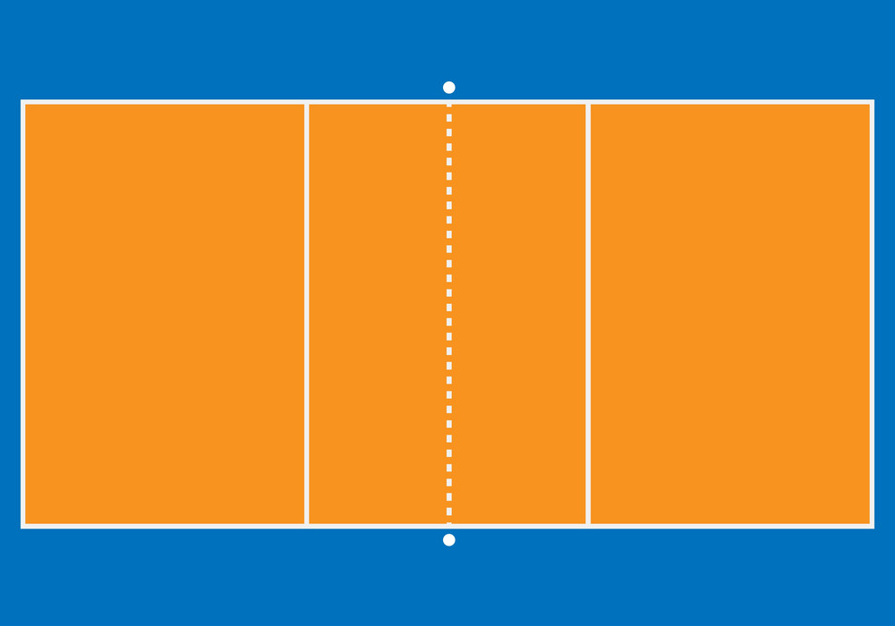

Scoring: Students will record the number of laps they successfully complete in 12 minutes.

Agility Run (seconds)

Purpose: to test running agility
Equipment required: 8 marking cones, stopwatch, measuring tape, recording sheets
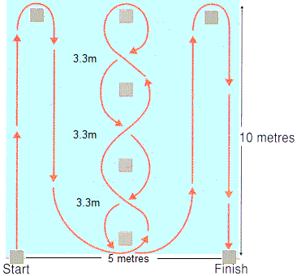
Procedure: The length of the course is 10 meters and the width (distance between the start and finish points) is 5 meters. Four cones are used to mark the start (volleyball court outside line at center), finish (volleyball court outside line at center) and the two turning points (far gray badminton lines, in line with the start and finish cones). Another four cones are placed down the center an equal distance apart. Each cone in the center is spaced 3.3 meters apart. Subjects should lie on their front (head to the start line) and hands by their shoulders. On the 'Go' command the stopwatch is started, and the athlete gets up as quickly as possible and runs around the course in the direction indicated, without knocking the cones over, to the finish line, at which the timing is stopped.
Scoring: The scoring is recorded in seconds.

