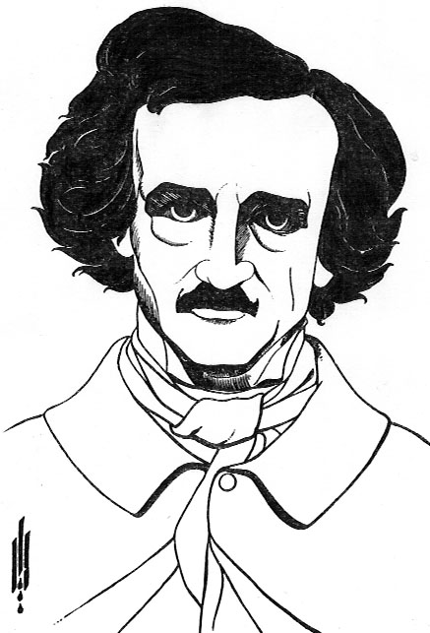
Edgar Allan Poe Poetry Assignments

NAME_________________________________________
For EACH outcome below you must choose ONE assignments to complete. You cannot use the same poem for both.

CC A10.3 Assignment Choice #2
Prepare a “Ted talk” on one poem. Express your personal point of view of this poem and defend your opinions. 1-3 minutes
CC A10.3 Assignment Choice #1
Create a narrative of one poem and present this narrative. 1-3 minutes
CC A10.3 Assignment Choice #3
Prepare and present an oral reading of one poem.
CC A10.3
- I can use oral language in both formal and informal situations to express ideas and information.
- I can prepare and present a talk on a familiar topic.
- I can prepare and present an interview.
- I can prepare and present an oral reading of prose or poetry.
- I can explain and defend a personal point of view.
- I can participate in class and group discussion.

CR A10.4 Assignment Choice #3
Create a comic strip that summarizes one poem.
CR A10.4 Assignment Choice #2
Write a 1 paragraph summery of one poem.
CR A10.4 Assignment Choice #1
Complete a question sheet on one poem
CR A10.4
- I can read information and ideas from both classical and modern literary texts (including drama, biography, autobiography, poetry, short stories, novels).
- I can interpret this information.
- I can summarize these ideas.

Poetry Choices
Alone (1875)

Annabel Lee (1849)

The Bells (1849)

The City in the Sea (1831)

The Conqueror Worm (1843)

A Dream Within A Dream (1850)

Eldorado (1849)

The Haunted Palace (1839)

The Sleeper (1831)

Spirits of the Dead (1829)

The Valley of Unrest (1845)

A poem of your choice (must be approved!)
CR A10.4 Assignment Choice #1
Complete a question sheet on one poem

Who is the speaker of the poem? Provide evidence from the poem to support your claims.
____________________________________________________________________________________________________________________________________________________________________________________________________________________________________________________________________________________________________________________________________________________
What is the theme of the poem? Provide evidence from the poem to support your theme.
____________________________________________________________________________________________________________________________________________________________________________________________________________________________________________________________________________________________________________________________________________________
What is the mood of the poem? Provide evidence form the poem to support your claims.
____________________________________________________________________________________________________________________________________________________________________________________________________________________________________________________________________________________________________________________________________________________
Identify symbols in the poem and discuss their significance.
____________________________________________________________________________________________________________________________________________________________________________________________________________________________________________________________________________________________________________________________________________________
Identify images in the poem. What do the images add to the poem?
____________________________________________________________________________________________________________________________________________________________________________________________________________________________________________________________________________________________________________________________________________________

CR A10.4 Assignment Choice #2
Write a 1 paragraph summery of one poem.

Questions to ask yourself before as you prepare to write your summary:
What is the story in the poem? What is the main point of the poem? How is the poem structured? What does the author use to bring us to this main point? What is the overall tone of the poem? What are the images in the poem? What is the theme in the poem? What is the conflict in the poem?
Summarize the poem of your choice.
______________________________________________________________________________________________________________________________________________________________________________________________________________________________________________________________________________________________________________________________________________________________________________________________________________________________________________________________________________________________________________________________________________________________________________________________________________________________________________________________________________________________________________________________________________________________________________________________________________________________________________________________________________________________________________________________________________________________________________________________________________________________________________________________________________________________________________________________________________________________________________________________________________________________________________

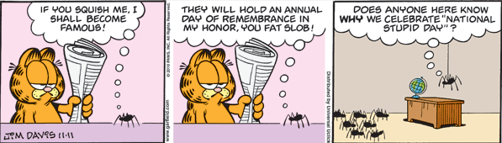
CR A10.4 Assignment Choice #3
Create a comic strip that summarizes one poem.
Create a comic strip that summarizes the main points or events in one poem. You may do this on a separate piece of paper if you choose.

CC A10.3 Assignment Choice #1
Create a narrative of one poem and present this narrative. 1-3 minutes

Narration means telling the story from your point of view. We generally narrate our day's incidents to our close ones. When we write a diary/journal, we write it in a narrative format. Narrative summary is something which you write in your diary, talking to yourself.
To complete this assignment you must select one poem and prepare an oral presentation that you will give to the class about the poem. Your presentation must be 1-3 minutes long.

CC A10.3 Assignment Choice #2
Prepare a “Ted talk” on one poem. Express your personal point of view of this poem and defend your opinions. 1-3 minutes

Point of view refers to who is telling or narrating a story. A story can be told in three different ways: first person, second person, and third person. Writers use point of view to express the personal emotions of either themselves or their characters
Read one poem and decide how you feel about it. In your presentations you will tell us which poem you chose, what you thought of it and why. You may choose to read a line or two from the poem to prove your point. Your presentation must be 1-3 minutes long.

CC A10.3 Assignment Choice #3
Prepare and present an oral reading of one poem.

Choose one poem and read it to the class. Use your reading skills and any dramatic effect you think will bring the poem to life. Prepare and practice your presentation BEFORE you do it for the class.

