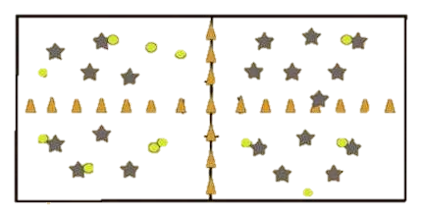
4 Corner Dodgeball
C
The goal of 4 Corner Dodgeball is for all players to be on one team and in one space. Players are never out and never stop moving.
D
Outcomes
B
A
This game fits outcomes related to strategy, situational decisions, invasion/territorial games, etc.
Setup
Using pylons, divide the space into 4 equal sized spaces.
Place an equal number of dodgeballs in each corner of the space.
Split the class into four equal teams.
Rules
- Standard dodgeball rules apply:
  - Head shots do not count.
  - If a player catches a thrown ball, the player who threw the ball is out.
  - The ball is dead off the floor, roof, or wall.
  - If a player is hit by a ball, but another player catches it before hitting the ground, the player who threw the ball is out.
  - If the ball hits two players without hitting the ground, both players are out.
- Players can throw dodgeballs at players in either attaching corner, but cannot throw at the team who is kiddy-corner across from them. For example, A may throw at B and C, but not D. B may throw at A and D, but not C.
- When a player is hit by a ball, they join the team of the player who hit them. Players will go back and forth as they are hit by different teams.
- When the last player is hit in a corner, the corner who hit that final player also takes their space by removing their pylons. For example, if A hits the final B player, A and B remove the pylons separating their space and take over that whole half of the space, becoming one team in one space.
- This continues until all four corners have become one team and one space.

