- Personal Stories
- Amelia Davidson
- Elizabeth Middle School
- Student Support
- The outcome for this artifact is to see student engagement and introduce vocabulary. It is based on recommendations from a Speech and Language Pathologist for students with Autism. This was part of an Eiip goal.
When creating these stories it is important to keep the following suggestions in mind.

- • Stories should be created using simple vocabulary and sentences. The stories should also be created using a repetitive format which will lend itself to allow the student to, eventually, fill in blanks in the story by handing picture cards to the reader (e.g., “Peter plays in the snow with ____.”).
- • If there is, eventually, an expectation for students to point to individuals in his/her personalized stories (e.g., mom, dad), he/she will need to have separate pictures to be taught who is who in pictures. Begin this process using errorless learning. This means that the student’s finger should be guided to select the right person he/she has been asked to identify in the picture.
- • If the student has demonstrated an interest in turning pages in books, it may be beneficial to use ‘page fluffers’ in the personalized stories to make the pages easier for him/her to manipulate and turn. (Joelle Lowen, 2016)

Ideally the student will be able to complete the cloze sentence either by using a picture or saying the word.
- Summary
When we have the opportunity we go out to different events and make stories out of them for increasing student engagement in ready and building vocabulary.
While students appear to enjoy being read to, it is also important for each student to be an active participate in reading. Before one can expect the student to actively participate in story reading, it will be important to establish joint attention while reading. This may be done by using personalized story books about the student, his/her family, interests, and/or activities he/she participates in, both, at home and at school.

Reflection
When we first began reading this stories it was more about just getting to the end. The student would flip through the pages but not pay close attention to the photos. As we have slowed the pace and made it relevant for him, we have witnessed him looking at the pages, he will give you his figure to point out the different people. I would highly recommend personal story for students with autism or even for other non-verbal students as a way to create meaningful engagement in story time.

Peter Goes to a Planting Party! 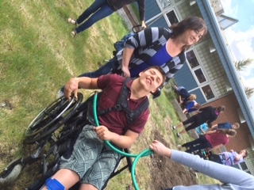
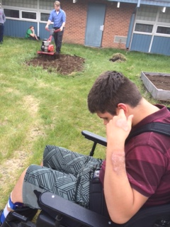

The tiller is very loud.
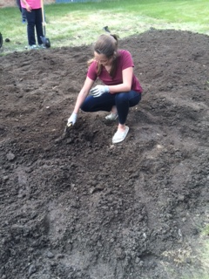
First, we dig a hole in the garden.

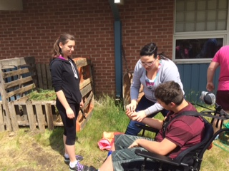

You hold the seed, Peter. You hold the seed.

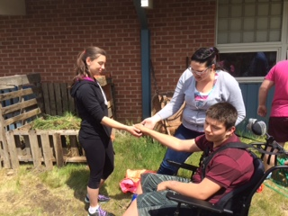

Peter gives the seed to Maddy to be planted.

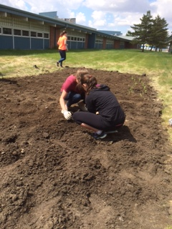

The girls cover the seed with dirt.

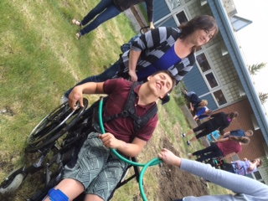

Time to water the seed!

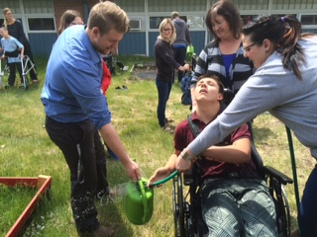

You fill the water jug, Peter.
You fill the water jug.

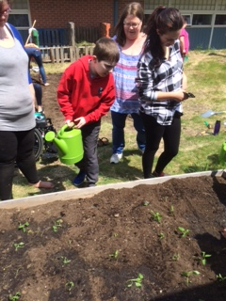

Fred waters the garden.

