**21 CC – Cake Decorating in the Classroom**

**Teacher:** Cindy Menzies

**Subject Area/Grade Level: PAA 9**

**Goal:** Food Studies 7 provides the basic cooking and baking skills. Food Studies 8 provides how to take those skills and apply them to meal planning and nutrition. Food Studies 9 provides an opportunity to find personal style, talent, and potential career goals in Food. This is where they have the opportunity to be creative. I think cake decorating is such a great creative life skill – designing birthday cakes for their families or maybe learning they have a gift for it and becoming cake designers or bakers as a career!

**Summary:**

In Food Studies 7 and 8 students already have the basic background so I really like Food Studies 9 to be all about creating – providing them with the end result and having them think through the process to create that desired result. So long as they are able to explain their process and meet the criteria there are few limitations put on them. Students view videos on cake decorating, we discuss varieties of cakes, purposes for learning to cake decorate and do some searches of different designs and ideas to get a feel for what they would like to learn. We then get a cake decorator in (locally we have 2!) and they do a demo of simple basics and they get time to practice. We then have a Cake Boss day where they decorate their cake in a time limit and are judged by volunteer teachers.

**PAA 9 Outcomes:**

* FS9.1 To review and apply and demonstrate competency in kitchen skills for basic food preparation, serving, cooking and baking.
* ***FS9.2 To utilize basic cooking and baking skills while exploring creativity and variety in cooking and baking.***
* FS9.3 To understand and explore social and cultural aspects of food for all people
* FS9.4 To develop an awareness of career and employment opportunities related to diet, food, and food preparation

**Attached Lesson Plan –**

* I have attached the Lesson Plan and Worksheets I use to the end of this if you want to use it – go for it!
* You would be surprised how many cake decorators are in your community – many moms, grandmas, etc take it up as a hobby, have taken a class or two, and have tons of tools and love sharing their gift. Ask around in your community!

**Evidence:**

* Regardless of whether the students have chosen something difficult or simple this plan is always enjoyed and creates an awesome school memory.
* Here are some pictures of the kids creating!
  + 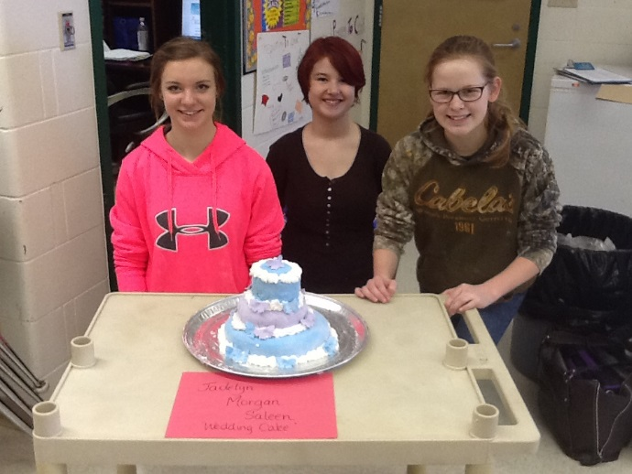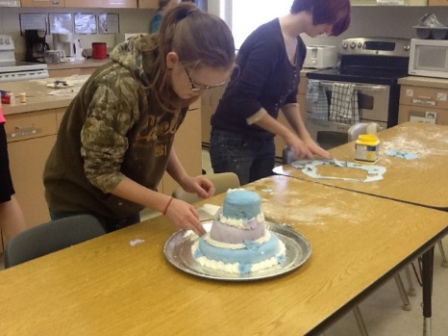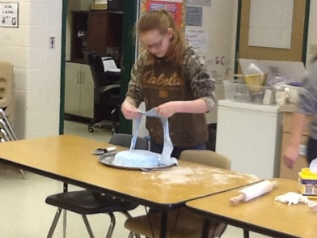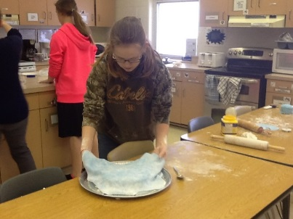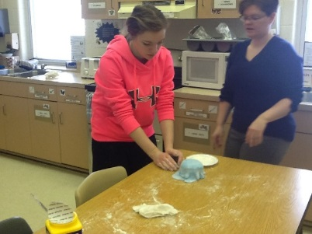**Wedding Cake (lots of work with tiering and fondant)**
* 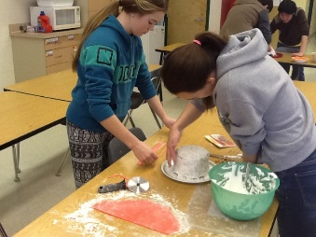**Popcorn “Movie Night” Cake – yup there’s popcorn on top of that cake!**
* 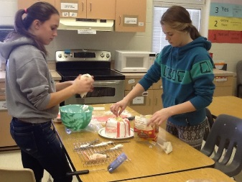

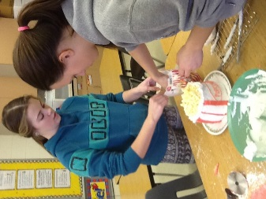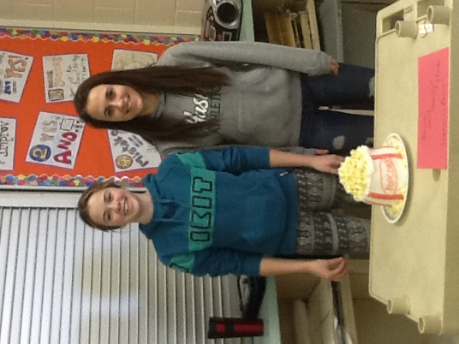

* **Volcano cake!**

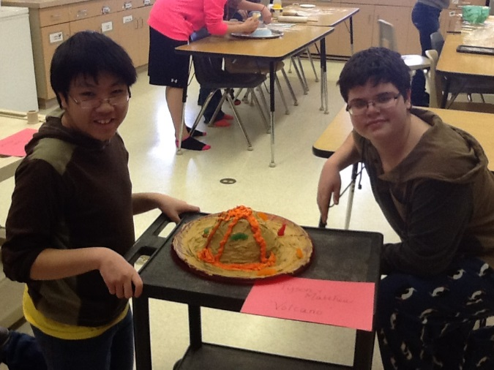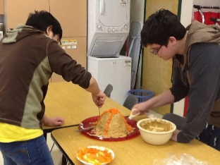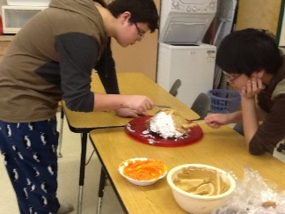

**Reflection –**

* **Roadblocks:**
  + TIME – with only 1 PAA class it takes several days to prep – do the lesson, have the demonstrator come in, plan, bake the cakes, and actually design
  + TIME – the kids’ visions are often shortened due to time limit – they would love to create more but get cut short on time
  + Having a Cake Decorator – we are super lucky to have a few around, otherwise you would need to go searching or teach yourself!
  + Having to Eat it when it’s done – its too beautiful to destroy!
* **Benefits:** 
  + Creativity – I don’t limit their idea unless there is no way they could get it done in time – then we just tweak the idea
  + right tools and direction
  + Collaboration – they learn to work together, share ideas, set a goal and rely on each other to achieve it
  + Problem Solving – they learn to adjust, tweak and “make it work!” all on the fly
  + Time Management – they learn to organize their time to achieve their goal
  + Pride – they are so incredibly proud of what they create and can’t wait for their friends and other teachers to see – I always email the pictures home too – I have never had a student discouraged – they amaze themselves with what they can create!
* Practical Application – I have heard stories of kids designing cakes at home – I have learned skills I can use too!

**Lesson 4 - Specializing in Cakes and Cupcakes**

**Outcomes**

* FS9.2 To utilize basic cooking and baking skills while exploring creativity and variety in cooking and baking.

**Indicators:**

FS9.2a) To identify types of cakes and cupcakes

FS9.2b) analyze the principles involved in successful preparation of cakes and cupcakes

C:\Users\cindy.menzies\AppData\Local\Microsoft\Windows\Temporary Internet Files\Content.IE5\UJPHZI8K\MC900434411[1].wmf

**Big Questions**

This lesson we will look at:

1. What are the different types of cakes?
2. What do you need to know to be able to prepare cake well?
3. How do you decorate cake?

C:\Users\cindy.menzies\AppData\Local\Microsoft\Windows\Temporary Internet Files\Content.IE5\XR6CXQZS\MC900440452[1].wmf

**Opening Activity**

It seems like they have a reality show for every kind of cooking and baking now. Have you heard of Cupcake Wars? Let’s do a You Tube search on Cupcake Wars to see their process.

Mrs. Owen is a cake decorator. My children have had “Mrs. Owen” cakes since they were babies. She has made Mickey Mouse, the Wiggles and Elmo for Brady. She has made Scooby doo, Barney, Woody and Thomas the Tank for Eric. She is very talented! We have invited her to give us some tips on cake decorating! (*Mrs Owen will do a demonstration next day!)*

Description: C:\Users\cindy.menzies\AppData\Local\Microsoft\Windows\Temporary Internet Files\Content.IE5\CYHP788G\MC900440424[1].wmf**Lesson 4**

**Important Terms:**

**All About Cakes**

What are cakes?

* an item of soft sweet food made from a mixture of flour, fat, eggs, sugar, and other ingredients, baked and sometimes iced or decorated. (Wikipedia)

**Common Ingredients:**

* Flour
* Sugar
* Eggs
* Liquid
* Salt

# Types of cakes

The majority of cakes contain some kind of flour, egg and sugar. These ingredients are not listed:

| **Name** | **Image** | **Origin** | **Main ingredients** |
| --- | --- | --- | --- |
|  |  |  |  |
| [Angel food cake](http://en.wikipedia.org/wiki/Angel_food_cake) | [AngelFoodCake.jpg](http://en.wikipedia.org/wiki/File:AngelFoodCake.jpg) | [United States](http://en.wikipedia.org/wiki/United_States) | Egg Whites, Vanilla and [cream of tartar](http://en.wikipedia.org/wiki/Cream_of_tartar) |
|  |  |  |  |
| [Birthday cake](http://en.wikipedia.org/wiki/Birthday_cake) | [Birthday cake.jpg](http://en.wikipedia.org/wiki/File:Birthday_cake.jpg) | International | Varies, usually chocolate or sponge, and is often topped with [icing](http://en.wikipedia.org/wiki/Icing_%28food%29) and [candles](http://en.wikipedia.org/wiki/Candles); number of candles on top of the cake is often said to represent some one's age, for example, a birthday cake for a nine year old will have nine candles on top of it. |
| [Black Forest cake](http://en.wikipedia.org/wiki/Black_Forest_cake), often known as "Black Forest gâteau" | [Kirschtorte.jpg](http://en.wikipedia.org/wiki/File:Kirschtorte.jpg) | [Germany](http://en.wikipedia.org/wiki/Germany) | Cherries, [kirsch](http://en.wikipedia.org/wiki/Kirschwasser), and [chocolate](http://en.wikipedia.org/wiki/Chocolate) |
| [Bundt cake](http://en.wikipedia.org/wiki/Bundt_cake) | [BundtCake.JPG](http://en.wikipedia.org/wiki/File:BundtCake.JPG) | [United States](http://en.wikipedia.org/wiki/United_States) | Varies, often [chocolate](http://en.wikipedia.org/wiki/Chocolate) |
| [Carrot cake](http://en.wikipedia.org/wiki/Carrot_cake) | [Carrot cake.jpg](http://en.wikipedia.org/wiki/File:Carrot_cake.jpg) | United Kingdom | [Carrots](http://en.wikipedia.org/wiki/Carrots) |
| [Chiffon cake](http://en.wikipedia.org/wiki/Chiffon_cake) | [Chiffon cake 02.jpg](http://en.wikipedia.org/wiki/File:Chiffon_cake_02.jpg) | [United States](http://en.wikipedia.org/wiki/United_States) | [Vegetable oil](http://en.wikipedia.org/wiki/Vegetable_oil) |
| [Chocolate cake](http://en.wikipedia.org/wiki/Chocolate_cake) | [Chocolate cake with chocolate frosting topped with chocolate.jpg](http://en.wikipedia.org/wiki/File:Chocolate_cake_with_chocolate_frosting_topped_with_chocolate.jpg) | Unknown | [Chocolate](http://en.wikipedia.org/wiki/Chocolate) |
| [Coffee cake](http://en.wikipedia.org/wiki/Coffee_cake) | [Walnut cinnamon coffee cake.jpg](http://en.wikipedia.org/wiki/File:Walnut_cinnamon_coffee_cake.jpg) | [Germany](http://en.wikipedia.org/wiki/Germany) | [Cinnamon](http://en.wikipedia.org/wiki/Cinnamon) |
| [Cupcake](http://en.wikipedia.org/wiki/Cupcake) | [Chocolate cupcakes.jpg](http://en.wikipedia.org/wiki/File:Chocolate_cupcakes.jpg) | Worldwide | Varies; is usually topped with icing, but the colour of the icing may vary (is sometimes topped with [chocolate](http://en.wikipedia.org/wiki/Chocolate) flavoured icing in which the case the icing will be brown, is sometimes lemon, and is sometimes orange). |
| [Devil's food cake](http://en.wikipedia.org/wiki/Devil%27s_food_cake) | [Devil's Food Cake.jpg](http://en.wikipedia.org/wiki/File:Devil's_Food_Cake.jpg) | [United States](http://en.wikipedia.org/wiki/United_States) | [Chocolate](http://en.wikipedia.org/wiki/Chocolate) and/or [cocoa](http://en.wikipedia.org/wiki/Cocoa_solids), and [baking soda](http://en.wikipedia.org/wiki/Baking_soda) |
| [Fruitcake](http://en.wikipedia.org/wiki/Fruitcake) | [Traditional fruitcake.jpg](http://en.wikipedia.org/wiki/File:Traditional_fruitcake.jpg) | [Caribbean](http://en.wikipedia.org/wiki/Caribbean) | [Candied fruit](http://en.wikipedia.org/wiki/Candied_fruit); many versions of the fruit cake contain currants, sultanas and glace cherries. |
| [Ice cream cake](http://en.wikipedia.org/wiki/Ice_cream_cake) | [Three inch ice cream cake with fruit from Singapore.jpg](http://en.wikipedia.org/wiki/File:Three_inch_ice_cream_cake_with_fruit_from_Singapore.jpg) | Unknown | [Ice cream](http://en.wikipedia.org/wiki/Ice_cream) |
| [Layer cake](http://en.wikipedia.org/wiki/Layer_cake) | [Meyer lemon chiffon cake, chocolate.jpg](http://en.wikipedia.org/wiki/File:Meyer_lemon_chiffon_cake,_chocolate.jpg) |  | Yolk, sugar, butter, flour |
|  |  |  | Varies |
|  |  |  |  |
|  |  |  | Butter, sugar |
| [Red velvet cake](http://en.wikipedia.org/wiki/Red_velvet_cake) | [Red velvet cake slice.jpg](http://en.wikipedia.org/wiki/File:Red_velvet_cake_slice.jpg) | [United States](http://en.wikipedia.org/wiki/United_States) | red colouring and cocoa |
|  |  |  |  |

Other:

* Fillings: fluffy whipped cream, pudding, sweet fruits
* Frosting: canned, icing sugar, creative

**Cake and Cupcake Decorating – Here are some examples! Search some more!!**

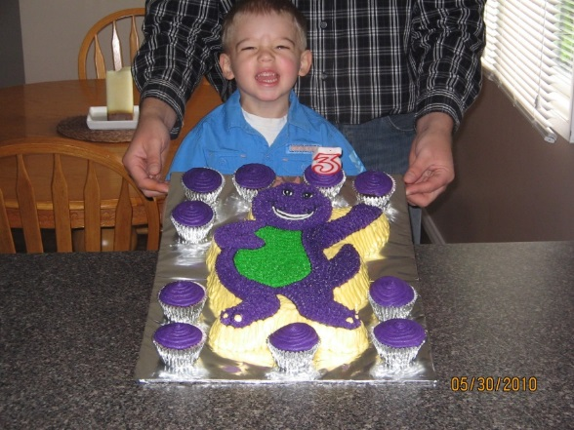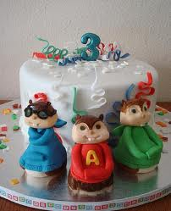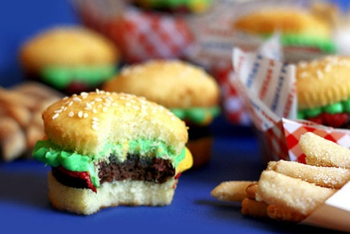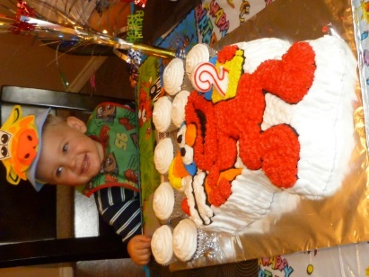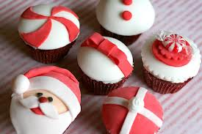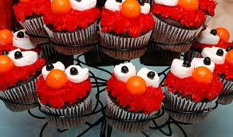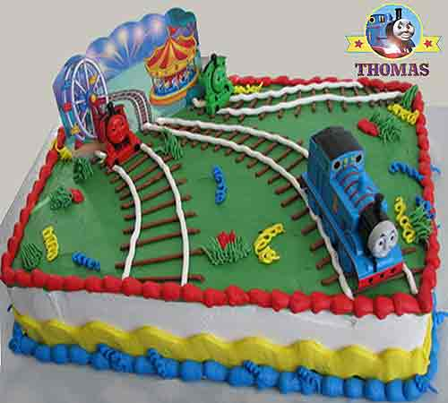

C:\Documents and Settings\Cindy\Local Settings\Temporary Internet Files\Content.IE5\UTUIIMGM\MC900434389[1].wmf**Think About It…**

1. So what do we know about cakes then. They have flour, sugar, eggs, liquid of some kind and salt. There are many different types and they are sweet desserts. What occasions are cakes usually made for? Birthdays, weddings, etc. Coffee cakes aren’t made of coffee. They are cakes to share with friends while going for coffee. Cake is a pleasant part of a pleasant occasion.

C:\Users\Cindy\AppData\Local\Microsoft\Windows\Temporary Internet Files\Content.IE5\GRGI3GHN\MC900410487[1].wmf**C:\Users\cindy.menzies\AppData\Local\Microsoft\Windows\Temporary Internet Files\Content.IE5\PCS5PKN3\MC900442026[1].wmf**

**Learning Activity:**

**All About Cakes**

1. You will receive a recipe for a simple chocolate cake. (worksheet attached)
2. In your groups you will analyze the recipe by answering the questions then you will create the cake.
3. If you get finished early go ahead and search some more cake designs on your iPad – save photos of the ones you love!

C:\Documents and Settings\Cindy\Local Settings\Temporary Internet Files\Content.IE5\UTUIIMGM\MC900434389[1].wmf**\*\*\*Demonstration - Let’s watch a real cake decorator to show us how to decorate some cakes\*\*\***

**Think About It…**

Part of being creative in the kitchen is knowing the bare basics and then getting creative! Think about which you are more comfortable working with confidently - salads or cakes. In your groups make a plan for a salad or cake. Create a base to start with then think of a theme - what are you going for? A special summer salad? A snow themed cake? Zoo animal cupcakes? Once you have a theme both salads and cakes are intended to be fun and colourful and tasty.

So plan for that - what makes your choice fun? What brings colour to it? What ingredients are going together well to make it tasty? Then the fun part - you are going to be judged! I’ll show you the judges’ cards so you know what you are being judged on and then let’s get to work!

Getting excited about cake decorating? You may decide you have a real knack for it and start designing and selling your own!

**Summative Assessment:**

**Cake Boss**

1. In your groups plan out the Cake Boss Worksheet focusing on:
   1. a fun theme
   2. colour and design
   3. taste.
2. Your judges will judge you and I will tabulate the judge cards as well as my own judging and those scores will be combined and that will be your assessment score for this outcome.

**C:\Documents and Settings\Cindy\Local Settings\Temporary Internet Files\Content.IE5\J6N94XK1\MM900185588[1].gifTime to Check in with:**

**Big Answers!**

* Can you respond to the Big Questions?
  1. What are the different types of cakes?
  2. What do you need to know to be able to prepare cake well?
  3. How do you decorate cake?
  4. How could you use this skill in real life?
* Check for completion of Formative Learning Activity: All About Cakes
* Rubric scoring for Summative Assessment: Cake Boss

C:\Users\Cindy\AppData\Local\Microsoft\Windows\Temporary Internet Files\Content.IE5\ETQSPCSJ\MC900445196[1].wmf**Lesson 4**

**All About Cakes**

1. Locate the recipe for a simple chocolate cake in your recipe book.
2. In your groups you will analyze the recipe by answering the questions.
   1. What are the ingredients common to all cake recipes that are in this recipe:
   2. What ingredient is making this recipe specifically a chocolate cake?
   3. What are the uses for this cake?
   4. What occasion would your group like to use this cake for? How would you like to decorate it? Create a plan

*For example: We would like to make it a toddler birthday and we will decorate it in the shape of a teddy bear.*

**Lesson 4**

**Chocolate Cake**

**Yield** – 1 - 9x13 cake

**Ingredients:**

* ½ c room temperature margarine
* 2 c white sugar
* ½ c cocoa
* 1 c warm water
* 1 c milk
* 1 tsp vanilla
* 2 eggs
* 2 c flour
* 2 tsp baking soda
* 1 tsp baking powder
* ½ tsp salt

**Directions:**

1. Preheat the over 350 degrees
2. Cream together margarine, white sugar, cocoa, water, milk, vanilla, eggs
3. Fold in flour, baking soda, baking powder, salt
4. Spray 9 x 13 pan with cooking spray and pour batter in with a rubber spatula
5. Bake 25-30 minutes
6. Cake is done when it springs to the touch and a toothpick can be slid into the middle and come out clean

MC900440428[1]**Lesson 4**

**Cake Boss**

Part of being creative in the kitchen is knowing the basics and then getting creative! Think about which you are more comfortable working with confidently - salads or cakes. In your groups make a plan for a salad or cake. Create a base to start with then think of a theme - what are you going for? A special summer salad? A snow themed cake? Zoo animal cupcakes? Once you have a theme both salads and cakes are intended to be fun and colourful and tasty. So plan for that - what makes your choice fun? What brings colour to it? What ingredients are going together well to make it tasty? Then the fun part - you are going to be judged! I’ll show you the judges’ cards so you know what you are being judged on and then let’s get to work!

In your groups choose to make a salad or a cake and plan out the worksheet below focusing on a fun theme, colour and design and taste. Your judges will judge you and I will tabulate the judge cards as well as my own judging and combined that will be your assessment score for this outcome.

1. Cake - _______________________________
2. Theme - _________________________________________________
3. How is your group going to show the theme in your creation? Colours, decorating styles, etc?

*For example: We are doing a snow theme so we are going to make sure that we use a lot of white - maybe coconut, white icing, etc. to make sure that theme is clear.*

1. What ingredients are you planning to bring together to ensure that the taste isn’t sacrificed by the design?

*For example: We’d love to add some black licorice pieces to the cupcake however we don’t want to attach a strong taste that might not be pleasing to young children. We may use chocolate bar pieces instead.*

1. Make your design plan:

Complete a sketch of your final product:

Complete an ingredient list - one here and copy one to give to your teacher to collect ingredients. Remember if the ingredients cannot be commonly found in our local grocery store you will either need to change that ingredient or supply it yourself.

1. Reflect - how did it go – did you find you have a knack and would maybe be interested in furthering your skills – could you design your own family birthday cakes – are you just glad you did it!?

**Rubric Rating for Cake Boss**

**Outcome: FS 9.2**

**For those using this Rubric Scoring Card:**

* 1. Read the result that you should see beside each check mark. If you feel it fits there circle it.
  2. I have attached a few indicators to help you know the difference between the numbers that hopefully will help.
  3. When you have judged all categories look what score you gave the majority of and give them an overall numeric score 1-5.
  4. The student’s overall mark will not be an average of judge scores - judge scores will be accounted for as the teacher gives the final score.

|  |  |  |
| --- | --- | --- |
| **Score** | **Judge Scoring** | **Comments** |
| **5 – WOW!!!!**  Restaurant/  Professional Quality  Never before seen creativity | * Cake theme was an exciting, creative idea that took incredible thought and planning to achieve * The colours were eye catching, and perfectly matched the theme that was to be achieved * The creator demonstrated incredible skill and effort to create their design, which was flawless for a designer their age * If there were issues in design they were problem solved independently with perfect results * The creator spoke very clearly and enthusiastically about their design and purpose |  |
| **4 – YES!**  Matches expectations  extremely well  Creative and tasty | * Cake theme was creative and appeared well-planned * The creator demonstrated great skill and effort to create their design for a designer their age * If there were issues in design they were problem solved with very little support * The colours were bright and matched the theme well * The creator spoke very clearly and about their design and purpose |  |
| **3 – Yes, but…**  Matches most expectations | * Cake theme was reasonably clear and interesting * The creator demonstrated their personal best skill and effort to create their design for a designer their age * If there were issues in design they were problem solved with some support * There was a great attempt at colour and design matching the theme * The creator stated their design and purpose |  |
| **2 – Just Beginning**  Matches half of the expectations | * Cake theme was a bit unclear, but an effort was made * The creator’s struggled at times and skill was inconsistent for a designer their age * If there were issues in design they were problem solved with significant support * There was evidence of an attempt at colour and design matching the theme * The creator spoke briefly about their design OR purpose |  |
| **1 – Not there at All**  Missed the mark | * Cake theme was unclear * The creator’s skill was completely lacking * If there were issues in design they were not solved * There was no evidence of an attempt at colour and design matching the theme * The creator was uncomfortable speaking or spoke off topic |  |

**Overall Score for these designers?___________**

**Any comments for these designers?**