Grade 7: November- Historical and FNMI Events and Their Impact
Project Rubric
Name:
 | 4  Exemplary | 3  Meeting | 2  Approaching | 1  Beginning
Historical Event and Artistic Analysis
Social Studies DR8.3  Assess how historical events in Canada have affected the present Canadian identity | I showed an in-depth understanding, demonstration and/or application of the content | I showed an understanding, demonstration, and/or application of the outcome | I am progressing towards understanding, demonstrating, or applying the outcome | I have an initial understanding, demonstration or application of the outcome.
Arts Education: CH8.1  Research and share insights about arts expressions that incorporate social commentary. | I showed an in-depth understanding, demonstration and/or application of the content | I showed an understanding, demonstration, and/or application of the outcome | I am progressing towards understanding, demonstrating, or applying the outcome | I have an initial understanding, demonstration or application of the outcome.
ELA: CC7.1 &CC7.5  - Create various visual, oral, written, and multimedia texts  - Create and present a display and enhance communication with appropriate timelines and maps | I showed an in-depth understanding, demonstration and/or application of the content | I showed an understanding, demonstration, and/or application of the outcome | I am progressing towards understanding, demonstrating, or applying the outcome | I have an initial understanding, demonstration or application of the outcome.
Treaty Relationship & Artistic Analysis
Social Studies: DR8.1  Develop an understanding of the significance of land on the evolution of Canadian identity. | I showed an in-depth understanding, demonstration and/or application of the content | I showed an understanding, demonstration, and/or application of the outcome | I am progressing towards understanding, demonstrating, or applying the outcome | I have an initial understanding, demonstration or application of the outcome.
Social Studies: DR8.2  Describe the influence of the treaty relationship on Canadian identity. | I showed an in-depth understanding, demonstration and/or application of the content | I showed an understanding, demonstration, and/or application of the outcome | I am progressing towards understanding, demonstrating, or applying the outcome | I have an initial understanding, demonstration or application of the outcome.
Arts Ed. CH8.2  Analyze the influence of social issues on the work of contemporary First Nations, Métis, and Inuit artists, and share results. | I showed an in-depth understanding, demonstration and/or application of the content | I showed an understanding, demonstration, and/or application of the outcome | I am progressing towards understanding, demonstrating, or applying the outcome | I have an initial understanding, demonstration or application of the outcome.
Arts Ed. CR8.2  Investigate and identify ways that today’s arts expressions often reflect concern for social issues | I showed an in-depth understanding, demonstration and/or application of the content | I showed an understanding, demonstration, and/or application of the outcome | I am progressing towards understanding, demonstrating, or applying the outcome | I have an initial understanding, demonstration or application of the outcome.
ELA: CR7.6  Read and demonstrate comprehension and interpretation texts including traditional and contemporary prose fiction, poetry, and plays from First Nations, Métis, and other cultures. | I showed an in-depth understanding, demonstration and/or application of the content | I showed an understanding, demonstration, and/or application of the outcome | I am progressing towards understanding, demonstrating, or applying the outcome | I have an initial understanding, demonstration or application of the outcome.

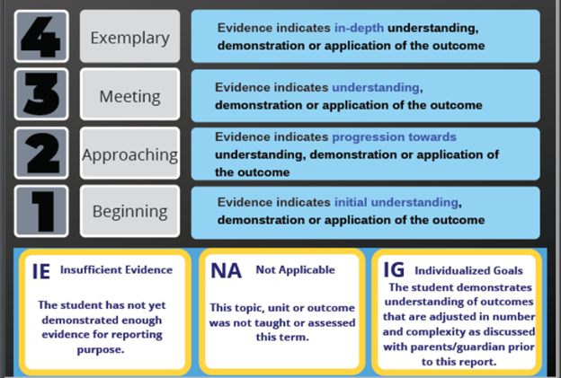
Comments:

Grade 8: November- Historical and FNMI Events and Their Impact
Project Rubric
Name:
 | 4  Exemplary | 3  Meeting | 2  Approaching | 1  Beginning
Historical Event and Artistic Analysis
Social Studies DR8.3  Assess how historical events in Canada have affected the present Canadian identity | I showed an in-depth understanding, demonstration and/or application of the content | I showed an understanding, demonstration, and/or application of the outcome | I am progressing towards understanding, demonstrating, or applying the outcome | I have an initial understanding, demonstration or application of the outcome.
Arts Education: CH8.1  Research and share insights about arts expressions that incorporate social commentary. | I showed an in-depth understanding, demonstration and/or application of the content | I showed an understanding, demonstration, and/or application of the outcome | I am progressing towards understanding, demonstrating, or applying the outcome | I have an initial understanding, demonstration or application of the outcome.
ELA: CC8.1 &CC8.5  - Create various visual, oral, written, and multimedia (including digital) texts  - Create and present a variety of visual and multimedia presentations including using presentation software | I showed an in-depth understanding, demonstration and/or application of the content | I showed an understanding, demonstration, and/or application of the outcome | I am progressing towards understanding, demonstrating, or applying the outcome | I have an initial understanding, demonstration or application of the outcome.
ELA: CC8.9  Experiment with a variety of text forms (e.g. an electronic presentation, using graphics and statistics in a multimedia presentation). | I showed an in-depth understanding, demonstration and/or application of the content | I showed an understanding, demonstration, and/or application of the outcome | I am progressing towards understanding, demonstrating, or applying the outcome | I have an initial understanding, demonstration or application of the outcome.
Treaty Relationship & Artistic Analysis
Social Studies: DR8.1  Develop an understanding of the significance of land on the evolution of Canadian identity. | I showed an in-depth understanding, demonstration and/or application of the content | I showed an understanding, demonstration, and/or application of the outcome | I am progressing towards understanding, demonstrating, or applying the outcome | I have an initial understanding, demonstration or application of the outcome.
Social Studies: DR8.2  Describe the influence of the treaty relationship on Canadian identity. | I showed an in-depth understanding, demonstration and/or application of the content | I showed an understanding, demonstration, and/or application of the outcome | I am progressing towards understanding, demonstrating, or applying the outcome | I have an initial understanding, demonstration or application of the outcome.
Arts Ed. CH8.2  Analyze the influence of social issues on the work of contemporary First Nations, Métis, and Inuit artists, and share results. | I showed an in-depth understanding, demonstration and/or application of the content | I showed an understanding, demonstration, and/or application of the outcome | I am progressing towards understanding, demonstrating, or applying the outcome | I have an initial understanding, demonstration or application of the outcome.
Arts Ed. CR8.2  Investigate and identify ways that today’s arts expressions often reflect concern for social issues | I showed an in-depth understanding, demonstration and/or application of the content | I showed an understanding, demonstration, and/or application of the outcome | I am progressing towards understanding, demonstrating, or applying the outcome | I have an initial understanding, demonstration or application of the outcome.
ELA: CR8.6  Read and demonstrate comprehension and interpretation texts including prose fiction, poetry, and plays from First Nations, Métis, and other cultures. | I showed an in-depth understanding, demonstration and/or application of the content | I showed an understanding, demonstration, and/or application of the outcome | I am progressing towards understanding, demonstrating, or applying the outcome | I have an initial understanding, demonstration or application of the outcome.

Comments:

