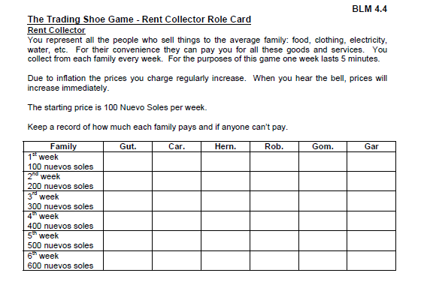
Rent Collectors Role Card:
600
700

V

You are collecting rent from: the Gutierrez, Hernandez, and Gomez families

Rent Collectors Role Card:
600
700

V

You are collecting rent from: the Vargas, Robles, and Garcia families

