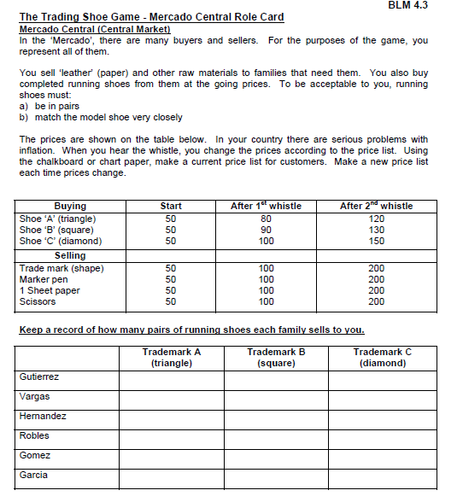
Mercado Central Vendor Role Card:
40
2nd alarm
4th alarm

*Prices don’t increase until 10 minutes into the game, and twenty minutes into the game*
You are selling to and buying from: the Gutierrez, Hernandez, and Gomez families
Mercado Central Vendor Role Card:
40
2nd alarm
4th alarm

*Prices don’t increase until 10 minutes into the game, and twenty minutes into the game*
You are selling to and buying from: the Vargas, Robles, and Garcia families
Please Line Up Single File!

Verbal Abuse will not be tolerated and you will be turned away if we detect any threat to us, the vendors.

Gutierrez, Hernandez, Gomez Families line up here!

Please Line Up Single File!

Verbal Abuse will not be tolerated and you will be turned away if we detect any threat to us, the vendors.

Vargas, Robles, Garcia Families line up here!

