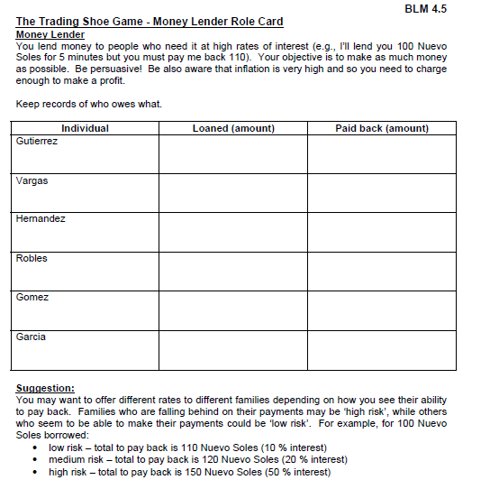
Money Lenders Role Card:

(IOU cards)

IOU Cards: write the amount the family owes you (interest included) on the IOU and give it to the family. Record it for yourself on this page as well.

You are the money lender for: the Gutierrez, Hernandez, and Gomez families
Money Lenders Role Card:

(IOU cards)

IOU Cards: write the amount the family owes you (interest included) on the IOU and give it to the family. Record it for yourself on this page as well.

You are the money lender for: the Vargas, Robles, and Garcia families

