Created by Kindergarten PLC
Early Years Writing Progression
Behaviours to notice
Pencil Grip | Whole hand fist grasp using whole arm movements to draw. | Whole hand palm grasp using whole arm movements to draw.  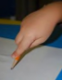 | Grasps using fingers and thumb, with whole arm movements  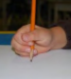 | Grasps using index finger, tip of the thumb and middle finger, with active wrist and finger movement
Pathway of motion/  Directionality | Not yet able to recognize where print starts | Forms letters from the top down  Places letter-like shapes in a left to right direction  Recognizes letter formation | Attempts to form letters between lines  Some letters may be backwards | Letter touches top line and bottom line  Letter size is consistent  Letters are facing the correct way
Drawing a person | Drawing is not recognizable as a person. May have head and one or two other parts  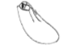 | Draws a recognizable person with head, at least two limbs, and eyes; parts may be detached or of incorrect size or location  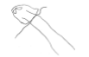 | Draws a recognizable person with head, 4 limbs, eyes, and mouth in relatively correct location  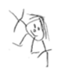 | 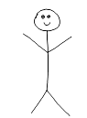  Draws a recognizable person with head, 4 limbs, eyes, and mouth in the correct location | 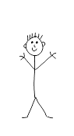  Draws a recognizable person with head, 4 limbs, eyes, mouth, in the correct location with more detail. | Person has head, trunk, arms, legs, eyes, nose and mouth (realistic) with correct location and more detail (i.e. clothing)  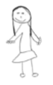
Printing Upper and Lowercase letters | Places squiggles or letter-like shapes randomly on the page | Prints using mostly uppercase letters. May use some lowercase letters | Prints using a mixture of uppercase and lowercase letters. i.e. name | Prints using an uppercase letter at the beginning of a sentence. | Prints using uppercase and lowercase letters appropriately
Spacing, punctuation | No finger spaces, no punctuation | May have space between letters | May have space between two words and may have punctuation | May have space between most words and may have punctuation | Has space between words and ends sentence with punctuation | Continues to have space between words and ends 2 or more sentences with punctuation.
Word Choice | Writes own name | Uses familiar words  -Mom  -Dad  -Family names | Environmental Print  -Theme Words  -Schedule words  -Classmates names | Uses some pre-primer words  -Like  -I  -See | Uses some primer words  -They  -Get  -help
Spelling | Represents words with letter like shapes and no sound correspondence. | Write most beginning sounds correctly | Write beginning and some ending sounds | Write beginning and ending sounds with some vowels. | Writes cvc words and known words
Writing Continuum Samples | Not recognizable | 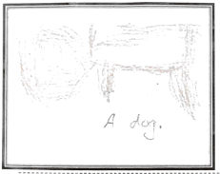  Clear idea and recognizable | 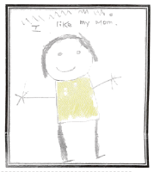  Scribble writing | 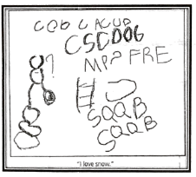  Letter or word like forms | 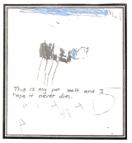  Copied and random letters | 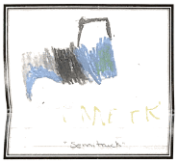  Words | 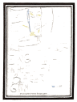  Sentence
Ideas | Unable to develop ideas | Develops an idea with assistance | Develops ideas independently | Tells details (1 sentence) about their idea | Adds more detail | Clear beginning midlde and end
Sentence Structure | No evidence of intended message | Includes 1 intentional word | Includes 1 intended simple sentence | includes 2-4 simple and/or 1 complex/compound sentences | Includes 5 simple and/or 2 complex/compound sentences | Includes 3 compound/complex sentences | Includes 4-6 complex/compound sentences

