Lesson Planning
Teacher(s) | Subject(s)  ELA | Grade  3 |  | Learning Experience/Unit/Theme  Narrative Writing – Pourquoi tale  Imaginative and Literary - Children need to consider imaginary worlds and possibilities as well as a range of literary genres and authors. |  | Date
Consider the Transfer of Responsibility (the movement back and forth between I do, We do, You do)
I do | We do | You do
The “I do” phase of a lesson involves you telling students what they need to know and showing them how to do the things that they need to be able to do.  (Marzano)  Teacher reads examples of pourquoi tales | The “We do” phase involves doing tasks together. You can help students use the steps they need to follow and complete particular tasks.  (Marzano)  Teacher and students compose one or more oral or written pourquoi tales | The “You do” phase involves students practicing what you have already taught them by themselves. Such practice helps student retain what they may have learned and to become fluent with what they must be able to do.  (Marzano)  Students independently compose their own pourquoi tale

Big Ideas/Key Questions/Essential Understandings

What lesson do tales teach? Why do characters in stories act the way they do?

Outcome(s)  CC3.4 Write to communicate ideas, information, and experiences pertaining to a topic by creating easy-to-follow writing (including a short report, a procedure, a letter, a story, a short script, and a poem) with a clear purpose, correct paragraph structure, and interesting detail  Indicators  c. Cues and conventions  e. Write narratives that provide a context within which an action takes place and includes characters and their traits, setting, and problem and solution in students’ stories.  f. Create characters and events from outside students’ personal environment.  j. Extends, reworks, and polishes pieces of writing for an audience in and beyond the classroom. |  |  | I Can Statements  I can write an interesting story from my imagination.
Assessment Plan
Pre-Assessment Plan  Have students compose a piece of imaginative narrative writing, about 3 paragraphs long, that includes a main character, setting description, simple story line (problem & resolution)  Assess the writing skills of the group and plan for whole group and small group instruction | Formative Assessment Plan  -Written and verbal feedback on first draft (we do) |  |  |  | Summative Assessment Plan  https://www.stf.sk.ca/sites/default/files/spdu-resources/writing_rubric_grade3_2012may.pdf  - Assess each student’s final copy of their pourquoi tale using the writing rubric from SPDU or Sun West Resource bank
Motivational Set

- Read aloud Pourquoi tales from Collections MIR or other tales from your library such as “Why Mosquitoes Buzz People’s Ears”, “How the Chipmunk Got its Stripes” or retellings from the online Scholastic resource listed below.
- Have students read a Pourquoi tale from their MIR or from the library (Title will begin with “How…” or “Why…”)
- These reading examples become the background knowledge for the pourquoi writing lesson
Instructional Strategies/Activities (Before/During/After)

Before:
- Discuss the meaning of “pourquoi” – in French, it can mean “how” or “the reason why”
- Brainstorm possible examples of pourquoi tales (How Snake lost its Legs, How Leopard got his Spots) For each example, have students come up with ideas about how the animal/character used to be, what happened to change things, and what the animal/character is like now (I do)
- Introduce alliteration and personification and brainstorm examples of how they can be used in tales. Students will be able to provide their own examples of alliteration and personification.
- Review the stages of the writing process. Refer to classroom poster of the writing process.
- Model the writing of a pourquoi tale by having teacher and students create a story as a class. (we do)

During:
- Fill out a narrative writing graphic organizer of your choice detailing the specific character/animal central to the student’s tale, the original state of the character/animal and the final state of the character/animal (you do)
- Write a first draft of the tale, leaving one or two lines between writing to use for editing (you do)
- Go through the editing process for cues, conventions, word choice - find the nouns in the draft and add one or two adjectives to describe the noun (we do)
- Use alliteration two or three times in the tale
- Produce a final copy of their pourquoi tale (you do)

After:
- Publish the student-created pourquoi tale in a booklet with accompanying representations/illustrations (see CC3.2 e)
- Display finished pourquoi tale booklets in a space in the classroom for other students to read and enjoy
- Loan the students’ pourquoi tale booklets to the library
- Buddy read the pourquoi tales to other students in the class or to K or Gr. 1 students
- Reflect on the writing process curriculum outcomes AR3.1 and AR3.2 Example: “What specific writing techniques did I do well? What areas of writing do I need to work on?”

Ways to differentiate to meet individual student's needs
Have student use voice-to-text device to dictate their pourquoi tales or have someone scribe the tale
Provide student with easy-to-follow narrative writing graphic organizers – many available free online
Provide student with three sample characters/ideas to choose from and develop one of them

Opportunities for Personalization

Students may choose the animal to write about.
Students will use various techniques to represent / illustrate their writing

Materials/Resources/FNMI

Scholastic resource “Teaching With Pourquoi Tales”: https://www.scholastic.com/teachers/articles/teaching-content/teaching-pourquoi-tales/
Collection MIR “Tales – Princesses, Peas and Enchanted Trees” – “How Eagle Got His Good Eyes
Pourquoi tales from library
Many First Nations legends explain how things came to be through the use of pourquoi tales – ask your librarian
Writing rubric from SPDU: https://www.stf.sk.ca/sites/default/files/spdu-resources/writing_rubric_grade3_2012may.pdf

7 C’s  Consider how to incorporate:  - Creativity, Innovation and Entrepreneurship  - Critical Thinking  - Collaboration  - Communication  - Character  - Cultural and Ethical Citizenship  - Computer and Digital Technologies (Learning Tools)  Details  Composing tales gives students opportunity to be creative and communicate their ideas in the pourquoi format |  | REORDER  Consider how to incorporate:  - Relationships  - Environment  - Opportunities  - Resources  - Distribution of Leadership  - Evaluation  - Recognition  Details  Students can read their tales to other students
Reflection

In what areas of the writing process are students proficient?
In what areas of the writing process are some students still experiencing difficulty or need further development and practice?
How can these imaginative narrative writing skills be transferred to another form of story writing?

Sample grade 3 pourquoi tales with representations/ illustrations.

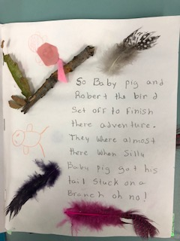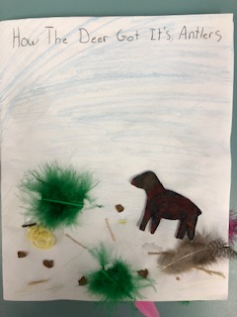

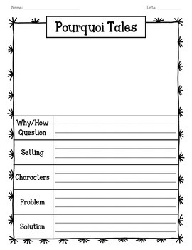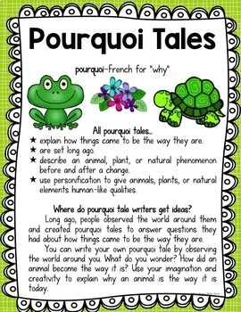

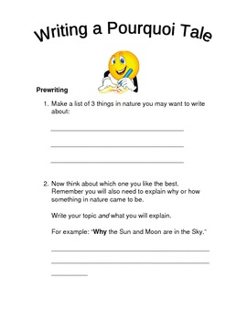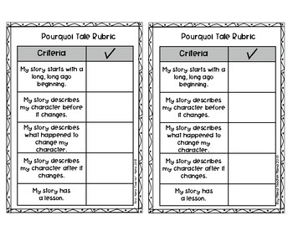
https://ecdn.teacherspayteachers.com/thumbitem/Pourquoi-Tales-Graphic-Organizers-1867423-1513119751/original-1867423-1.jpg
https://ecdn.teacherspayteachers.com/thumbitem/Pourquoi-Tale-Graphic-Organizers-and-Writers-Notebook-Charts-1485758798/original-589600-2.jpg
https://www.teacherspayteachers.com/Product/Pourquoi-Tales-589600
https://www.teacherspayteachers.com/Product/Pourquoi-Tales-Porquoi-1871026

