21st Century Competencies’ Artifact 2014-15
Creativity – Expert Writing

Pamela Schmaltz
Glidden Colony School

English Language Arts: Expert Writing Presentations
Grades: 4-8
Outcomes:
CR 6.7
Read independently and demonstrate comprehension of a variety of information texts with some specialized language including grade level instructional materials, non-fiction books, reports and articles from magazines and journals, reference materials, and written instructions.

CC 6.4
Create and present a variety of representations that communicate ideas and information to inform or persuade and to entertain an audience, including illustrations, diagrams, posters, displays, and cartoons.

CC 6.6
Use oral language appropriately to express a range of information and ideas in formal and informal situations including presenting an oral report based on research, a demonstration, and a short dramatization.

AR 6.1
Consider which viewing, listening, reading, representing, speaking, and writing strategies work best for each task and situation.

Summary of Plan
I have been doing expert writing with the older students for a few years now as an independent English Language Arts project while I am working with the younger students. However, I have been disappointed with the variety and creativity in presentations. I give them a list of possible formats and they choose the topic they are interested in researching and how they want to present what they have learned. Only 1 or 2 have been brave enough to deviate from the traditional written report, or poster.

My plan was to do a variety of creativity projects from the Destination Imagination series to foster creativity and get them in the right frame of mind before doing their projects. I insisted that they had to choose a format other than a written report, or poster.

Evidence of Success
Success will be every student trying a new format to present their learning to the class. Not only their visual artifact, but their oral presentation as well. I get very excited whenever a student demonstrates creativity, so my reaction to their presentation will also be a sign of success!

Conclusion
The colony students found certain projects from Destination Imagination easier to be creative with than others, but I do feel that it helped prepare them for their Expert Writing assignment.

About 60% of the students really tried to move out of their comfort zone, with some of them being more creative than others. I am hoping that as the students see their classmates trying new ways of presenting, they will be inspired to try something new as well, and that they will all blow me away the next time they present what they have learned!

EXPERT WRITING
You are about to become an expert writer!
You will research and write about a topic that interests YOU! Ask yourself, “If I could learn about anyone or anything I wanted, who/what would it be?” What if you knew so much about a topic, that people went to you with their questions about it?!
You should always have 2 topics in mind. These could include:
- Current events
- Books/ authors
- Family interest
- Places
- Sports
- Celebrity (only 1 per year)
You might get ideas while you are reading a book and you come across something you would like to know more about. You could also ask your parents for ideas.

PROCESS
- Decide on a topic. Brainstorm questions you would like to answer about that topic.
- Check books from school and encyclopedias. Let me know what your topic is so I can copy some information from the internet for you.
- Once you have your research information, you will read it and get 3 sticky notes to keep track of 3 favourite bits of information, which you may share with the class.
- Using a highlighter, highlight all of the things that you think will be important or interesting (don’t highlight everything!)
- Complete R.A.F.T.S. Organizer
- Create ORGANIZED jot notes (use headings or questions that you are answering to divide information)
- Write a rough copy and hand in with research notes.
- Reread and revise rough copy.
- Edit (individually and peer)
- Publish and present using a format of your choice (BE CREATIVE)!
- This should take 3 weeks to 1 month.

Possible Formats for Expert Writing
- Story
- Song
- Board Game
- Brochure
- Picture Book
- Layered Book
- Application Form
- Complaint
- Letter
- Congratulations
- Debate
- Demonstration
- Wanted Poster
- Dialogue
- Dictionary
- Diorama
- Eulogy
- Time-line
- Poem
- Interview
- Introduction
- Model
- Prayers
- Resume
- Skit
- Survival Manual
- Collage
- Essay
- Any other appropriate format you can think of

RAFT GRAPHIC ORGANIZER

ROLE | AUDIENCE
FORMAT | TOPIC

The Writing Task:

As a _______________, write a ___________________
(role) (format)
to ______________________ ____________________
(audience) (strong verb)
about ___________________________.
(topic)

Criteria | Rating | Comments
Questions
- 5-10 questions
- Specific

Resources
- Locates resources independently
- Cites resources used

Research
- Creates jot notes
- Paraphrasing
- Answers questions fully
- Additional interesting information

Oral Presentation
- Speaks clearly/ volume
- Speaks fluently
- Shows an understanding of the topic
- Does not read directly from paper
- Can answer questions from audience
- Speaks using own voice/words
- Eye contact with audience
- Uses visuals at appropriate times

Display of Findings
- Variety
- Uses visuals
- Organized
- Neat
- Labelled
- Answers original questions
Self- Assessing Creativity & Innovation Student:
Phases of Creativity&  Innovation | Criteria | 5  WOW | 4  Yes, and | 3  Yes | 2  Getting There | 1  Not Yet
Phase 1:  Generating Ideas | I was able to:  - generate and share ideas  - share appropriate ideas  - consider the audience  - be open minded
Phase 2:  Ask Questions | I was able to:  - consider the audience  - explore questions based on generated ideas
Phase 3:  Be original& imaginative | I was able to:  - think in a new way  - consider my audience
Phase 4:  Evaluate | I was able to:  - identify skills and knowledge needed  - assess accuracy of sources & identify bias  - sort and/or combine ideas
Phase 5:  Elaborate | I was able to:  - implement an idea  - design the vision  - produce an idea to prepare for showcase
Phase 6:  Showcase | I was able to:  - engage target audience  - prepare and practice  - feel confident about the topic  - show/share/present in a purposeful & useful way

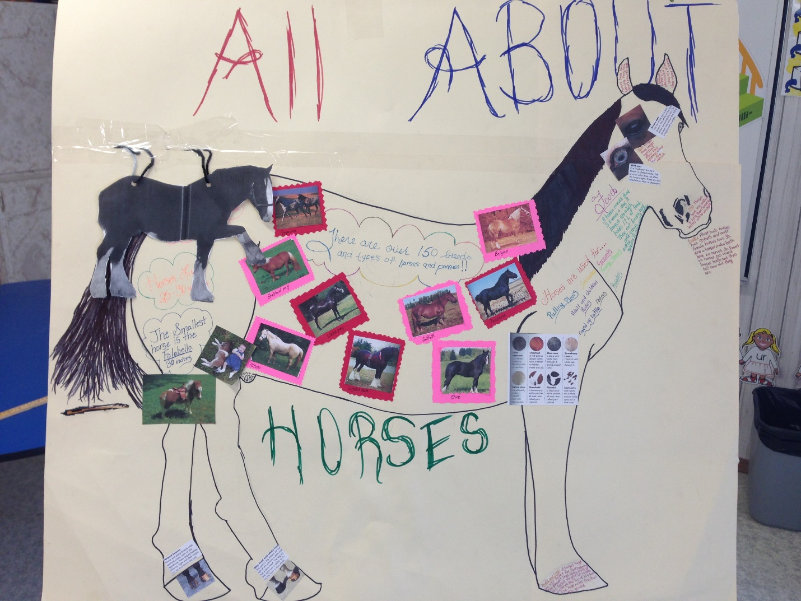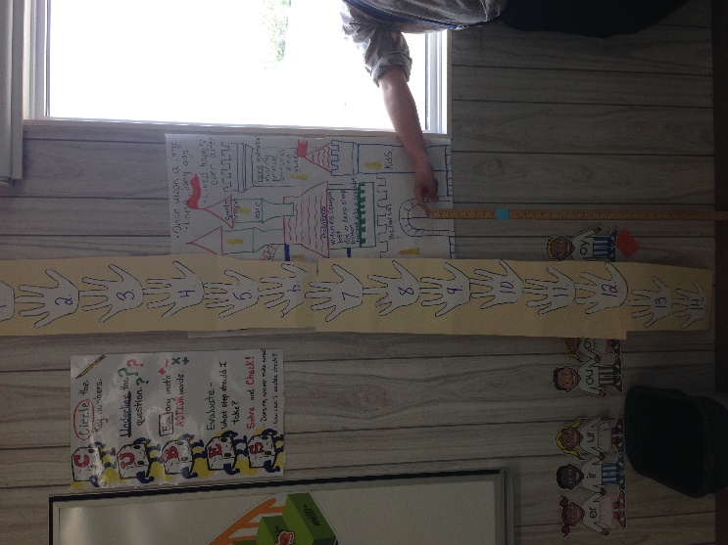
Demonstrating the height of a horse.
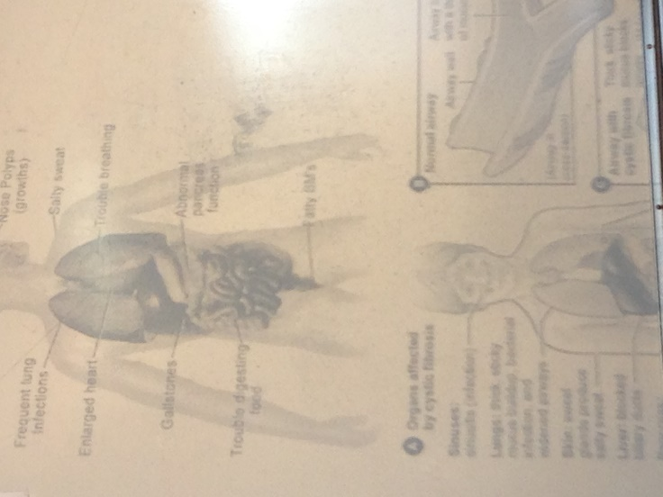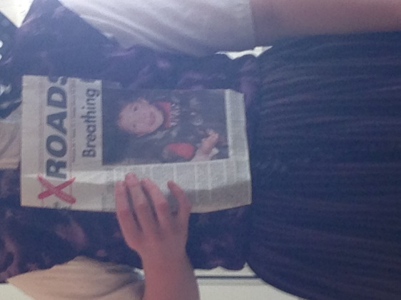Cystic Fibrosis Presentation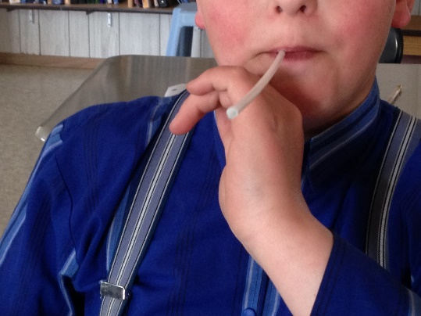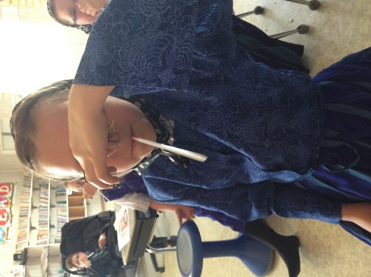Simulating what it’s like to have CF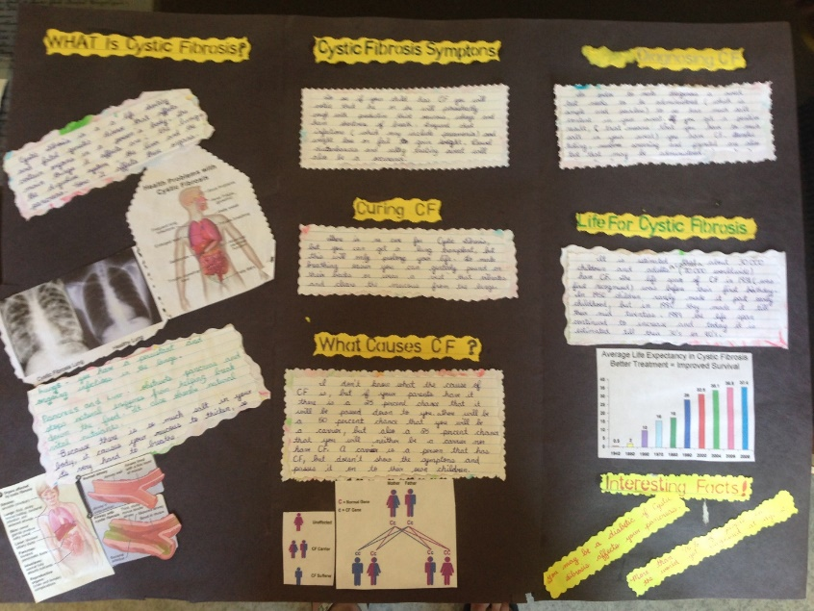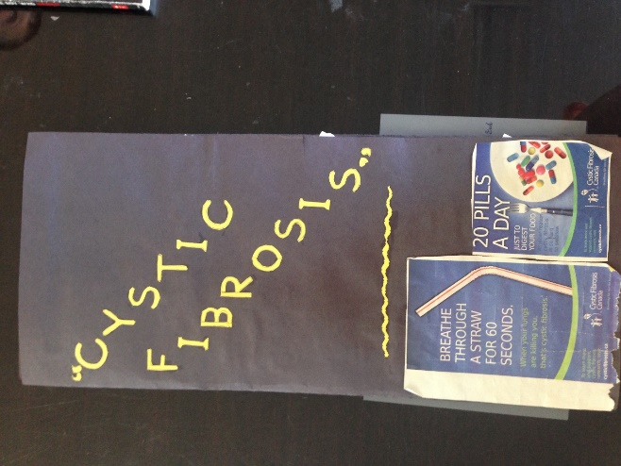Brochure
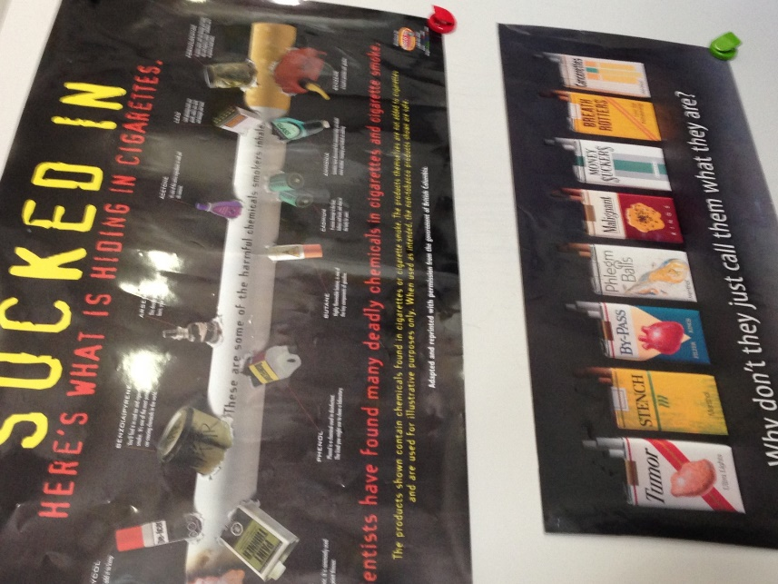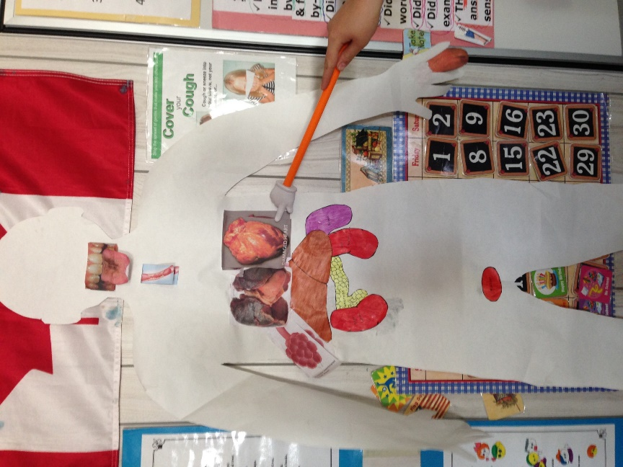
Showing how body is affected by smoking cigarettes.

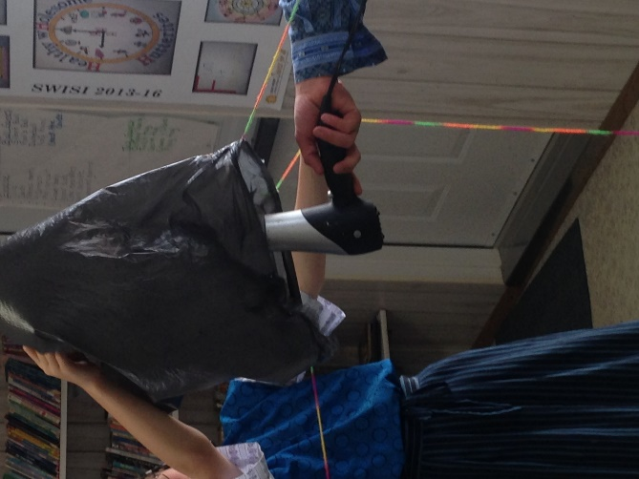
Hot air balloon presentation
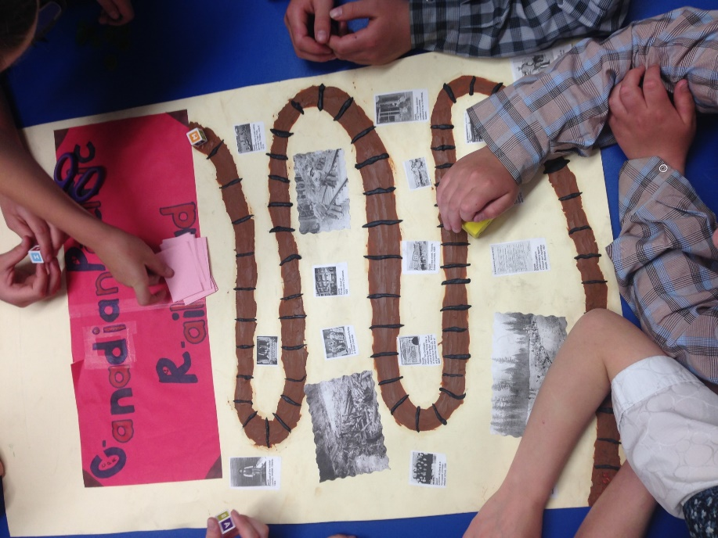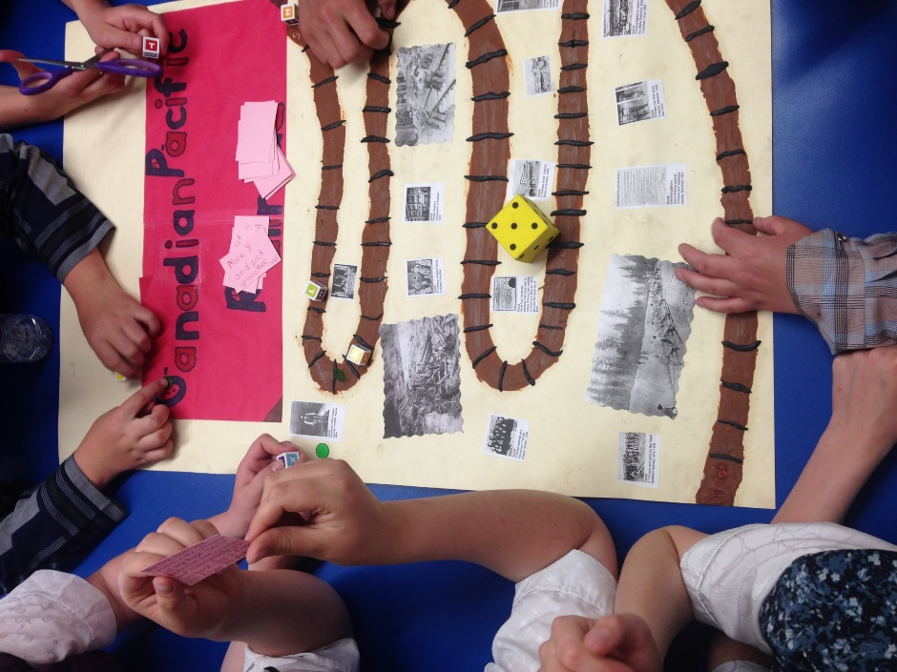Board game to show what was learned about Chinese immigrants and the building of the CP railway
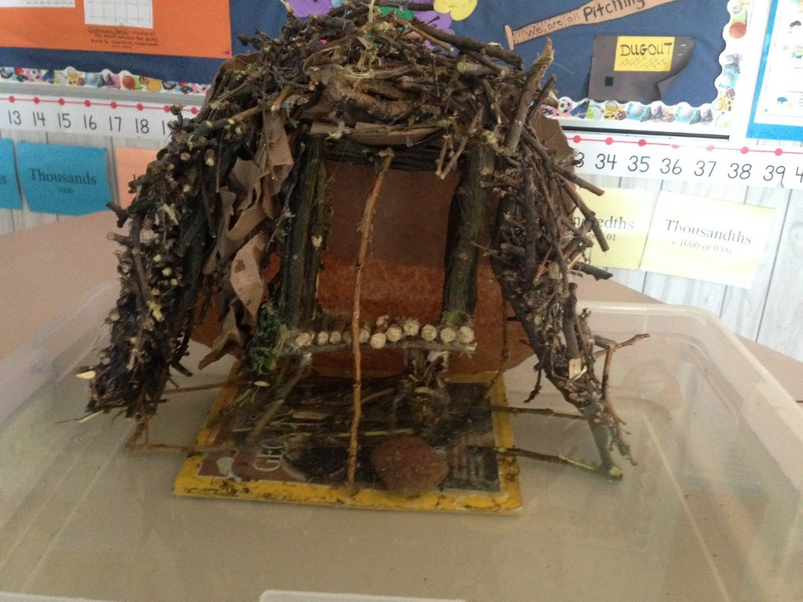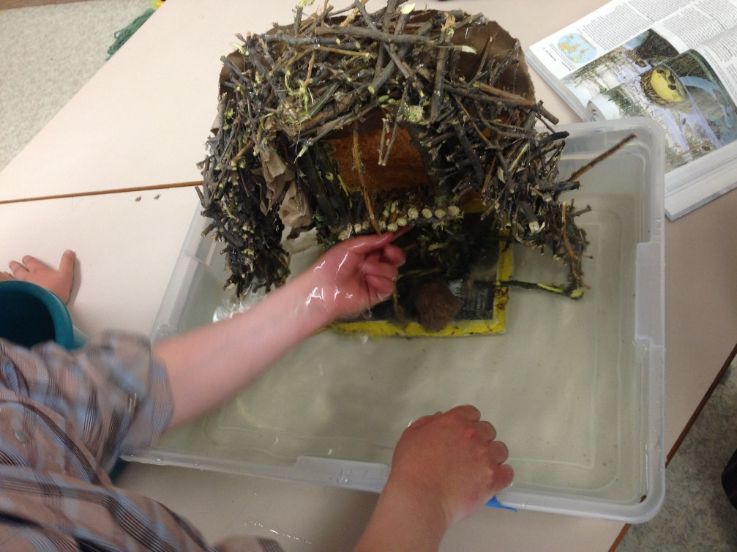
Presentation on Beavers (model of a dam)

