Literacy  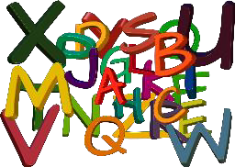 | - Complete the Seesaw activity.  Community Storytelling Activity  - Think about the community helpers that you know of. (Example: Firefighter, Police Officer, etc.) Get your family to help you write them down. Place each community member on a separate piece of paper. Place the paper cards in a hat. Pull one card out at a time. Complete the following steps for each card:  - Take the word and clap or tap out the syllables.  - Isolate the beginning sound.  - Isolate the final sound.  - Take your family on a community walk. As you are walking take a look around to notice all the great things in your community. When you arrive back at home, take a piece of paper and draw what you saw. Make sure to snap a photo of this and send it to your teacher. You can also record what you saw.
Numeracy  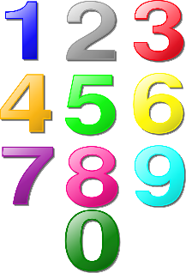 | - Complete the following Seesaw Activities  Community Helpers  Community Helper Sort  - Take monopoly money or other types of fake money and use that to go “shopping” in your own home. Have your family set up a fake store and work on your numeracy skills. (Example: Place a sticky note on your jug of milk with the number 2 on it. Use your communication skills and work out how much money you need to be able to purchase the milk.)  - Go on a Number walk and try to find places within your home or community that uses numbers. Here is the link to a Seesaw activity.  Number Scavenger Hunt
Get Moving  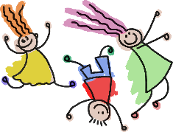 | - Get out and complete a community Chalk Walk. If you do not have chalk at home here is a sidewalk paint recipe.  2 tbsp of corn starch  4 tbsp of water  6-8 drops food coloring  *Make sure you stir before each use.  Chalk Walk  2. Go on a Community Scavenger Hunt while you are out on your Chalk Walk. Here are some clues that you can use to get you started. Feel free to make some or your own if some do not apply to your community.  1. This is a place you go to learn. (Your School)  2. You visit me to take out books and movies. (Library)  3. This is a place you go to buy food. There are rows upon rows of food to pick from. (Grocery Store)  4. When you are feeling too hot this is a great spot to visit and cool off in the water. (Pool)  5. I deliver parcels and mail to your town. Remember to bring your key to check your mailbox. (Post Office)  6. The people who work at this place keep our town safe. Their vehicles have a loud sirens and red and blue lights. (R.C.M.P Detachment)  7. This building is filled with helpful people: Nurses, Doctors, X-Ray Techs., Lab Techs., etc. Sometimes you come to visit me when you are injured or sick. (Hospital or clinics or ambulance hall)  8. This is a place to visit and learn all about the past. (Museum)  9. I smell amazing from April to June. You can come in a pick out a plant or flowers to purchase and take home. (Green House or flower pots)  11. This building holds some large red trucks. Volunteers drive these trucks to fires to help put out the flames. (Fire Hall)  12. After a long hot day, a cold treat is what hits the spot. This place serves many kinds of food, but it’s known for ice cream. (Restaurant, Dairy Queen, or any place to grab a treat for your success)
Get Creative  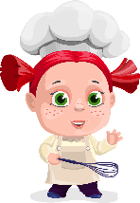 | - Check out ArtHub: Community Helper  Drawing Health Heros  - Go on a Musical Scavenger Hunt.  Musical Scavenger Hunt
Passions  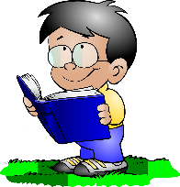 | - Check out Scholastic Community Activities  Scholastic Link  - Create thank you cards for the essential workers in your community. Deliver the cards to those who help you the most.
Additional Resources | - Community Helper Hats:  Community Helper Hats Link  - School Bus Ten Frames  School Bus Ten Frame Link  - Community Helper Math Games  Math Game Link  - Community Helper Clip Cards  Clip Card Link  - Community Helper Mazes  Community Mazes Link  - Community Member Color by Number  TPT Resource Community Color by Number  - Community Worker BINGO  Community Worker BINGO link

