Ryan’s Strategies for the 2019/2020 School Year
Strategy | Useful? | Recommended For…
Individual Behaviour Report | Yes, but not sustainable for long term tracking if working together with the student | An intense two week tracking to have data for the next steps
Behaviour Cue Picture Reminder | Yes, but must be paired with some sort of reward in the younger years | Students who struggle with remembering to keep hands to themselves, regulating emotions, or who need a visual reminder that you care
Colour Coded Expected Behaviour Slide Chart | Yes, as long as it is easily accessible. I have used this as a whole class or on an individual basis | Students who need a visual to see when they are crossing the line from expected to unexpected behaviour (with levels in between to recognize and adjust their behaviour)
Silent Signal | Yes. This allows the student to let you know when they need a break or need to talk | Students who have a difficult time stepping forward when they need something. This can be as simple as a paper badge or cut out placed on top of their pencil case (and it can be stored inside their pencil case)

Name:___________________________________ Date: __________________________
Best Self Report: Individual Student Daily Progress

– Try Again (0 points)  – OK (1 points)  – Excellent (2 points) | Be Respectful | Be Responsible | Be  Safe | (Points)
Morning Routine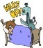
Guided Reading 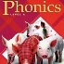
Recess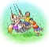
Writing, PE or Lib. 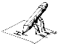
Lunch 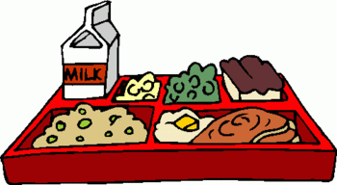
Math 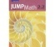
Investigations 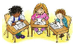
Recess
Art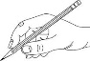
Home Time
Classmates
Teachers
Self
Possible Points – 78 Goal – 47 (60%) Total Earned – ______
Was my goal met? YES or NO __________ %
Comments may be included on back.

Be Respectful: let others have their turn, no teasing, speak kindly to others
Be Responsible: keep your area tidy, take care of school supplies, don’t take other peoples things
Be Safe: using classroom equipment appropriately, no pushing or hitting, take time to calm down

