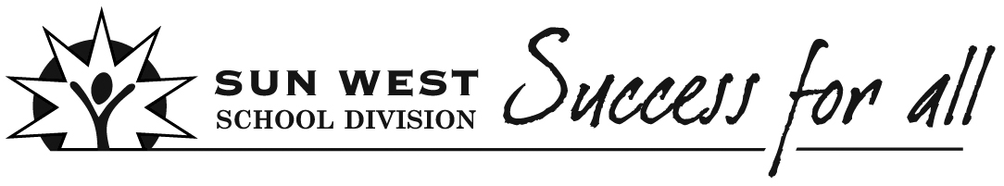 Lesson Plan Template
Teacher  Mrs. V. Lewis | Subject  Career Education |  | Grade  9 | Activity  STEAM Challenge | Duration  1 class period
Big Ideas/Key Questions
Who Am I? What are my strengths/skills?
What do I know about the world of work?
What can I do now to prepare for my future?

Goals
This activity was created to help students explore various outcomes related to the following Career Education Goals:
- All students will develop career management competencies through an exploration of personal change and growth.
- All students will explore the connection between learning and work pathways and their connections to community.
- All students will engage in inquiry to construct a personal life and work plan.
Outcome(s)
This activity was created to help you explore the following Career Education Outcomes:
CC9.1 Utilize career information to construct an organized plan of career building which reflects an attitude and expectation of lifelong learning.
LW9.1 Assess one’s own abilities to seek, obtain, and/or create work through researching successful strategies and applying them to one’s own life.
LW9.2 Use acquired knowledge to create a plan for life and work based on one’s preferred future.

Assessment Strategy  - Pre-Assessment  - Formative Assessment  - Summative Assessment  - General Feedback (not included in  Final Grade) |  | As the educator, you can decide if/how this STEAM Challenge experience will be assessed.
Instructional Strategies/Activities
Choose various STEAM Challenges to support students with life/career explorations as they explore curriculum outcomes.

The Cup Holder Challenge is outlined below, but do some searching to find challenges that will work for you or your students as you help them develop 21st Century Skills and explore STEAM related occupations.

Materials/Resources
Various materials needed depending on the challenge. I always try to choose low cost activities. There is a multitude of great ideas online. As well, the Destination Imagination Challenges at the Division Office contain ideas which could be adapted for STEM Career Investigation Challenges for students.

For the Cup Holder Challenge, you will require the following items per team:
2 Cups
1 Piece of Paper
1 Piece Tinfoil
6 Straws
2 Paperclips
2 Pieces of String
2 Pipe Cleaners
3 Mailing Labels
1 Envelope
5 Pennies

Notes/Reflections following the experience:
STEAM Challenges
STEAM Challenges for Students
Make learning come to life! Participating in hands-on STEAM (Science, Technology, Engineering, Art, Math) Challenges can provide students with opportunities to develop new skills and understandings related to their preferred life/career choices. These challenges help students build 21st Century Skills while exploring potential occupations of interest. Students will be able to reflect on what areas best fit their interest, skills, values, etc. as they work to create the life they want to live.

“In the 21st century, scientific and technological innovations have become increasingly important as we face the benefits and challenges of both globalization and a knowledge-based economy. To succeed in this new information-based and highly technological society, students need to develop their capabilities in STEM…” (National Science Foundation)

Top 15 Benefits of a STEM Education Revisited Retrieved from: STEM Jobs: Do What You Love

A STEM education can open many doors for students - even students who don't pursue a STEM career.

STEM scares many students because it is perceived as being too difficult and – tragically – boring. Clear up the misconceptions and check out these benefits of a STEM education. The truth is that STEM encompasses the most engaging, hands-on subjects in our schools. Strong STEM skills lead to more beautiful art, more engrossing performances, and more polished productions.
STEM classes develop those soft skills that so many careers need, and so many students lack – skills like communication, problem solving, critical thinking, creativity, and data analysis. In fact, non-STEM fields heavily recruit graduates with STEM degrees because they possess these skills that students from other majors have not developed. Here are some other benefits of a STEM education you may have never considered:

1. It helps you stay current.
In a technology-based society, technology is forever changing. It’s also used in almost every aspect of our lives. As work places change with updated software, and office equipment and machinery become more advanced, STEM knowledge is vital. Keeping up with technology, not the Kardashians, is incredibly important.

2. It allows you to be innovative.
Someone created an app that allows you to take a picture of a piece of clothing and finds similar looks throughout the web. Just think of the latest device you have in your hand or at the top of your wish list. STEM helps to transform new ideas into the best inventions.

3. It helps you make a difference.
Building that shelter, finding that cure, inventing the best way for people to communicate, or helping people overcome financial obstacles makes a huge difference – and with a STEM education, you can make that happen.

4. It fosters – and benefits from – creativity.
Creativity is one of the many benefits of a STEM education. Ironically, creativity is also the result of a STEM education! According to the NYTimes, James Michael Leake, director of engineering graphics at the University of Illinois, said that learning to make even rudimentary drawings is critical to development as an engineer. Design can help students understand how to effectively use the space within the structure.

5. It can get you a job in the beauty industry.
Without new innovative products hitting the shelves constantly, brands such as Covergirl and L’Oreal will not stay current and may lose business. This creates a lot of new opportunities for scientists to break into this industry. Just think – a product you design or create could help people feel more confident and comfortable in their own skin.

CUP HOLDER STEAM CHALLENGE
This is just one of many possibilities. I chose this one as set-up is relatively simple and inexpensive. More elaborate STEAM Challenges could be chosen, however, based on student interest, abilities, career investigations, etc.
Cup Holder Challenge Instructions can be found at: http://www.homeschoolcreations.net/cup-holder-stem-challenge/ A summary from the website follows:

If you were given a piece of paper, tinfoil, six straws, two paperclips, two pieces of string, two pipe cleaners, three mailing labels, and an envelope – and then had five minutes – would you be able to build a structure that could support two cups while getting both cups off the ground and as far apart from each other as possible?

Essentially, the children are given a set of objects and a challenge to build something specific within an allotted amount of time. The bulk of our Instant Challenge STEM ideas come from this site and we tweak them to make them work for us.

The Cup Holder Challenge
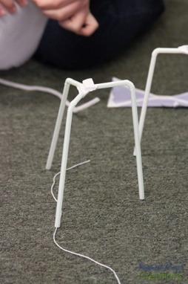
For our first class, we introduced the overall structure of what we would be working on and broke the kids up into four teams (class of eleven, so one team has only two). Each team had at least one boy and one girl to balance it out. The kids were ‘scored’ on teamwork first and then based on completion of the challenge.
In all honesty, the challenge didn’t go quite as easily as I (or the kids) thought it was – a bit of a surprise to me, but I do think we figured out the why behind our issue…read on!

Breaking Up into Teams
Each team (between 2-3 children) was given 2 minutes to come up with a design, 6 minutes to work on their cup holder structure, and then show how their structures worked, compare designs, and make improvement suggestions to other teams or for their own structure.

Challenge: Create a structure that holds two cups as high as possible and as far apart as possible. Each team has 2 minutes to design, 7 minutes to create, and 1 minute to test their structure.
Materials: 6 straws, 1 piece of paper, a piece of tinfoil, 3 mailing labels, 2 paperclips, 2 pieces of string, 1 envelope, 2 pipe cleaners, and 5 pennies

The Results
One of the things that I love about these challenges is seeing the creativity and difference that each group comes up with in their designs. Even though they each have the same set of supplies, their brains are all whirling in different directions and putting those items together in alternate ways.

As each of the groups were working, the other mom and I walked around the room observing, offering suggestions if needed, and giving time updates.

Group 1
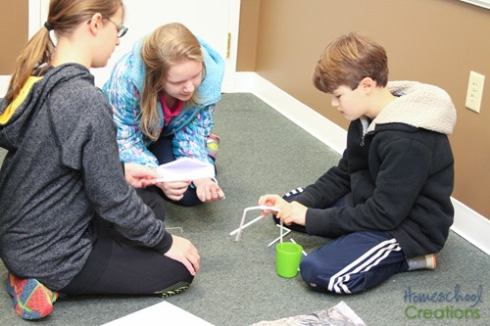
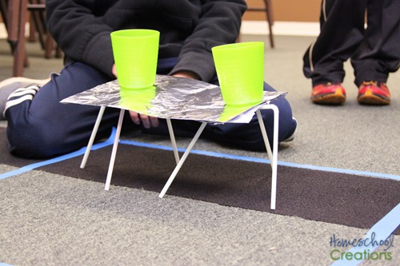
Out of all of the groups, Group 1 was the only one to have a completed structure at the end of the original challenge time period. They were able to transfer their structure to the middle of the room, set it up, explain their building process, and support the two cups.
They wrapped their paper in tinfoil and added the envelope for extra support on the main ‘shelf’ of their structure. Pipe cleaners and string were used to hold the straw legs together.
Their main focus was the base support, which definitely worked to their advantage. While it wasn’t raised from the floor as much as they wanted, it was a solid structure as long as the straws were all balancing properly.
Completed structure: cups were 6“ off the floor and ” apart.

Group 2
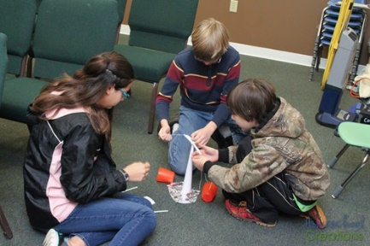
This group almost had a structure that supported the cups, but the moment they let go of the cups, their structure tipped over. They built for height, but had a base that wasn’t sturdy enough, despite the tinfoil, to support the two cups.
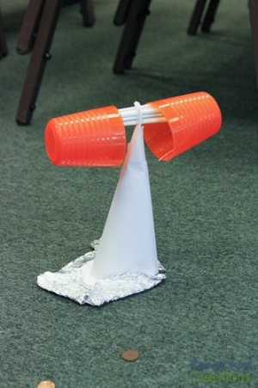
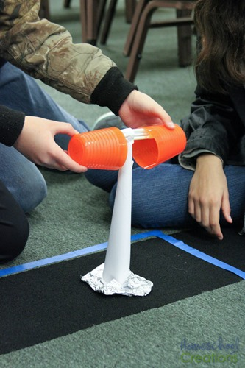
Their paper and envelope were rolled in a cone shape, with tinfoil as their base support. The straws were then adhered to the cone using the mailing labels. Overall their concept was good, but not quite there. Their ‘aha’ moment came during our group suggestion time (see below) when they were able to modify it a bit based on a recommendation from another team.
Completed structure: cups were 0“ off the floor and 0” apart.

Group 3

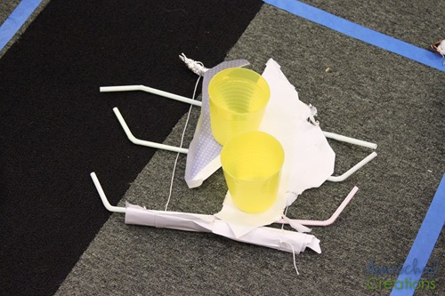
This team had some fun ideas and creative ways to hold things together (paper clips pushed through the straws), but their overall structure ended up with zero height. They tried to connect the straw and have them in an elongated “U” shape, but then they couldn’t get their straws to stay up and support weight.

They also used up several of their supplies (by rolling or crumpling), so there really wasn’t much help that could be given to create a working structure. They had a great attitude about their mistakes.
Completed structure: cups were 0“ off the floor and 0” apart.

Group 4
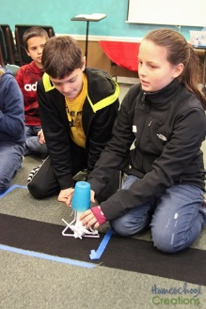
This team was the smallest of the four, and while the two started out with a good idea (again wanting to build it as tall as they could), they quickly realized they didn’t have enough base support when it came time to balance cups on either side of their structure.

They ended up trying to use the straws in a triangle-shaped base, which did work well to give support, but they weren’t able to get any distance between the two cups and instead stacked them on top of each other.
Completed structure: cups were 3“ off the floor and 0” apart.

Making Improvements and Suggestions
As we came together as a group, some of the kids were a bit frustrated their structures weren’t completed. Three of the teams were given an extra six minutes to continue building – and they still had nothing that really worked. Many of them had already used the bulk of their supplies in a way that couldn’t be recycled (tinfoil crumpled up or paper ripped), so they were stuck.

Each team was given a chance to explain their initial idea and what they thought worked best or didn’t work how they envisioned. We then talked through what they could have tried differently and what may have been a better use of their resources. Overall it was a very encouraging time for the kids and they definitely walked away with some ideas to build it better. One group (Group 2) took a few minutes to tweak their design by cutting the bottom of their cone and spreading out the bottom of the paper and returned a few minutes later with a working structure!

What We Realized
While the bulk of our groups didn’t have a completed structure at the end of the challenge (which was puzzling to me at first), we realized that many of them were over-thinking their designs. Rather than focusing on a stable structure, they focused on making their structures be the one that put the cups the highest off the ground so they could earn more points. They could have kept it very simple (made a more table-like structure) and even gotten it done more quickly.
We also spent some time talking about how in real life things are built and require support in various ways (bridges, pyramids, etc…).

Reflections and Connections to the World Of Work
As extension and/or reflection activities to the STEAM Challenge, you may want to have student engage in some reflective activities such as:
- What skills did you/your team use to complete the STEAM Challenge? Why are these skills important in the workplace?
- What are some Science, Technology, Engineering, Art, Math jobs that might require these types of skills?
- Whether or not you have ever considered pursing a STEAM career, what are your thoughts now? Do STEAM careers interest you? Think about your values, skills, abilities, lifestyle choices, preferred work environment, etc.
- Research a STEAM Career of Interest
Adapted from: http://www.ncwd-youth.info/sites/default/files/ilp-how-to-guide/Considering_a_STEM_Career.pdf

