ELA | Open the activity Plant Needs on Seesaw. Watch the video “The Needs of a Plant”. Use Seesaw to draw a picture of a plant. Click the microphone button to record yourself naming the 5 things a plant needs to live. Tap the check mark button to add to your folder.  Plant Needs
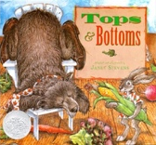
Listen to the story and draw a picture of your favourite character in your favourite part of the story.

Tops and Bottoms
Practice blending the following Plant words. For example – say “I am going to say the sounds in a word, and you tell me the word. What is /s/ - /u/ - /n/?”

sun bud stem flower water leaf root soil dirt plant

Math  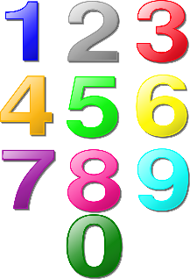 | 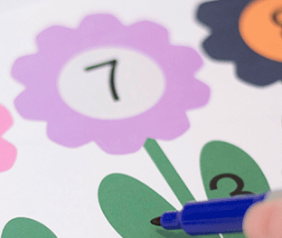  Draw a flower similar to the example and grab some manipulatives. Write a number between 6-10 in the center of each flower. On one leaf of each flower, write a number less than the number you wrote in the center. Have your child find the missing number.
 | Open your fridge and grab some fruits or vegetables. Order them from smallest to largest according to length. Use non-standard units such as paperclips, blocks, dominos, etc to measure the length of each object.
 | Using bean seeds and sunflower seeds (or use your own substitutions) have your child create the following patterns: AB, AAB, ABB, AABB, ABC. Then ask your child to extend a pattern that you create. Take turns for some addition fun!

Get Moving | Explore your local area to discover the many places that seeds grow from your back/front yard, to containers, living walls, greenhouses and farms.
Click the link to follow along with the video.

Cosmic Kids Yoga – The Very Hungry Caterpillar

Click the link to follow along with the video.

The Farmer Plants the Seeds

Get Creative | 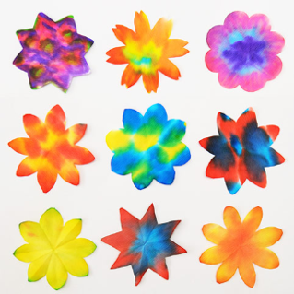  Coffee filter flower. Start with some round coffee filters. Fold in half four times to form a small wedge. Draw an arch and cut along the line to create the pedals. Carefully unfold. Using washable markers, draw lines, shapes, patterns or colour on the coffee filter. Lay on top of a sheet of wax paper then spray with water. Watch the colours spread and mix! Let dry. Once dry, you can glue a paper circle of paper, felt or button in the center. Add craft sticks or straws for the stem.
 | Using vegetable scraps from your home (such a lettuce, celery, carrots or green onion) cut the bottom base off. Place in a dish with 1 -2 cm of water. Put in a sunny spot and watch them grow!
“Seed in the Ground”
Click for video. Click for lyrics
Passions  Health/Science/Social | Learn about a plant using PebbleGo. Create a poster with a drawing and words to share your learning.
 | Collect 4 different plants (fruits or vegetables) from your fridge. Discuss which parts of the plant you eat. Examples: celery – stem, spinach – leaf, carrot – root). Encourage your child to create a label for what part they eat.

