Virtual Tours
- DISNEY WORLD/LAND
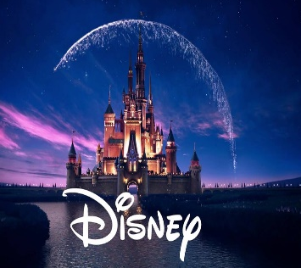
https://disneyparks.disney.go.com/blog/2018/03/disney-parks-launches-first-ever-360-degree-panoramas-on-google-street-view/

- It’s a Small World
Look around where you want. Up/Down/Left/Right & ZOOM IN if you want Filmed 12-13-17 Hello, I am Danny. Welcome to my fun and exciting DREAM driven life!
https://www.youtube.com/watch?v=09bowEw0td8
- Frozen Ever After
https://www.youtube.com/watch?v=J8OHP9OriMA

- Splash Mountain
This is a 360º interactive video of the complete attraction experience (queue/attraction) for Splash Mountain at Magic Kingdom in Walt Disney World. Click and drag to pan camera in any direction or simply move your mobile device/tablet to look around.
https://www.youtube.com/watch?v=Gg3Pi1wg56g
- Top 10 rides
Top 10 Disney! Since Disneyland is CLOSED as well as the other Disney theme parks, take a virtual trip with TPM to Disneyland in California. Explore the Disneyland Park and Disney California Adventure
https://www.youtube.com/watch?v=KJQLpDk1e9c
- Ariel’s the Little Mermaid
Look around where you want. Up/Down/Left/Right & ZOOM IN if you want Filmed April 2018 Set Sail Step into a clam to visit favorite characters and enjoy unforgettable music
https://www.youtube.com/watch?v=Hgs-GFffm5w

- SMITHSONIAN NATIONAL MUSEUM OF NATURAL HISTORY
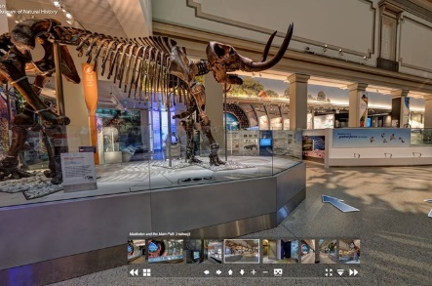
https://naturalhistory.si.edu/visit/virtual-tour

Dinosaur exhibit video
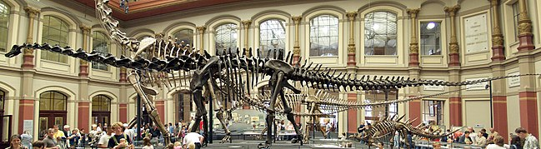
https://youtu.be/fdcEKPS6tOQ

- POLAR BEAR EXPEDITION
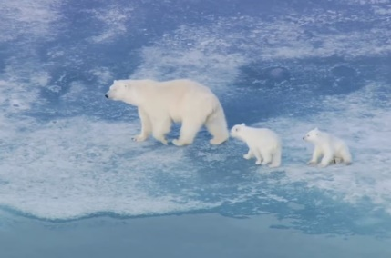
https://www.discoveryeducation.com/learn/tundra-connections/

- THE LOUVRE
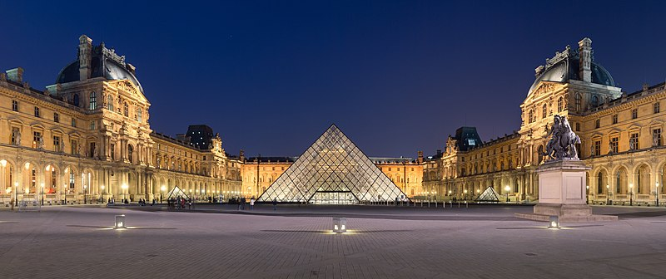
Visit the museum's exhibition rooms and galleries, contemplate the façades of the Louvre...
https://www.louvre.fr/en/visites-en-ligne
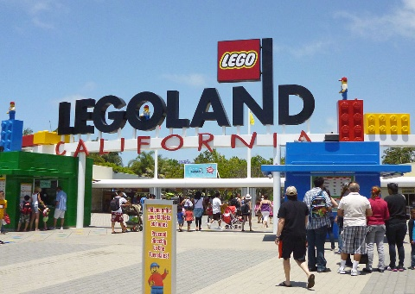
- LEGOLAND

http://www.film360.com/legoland_vtour2/

- SEAWORLD
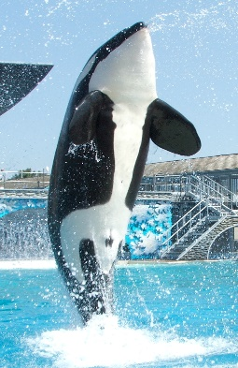

https://www.visitorlando.com/en/things-to-do/virtual-tours/seaworld-orlando

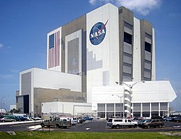
- NASA
Explore NASA Langley. See an exciting new view inside our remarkable facility. For more than 100 years, our Researchers have been pioneers and innovators, working in the interlocking fields of Aerospace.
https://oh.larc.nasa.gov/oh/

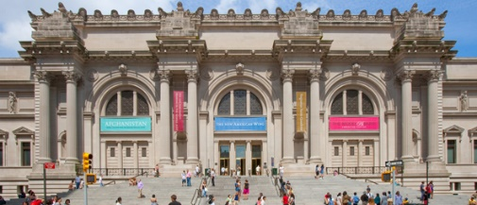
- METROPOLITIAN MUSEUM OF ART- New York
https://artsandculture.google.com/streetview/metropolitan-museum-of-art/KAFHmsOTE-4Xyw?hl=en&sv_lng=-73.9624786&sv_lat=40.7803959&sv_h=335.0285349959785&sv_p=0.9453475127378823&sv_pid=KeFx8oXHzeuY8L5rfepHaA&sv_z=0.6253222631835352
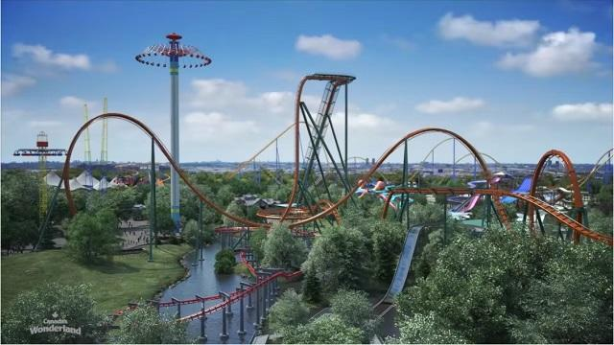
- CANADA’S ROLLER COASTER RIDES At WONDERLAND

https://youtu.be/jw3obttkmWs

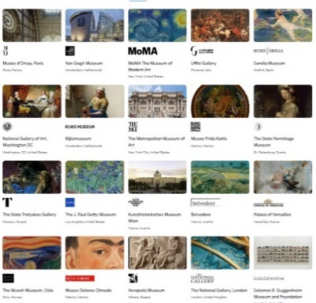
- ART MUSEUMS (2000 of them!)
Google Arts & Culture features content from over 2000 leading museums and archives who have partnered with the Google Cultural Institute to bring the world's treasures online.
https://artsandculture.google.com/partner

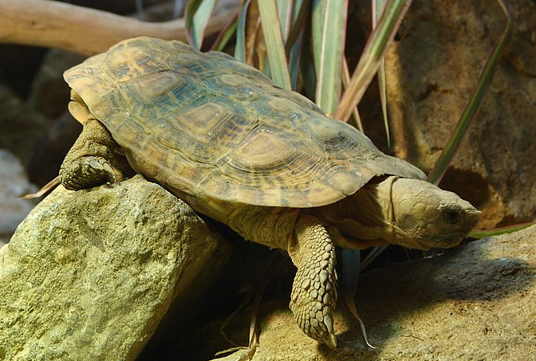
- LONDON ZOO- LIVE CAMERAS
Live streaming cams of exhibits at the London Zoo including meerkats, Otters and Galapagos tortoises
https://www.mangolinkcam.com/webcams/zoos/zoo-london.html

- BUCKINGHAM PALACE
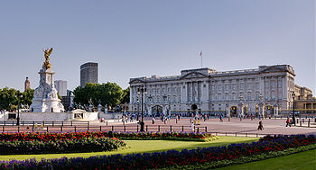

https://www.royal.uk/virtual-tours-buckingham-palace

- THE WHITE HOUSE
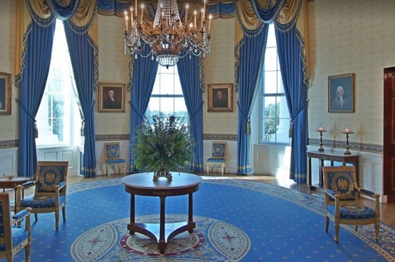
Explore different rooms in the White House
https://artsandculture.google.com/partner/the-white-house

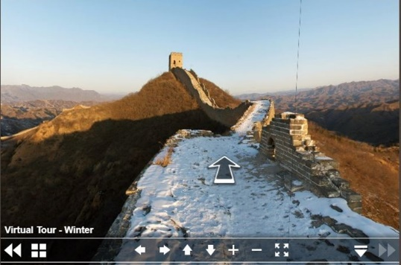
- GREAT WALL OF CHINA
As China's most famous attraction, the Great Wall of China is an essential stop in China. Commonly considered a wonder of the world, the Great Wall boasts a history of over 2,000 years and stretches more than 3,000 miles across several provinces of northern China, making it one of the most impressive ancient structures on the planet.
https://www.thechinaguide.com/destination/great-wall-of-china

- SON DOONG CAVE in VIETNAM
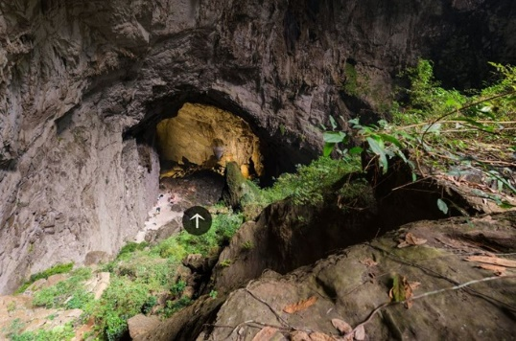

https://www.nationalgeographic.com/news-features/son-doong-cave/2/#s=pano60

- MARS and the MOON
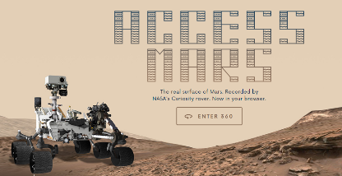
https://accessmars.withgoogle.com/
https://youtu.be/uOaOT_LIaOA

- THE TAJ MAHAL
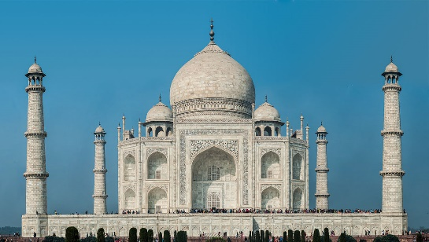
In 1997 famous Frenchman Bertran photographed Taj Mahal from a helicopter. Since that moment nobody else has been able to get a permission to shoot the Indian landmark from air for 15 years.

360 photo and video from a helicopter
http://www.airpano.com/360photo/Taj-Mahal-India/
https://artsandculture.google.com/streetview/taj-mahal/UwGKcX7FFM5U4g?sv_lat=27.17376226664116&sv_lng=78.04199578168942&sv_pid=vQAmRxAVGgXXQmPcT8d0cQ

- STONEHENGE
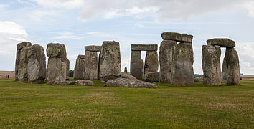
History https://www.english-heritage.org.uk/visit/places/stonehenge/history-and-stories/history/
Virtual Tour https://www.english-heritage.org.uk/visit/places/stonehenge/history-and-stories/stonehenge360/?utm_source=awin&utm_medium=Affiliate&utm_campaign=Affiliate&awc=5928_1585404673_9242673a63cf80c8b395b2dca0ccbe6a

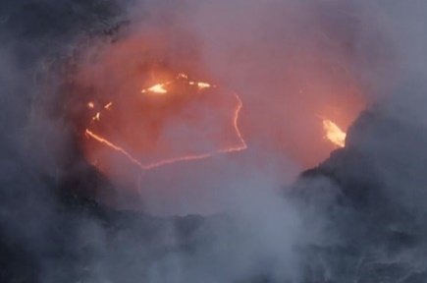
- HAWAII NATIONAL VOLCANO PARK
https://artsandculture.withgoogle.com/en-us/national-parks-service/hawaii-volcanoes/nahuku-lava-tube-tour

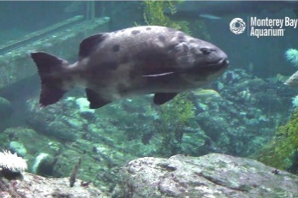
- MONTERAY BAY AQUARIUM- LIVE CAMERAS
Keep young ones entertained and educated while sheltering in place. Find online classes and guided science activities for learning at home.
https://www.montereybayaquarium.org/animals/live-cams

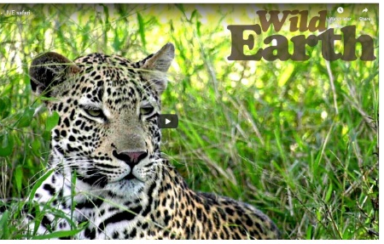
- SAFARI LIVE – WILD EARTH
safariLIVE is an award winning, expert hosted LIVE safari, broadcast directly from the African wilderness into your home.
https://wildearth.tv/safarilive/

- CARLSBAD CAVERNS
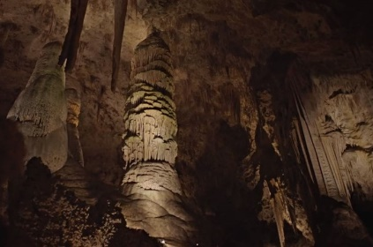
https://artsandculture.withgoogle.com/en-us/national-parks-service/carlsbad-caverns/natural-entrance-tour

- AFRICA-DRY TORTUGAS NATIONAL PARK
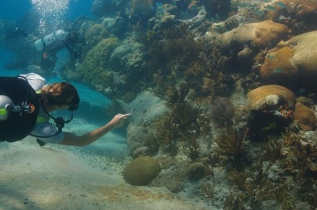
https://artsandculture.withgoogle.com/en-us/national-parks-service/dry-tortugas/near-little-africa-tour

- THE GRAND CANYON
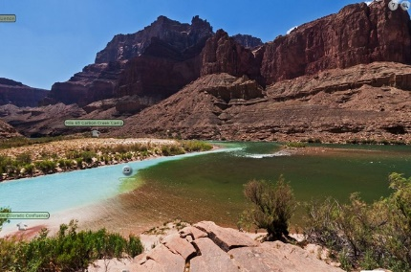

https://vft.asu.edu/iVFTLocations/GrandCanyon/GCoptions.html

- FARM VIRTUAL FIELD TRIP
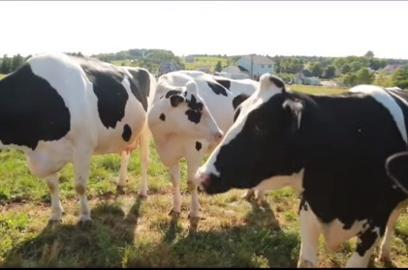
Farm 360 has difference videos to learn about different kinds of farms
https://www.farmfood360.ca/

- NATURE LAB
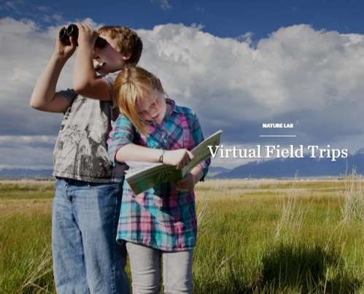

Different field trips into different habitats
https://www.nature.org/en-us/about-us/who-we-are/how-we-work/youth-engagement/nature-lab/virtual-field-trips/

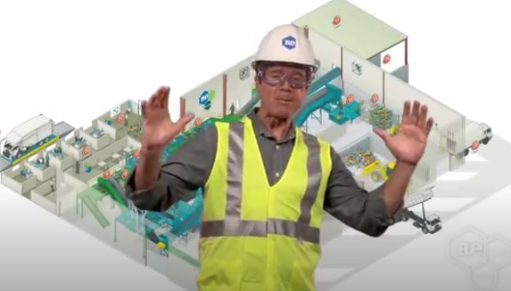
- RECYCLING CENTER
https://www.youtube.com/watch?v=zgLW9CSvpRw&feature=emb_title

- AMAZON RAINFOREST
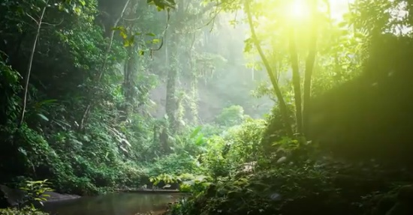
https://www.youtube.com/watch?v=JEsV5rqbVNQ&feature=youtu.be

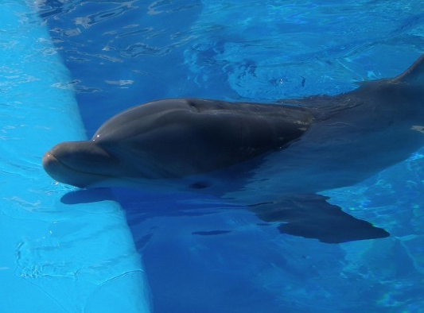
- MARINELAND DOLPHIN ADVENTURE
https://www.youtube.com/watch?v=6Ma3beD8Hos&feature=emb_rel_end

