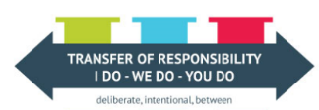 | Monday | Tuesday | Wednesday | Thursday | Friday
Read  (20 minutes or more) | https://resourcebank.ca/courseware/lesson/528/overview  Read over the assignment and choose a song. | Read lyrics of the song for presentation. | Circle any literary devices for song. | Review literature read or watched in the unit to find information for the project. | Read over and review your project to make sure it is complete.
Move Your Body  (2 X 30 minutes or more) | You need at least 2 players for this interactive game where the first person starts by performing a certain movement – this could be something simple like jumping 2 times, or more complex like holding a plank for 30 seconds. The next person has to perform the first movement, and then add on another, forming a chain. The following person does the previous 2 movements, plus adds their own. You continue in this fashion until the chain sequence is broken (usually forgotten!) and then that person is out. The last one standing is the winner. | Quick Clap Throw and Catch  (see Movement Specifics) | Use scrap or fresh paper to make paper airplanes. They can take turns throwing with family or friends to see whose goes the farthest. The catch? You have to collect it and bring it back to the start line without walking – this could be running, hopping, skipping, twirling, crawling… get creative! | Pillow Jumping (see Movement Specifics) | Fun activity for the whole family!  Assign-a-Dice: On a piece of paper assign each number from 1–6 a movement or action. Roll the dice and perform the task assigned to the corresponding number. Make it active yet silly for best results. Make a few rounds to change it up!
Healthy Snack &  Mental Break | Snack/Water | Snack/Water | Snack/Water | Snack/Water | Snack/Water
Math  (20 minutes or more) | Choose one or more activities from your grade level choice board. | Choose one or more activities from your grade level choice board. | Choose one or more activities from your grade level choice board. | Choose one or more activities from your grade level choice board. | Choose one or more activities from your grade level choice board.
Lunch | Healthy Foods | Healthy Foods | Healthy Foods | Healthy Foods | Healthy Foods
Write  (20 minutes or more) | Work on song assignment project (see Read – Monday for instructions) | Continue work on song assignment project. | Continue work on song assignment project. | Continue work on song assignment project. | Continue work on song assignment project. Review it and submit.
Healthy Snack &  Mental Break | Snack/Water | Snack/Water | Snack/Water | Snack/Water | Snack/Water
Get Creative  (As much time as needed) | Make a comic strip with at least 4 panels – use pictures and text | Visual Art - Research ‘found object sculpture’ or ‘found object jewelry’. Gather objects from around your house, or your yard and use them to create a piece of art. | Sketch book Prompt – Let’s celebrate spring by drawing an indoor or an outdoor plant. Add in colour, texture and shading to bring your sketch to life. | Create a Dance Move-  Use the QR code and watch the Canadian Dance Moves Video – Create your own 6 Canadian dance moves to add in to the song. | Leah Dorion – Use the QR code to explore Leah Dorion’s art work. Create your own piece of work at home using her work as inspiration. To create the ‘dots’ you could use the end of a paint brush or a  Q-tip.
Science/Social/Passions  (As much time as needed) | Choose at least one activity from the science choice board and from the social studies choice board for your grade level to work on this week. | Continue work on choices from choice boards. | Continue work on choices from choice boards. | Continue work on choices from choice boards. | Continue work on choices from choice boards.

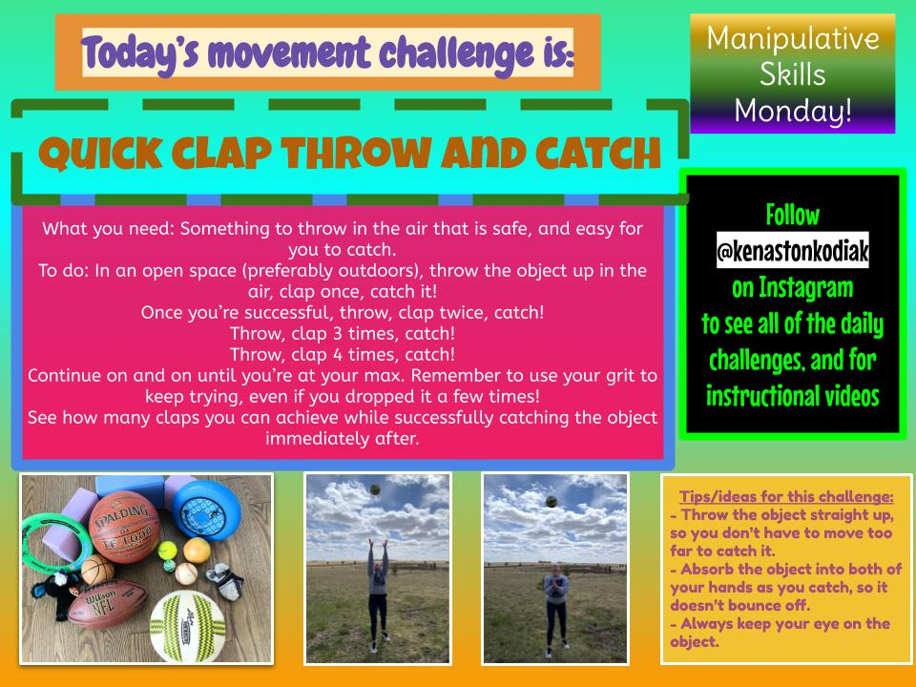
Movement Specifics

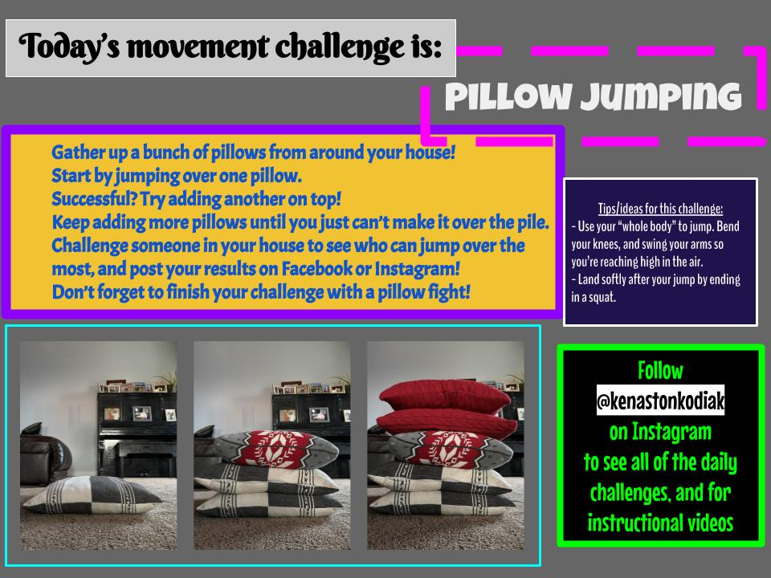
Math 7 Choice Board
Shape and Space
Outcomes:
- Demonstrate an understanding of circles, including circumference and central angles.
- Develop and apply formulas for determining the area of triangles, parallelograms, and circles.
- Demonstrate an understanding of 2-D relationships involving lines and angles.
- Demonstrate an understanding of the cartesian plane and ordered pairs with integral coordinates.
- Expand and demonstrate an understanding of transformations (translations, rotations, and reflections) of 2-D shapes in all four quadrants of the Cartesian plane.
Complete assigned practice questions from your math textbook as outlined by your teacher. | Complete area and plotting coordinates activities on Mathletics and/or IXL. | Find five treasures in the following online puzzle.  http://www.sineofthetimes.org/a-coordinate-plane-logic-puzzle/
Create a large cartesian plane outside either using sidewalk chalk on smooth pavement or using ropes on grass. Include a scale from -10 to 10 on each axis. Have someone give you 5 pairs of coordinates, one pair at a time. Move to the appropriate point on the grid. When you have gotten five correct in a row, switch spots and provide coordinates to your other participant.  Using objects from your yard, use a similar method for transformations. Place a large object on your grid. Have your partner give you a transformation to complete (e.g. reflection over x-axis). Move the object appropriately. Repeat five times with different transformations, then switch roles. | Watch the following videos to review or learn about key concepts:  - Circle – What is Pi? https://www.youtube.com/watch?v=cC0fZ_lkFpQ  - Circumference & Area of Circles https://www.youtube.com/watch?v=O-cawByg2aA  - Area of 2-D Shapes https://www.youtube.com/watch?v=xCdxURXMdFY | Complete a photo scavenger hunt. Take photos of two examples of each of the following elements that you find in the world around you. Assemble your photos into either a clearly labelled document or a series of clearly labelled slides.  - Parallel Lines  - Perpendicular Lines  - Triangles  - Circles  - Parallelograms  - Rotation  - Reflection  - Translation  - Acute Angle  - Right Angle  - Obtuse Angle  - Straight Angle
Math 8 Choice Board
Shape and Space
Outcomes:
- Demonstrate understanding of the surface area of 3-D objects limited to right prisms and cylinders.
- Demonstrate understanding of volume limited to right prisms and cylinders.
- Demonstrate an understanding of tessellation
Complete assigned practice questions from your math textbook as outlined by your teacher. | Find an item in your house that is at least the size of your hand. Your job is to design a package for this item that could be used to ship it in the mail.  You need to figure out the following information:  - What are the dimensions of the object? What is its volume?  - What shape will the package be? If you want an extra challenge, consider a shape other than a rectangular prism.  - What will the dimensions of the box need to be in order to fit the object safely? Because you are mailing it, you don’t want the box to be larger than it needs to be.  - What other factors need to be considered when designing the box?  Once you have completed your design by drawing the 3D form and the net, calculate the surface area of the package and the volume of the space it holds.
Complete area and plotting coordinates activities on Mathletics and/or IXL.
Watch the following videos to review or learn about key concepts:
- Geometry https://www.youtube.com/watch?v=qJwecTgce6c
- Tessellation https://www.youtube.com/watch?v=1kRDfXU-ZmY

Construct a composite form made up of at least three different right prisms and at least one cylinder. This might be made out of paper you fold yourself or items from around your house. The different parts all need to be connected.
Calculate the overall surface area and overall volume of your composite form. Record all of your measurements and show all of your calculations.
Complete a photo scavenger hunt. Take photos of three examples of each of the following elements that you find in the world around you. Assemble your photos into either a clearly labelled document or a series of clearly labelled slides.
- Rectangular prism
- Cylinder
- Triangular prism
- A prism with a base with at least 5 sides
- Tessellation
Math 9 Choice Board
Shape and Space
Outcomes:
- Demonstrate an understanding of circle properties
- Extend understanding of surface area to composite 3-D objects
- Demonstrate understanding of similarity of 2-D shapes
- Demonstrate understanding of line and rotation symmetry
Complete assigned practice questions from your math textbook as outlined by your teacher. | Complete geometry activities on Mathletics or IXL. | Create a video in which you demonstrate and explain each of the following circle properties using something similar to an ice cream pail lid, tacks, and string.  - Perpendicular line segments from the centre of a circle to a chord bisect the chord.  - Inscribed angles subtended by the same arc have the same measure.  - The measure of a central angle is twice the measure of an inscribed angle subtending the same arc  - Tangents to a circle are perpendicular to the radius ended at the point of tangency
Construct a composite form made up of at least three different right prisms and at least one cylinder. This might be made out of paper you fold yourself or items from around your house. The different parts all need to be connected.  Calculate the overall surface area and overall volume of your composite form. Record all of your measurements and show all of your calculations. | Watch the following videos to review or learn about key concepts:  - Similarity of Shapes https://www.youtube.com/watch?v=v1Q4AtjXOB0  - Circle Properties https://www.youtube.com/watch?v=91Coa59vJ-o  - Line and Rotation Symmetry https://www.youtube.com/watch?v=s4tS-ZmpJfw | Create an artistic design which has at least 4 level rotation. You must calculate the order and angle.

Social Studies 7 Choice Board
Interactions and Interdependence
Outcomes:
- Investigate examples of conflict, cooperation, and interdependence between Canada and circumpolar and Pacific Rim countries.
- Examine the effects of globalization on the lives of people in Canada and in circumpolar and Pacific Rim countries.
- Analyze the relationship of technology to globalization
Find out the country of origin for 20 items in your household. Record these in a chart. Sort the items and countries into categories like region of the world or type of item. What patterns or trends do you notice in the items and their origins? What does this sample tell you about some ways that your life is influenced by globalization? | Research an international organization. Share your learning in either a written report or a presentation.  Include the following details:  - What countries are involved?  - What are the aims and goals of the organization?  - How was the organization formed?  - What are examples of the work the organization does?  - How does the organization benefit people?  - What challenges or concerns are associated with the organizations? | Create a visual collage (digitally or by hand) including at least 20 examples of globalization and its impacts. What does globalization look like?  In an accompanying paragraph, explain the impacts of the things you have included visually on people in different parts of the world.
Write a properly constructed paragraph (including specific details and examples) to answer each of the following questions:  - How has technological development supported globalization?  - How has globalization influenced technological development? | Choose one of the following conflicts: Korean War, Territorial Claims in the Arctic, Cold War  Conduct research to determine and share the following details:  - Who was or is involved in the conflict? What roles did/do they play?  - What factors caused or contributed to the conflict?  - What key events were involved in the conflict?  - How was the conflict resolved? | How do conflict, cooperation, and interdependence connect to the correct global situation with COVID-19?  How has globalization benefitted the response to the virus?  How has globalization created challenges for the response to the virus?
Social Studies 8 Choice Board
Interactions and Interdependence
Outcomes:
- Investigate the meaning of culture and the origins of Canadian cultural diversity.
- Appraise the influence of immigration as a factor in Canadian cultural diversity.
Explore your own personal culture by creating a presentation that explains the following categories as they connect to your own life:  - Customs and Traditions  - Education  - Entertainment and Leisure  - Spirituality or Religion  - Language  - Food  Consider the things that influence you in each of these areas. | Watch this short video from Historica Canada: https://www.youtube.com/watch?v=IBaWoeXE5Uc#action=share  Consider the following:  - Why do you think Jason originally pushed back against his cultural heritage?  - What are the benefits of people maintaining their cultural heritage while living in Canada?  - What supports do you think that people like Jason’s parents may have needed when first arriving in Canada? | Read the overview of significant events connected to refugees in Canada, found at this link: https://resourcebank.ca/courses/canada-a-history-of-refuge/view  Answer the following questions:  - What factors and conditions have influenced refugees to leave their home countries and flee to Canada?  - What policies does Canada have in place surrounding refugees?  - How can refugee situations be seen as examples of conflict, cooperation, and interdependence?
In what ways do First Nations, Inuit, and Métis communities in Canada strive to preserve their culture?  In what ways do immigrants to Canada strive to preserve their culture?  Explain your answers to these questions in either a written report, a slideshow, or an oral presentation. | Read about Canada’s multiculturalism policy  https://pier21.ca/research/immigration-history/canadian-multiculturalism-policy-1971  What are the strengths and benefits of Canada’s multiculturalism policy?  What are the challenges associated with Canada’s multiculturalism policy? | Plan and cook a meal based on your family’s cultural heritage. Document the process using photos or video.  Include an explanation of your family’s connection to the meal.

Social Studies 9 Choice Board
Interactions and Interdependence
Outcomes:
- Explain what constitutes a society.
- Compare the factors that shape worldviews in a society, including time and place, culture, language, religion, gender identity, socio-economic situation, and education.
- Analyze the ways a worldview is expressed in the daily life of a society.
- Determine the influence of worldview on the choices, decisions, and interactions in a society.
Review the 8 features of a civilization from the Pearson Pathways to Civilization textbook. For each of the 8 features, identify examples of the feature in modern day Canada. | Present a 2-5 minute oral speech explaining the specific people and circumstances that influence your own worldview, and how they have that influence. Include factors such as time and place, culture, language, religion, socio-economic status, education. | Choose a society from the past. Record examples of how the eight features of a civilization are expressed in that society.  Compare your list to modern Canada. What elements are similar and which ones are different? Why do you think that is the case?
Consider how your life and perspectives may be different if you lived in Ancient Rome? What about in the Aztec empire? What about in modern day Europe?  Think about potential roles, what your beliefs or values may be, what daily life might look like.  Share your analysis in a written summary of each circumstance. | Create a Venn diagram comparing daily life in Canada today with daily life in the Renaissance.  This link will be a good starting point: https://www.ducksters.com/history/renaissance/daily_life_in_the_renaissance.php | Design a society of your own. Where will the society be located in the world? How will each of the features of a society be part of your society? What factors will influence the worldview of the people in your society?

Science 7 Choice Board
Physical Science: Heat and Temperature
Outcomes:
- Assess the impact of past and current heating and cooling technologies related to food, clothing, and shelter on self, society, and the environment.
- Explain how understanding differences between states of matter and the effect of heat on changes in state provide evidence for the particle theory.
- Investigate principles and applications of heat transfer via the processes of conduction, convection, and radiation
Build a solar oven and use it outside on a sunny day to cook or bake a treat.  Consider the following:  - How did the materials you used in construction help or hinder heat transfer?  - If you created a second oven, what would you do differently? | Plan and perform a skit or dramatization showing how particles behave in different states of matter at different temperatures. You may need to recruit some of your family members as actors to help you out. | Plan a mini-lesson to teach Grade 3 students about conduction, convection, and radiation. You need to make sure you are able to explain the concepts in terms they could understand, and make it interesting and engaging for them. Consider how you might be able to include a hands-on activity to model the processes.
Research how people at least 100 years ago used heating and cooling technologies for food, themselves, and structures.  - What methods did they use?  - What were advantages of these methods?  - What were disadvantages of these methods?  - What current technologies would align with these earlier methods?  - How did the past technologies impact people’s daily lives, business and industry, and the environment?  - How do current technologies impact people’s daily lives, business and industry, and the environment? | Saskatchewan is a very different place to live in the summer as compared to in the winter.  - What changes do you notice in vegetation?  - What changes do you notice in wildlife?  - What changes do you notice in people’s shelters?  - What changes do you notice in people’s clothing?  - What changes do you notice in daily life?  - How do each of the changes in #1-5 connect to the idea of heating, cooling, states of matter, and heat transfer? | Using the Heat and Temperature unit of your Pearson Science 7 textbook, complete the following questions from the Unit Review starting on page 250:  #2-8, 12-16, 18-20

Science 8 Choice Board
Physical Science: Forces, Fluids, and Density
Outcomes:
- Investigate and represent the density of solids, liquids, and gases based on the particle theory of matter.
- Examine the effects of forces in and on objects in fluids, including the buoyant force.
- Investigate and describe physical properties of fluids (liquids and gases), including viscosity and compressibility.
- Identify and interpret the scientific principles underlying the functioning of natural and constructed fluid systems.
Design and create a boat from materials around the house.  Option 1: Design the boat to hold as much cargo as possible. See how much cargo different boat designs can hold.  Option 2: Design the boat to be self-propelled. Race the boat against a parent or sibling’s design. | Complete the “Density Rainbow and the Great Viscosity Race” experiment found here:  https://resourcebank.ca/courses/density-rainbow-and-the-great-viscosity-race/view  You may need to substitute a liquid if you don’t have one of the ones on the list. Try to make the new liquid as similar as possible to the original. | Complete the “Cartesian Diver” lesson and experiment found here: https://resourcebank.ca/courses/cartesian-diver/view
Watch these two Crash Course videos:  - Fluids at Rest https://www.youtube.com/watch?v=b5SqYuWT4-4  - Fluids in Motion https://www.youtube.com/watch?v=fJefjG3xhW0  As you watch, make point form notes of the key ideas connected to the outcomes above. Use your notes to explain these ideas to someone else. | Use the Particle Theory to explain your observations of fluids. You need to start with a general, brief explanation of the theory. This should be several sentences long, and should include a diagram. Then, using separate paragraphs for each, explain how the following things affect or are affected by the particle theory:  - Viscosity  - Density  - Temperature  - Pressure  - Compressibility  You may choose to do this as a written response or as a series of slides. | In your Pearson Science 8 textbook, use the Forces, Fluids, and Density unit to complete the following questions in the unit review starting on page 264:  #3-10, 12, 13, 15-17, 19-20, 24, 25

Science 9 Choice Board
Physical Science: Characteristics of Electricity
Outcomes:
- Demonstrate and analyze characteristics of static electric charge and current electricity, including historical and cultural understanding.
- Analyze the relationships that exist among voltage, current, and resistance in series and parallel circuits.
- Assess operating principles, costs, and efficiencies of devices that produce or use electrical energy.
- Critique impacts of past, current, and possible future methods of small and large scale electrical energy production and distribution in Saskatchewan
Use the “Characteristics of Electricity” unit of the Pearson Science 9 textbook and complete the following questions in the Unit Review on page 299:  #2-13, 15, 17-22, 24, 25, 27, 29-32 | Watch the following videos from Crash Course:  - Electricity: History of Science https://www.youtube.com/watch?v=JoscDcbAjbY  - Electric Charge https://www.youtube.com/watch?v=TFlVWf8JX4A  - Electric Current https://www.youtube.com/watch?v=HXOok3mfMLM  - Circuit Analysis https://www.youtube.com/watch?v=-w-VTw0tQlE  Make point form notes of key ideas as you watch. After viewing, explain the key ideas to someone else. | Research the history of electricity production in Saskatchewan. Use your information to create a timeline that shows the progression of methods, government policies, and technological developments.  Using your research, include a paragraph explaining your predictions for the future of power generation in Saskatchewan.
Complete online circuit building simulations using the online simulator found at https://www.physicsclassroom.com/Physics-Interactives/Electric-Circuits/Circuit-Builder/Circuit-Builder-Interactive  Use the handouts provided in Exercises 1, 2, and 3 linked on the website beneath the simulator to guide your work. | If able, visit a local power generation facility such as Gardiner Dam and Coteau Creek Hydroelectric Station. If tours are not available, you can do your own research ahead of time on how the facility works, and share it with your family while enjoying a picnic near the site. | Create a comic strip or children’s book that illustrates at least 10 ways to use energy efficiently. Your comic strip needs to include why these tips or tricks are effective and connect back to the principles of electricity.

