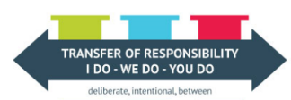 | Monday | Tuesday | Wednesday | Thursday | Friday
Read  (20 minutes or more) | https://resourcebank.ca/courseware/lesson/530  Read over project | Research on your project | Research on your project | Research on our project | Read over the final draft
Move Your Body  (2 X 30 minutes or more) | What's in the Cards- At home fitness circuit | Learn the Fight Song – while using fundamental dance moves- | INCREDI-BOWL  (see Movement Specifics) | Can Curling | 10 Star Jumps –With a Twist  (see Movement Specifics
Healthy Snack &  Mental Break | Snack/Water | Snack/Water | Snack/Water | Snack/Water | Snack/Water
Math  (20 minutes or more) | Continuing working on choice board tasks from Set #3  Bonus Skill: Estimate the surface area of volume of 2 packages you find in your house. Then calculate the actual value to see how close you were. | Continue working on choice board tasks from Set #3  Bonus Skill: Create a doodle that includes 4 circles, 2 acute angles, 2 right angles, 2 obtuse angles, 3 parallelograms, 3 pairs of parallel line segments, and 2 pairs of perpendicular line segments. | Continue working on choice board tasks from Set #3  Bonus Skill: Play a game of ‘Buzz’ with at least one other person. Use the “Multiplication Game” version.  Instructions:  https://childhood101.com/maths-games-for-kids-how-to-play-buzz/ | Continue working on choice board tasks from Set #3  Bonus Skill: Complete tangrams geometry puzzles using this website. Challenge yourself with the “hard” level https://www.abcya.com/games/tangrams | Continue working on choice board tasks from Set #3  Bonus Skill: Practice your angle measurements using Age of the Angles https://mrnussbaum.com/age-of-the-angles-online-game
Lunch | Healthy Foods | Healthy Foods | Healthy Foods | Healthy Foods | Healthy Foods
Write  (20 minutes or more) | Write notes down on your inquiry project | Creating your project | Creating your project | Creating your project | Finalizing your project
Healthy Snack &  Mental Break | Snack/Water | Snack/Water | Snack/Water | Snack/Water | Snack/Water
Get Creative  (As much time as needed) | Create a Tape/Chalk mural that celebrates your community or Saskatchewan. You can connect it to the geography, local symbols, or landscape. If you create a tape mural you can use painters tape or electrical tape to ensure it won’t hurt your walls. | Sketch book Prompt Draw a view from the window. It can be a view from your own window. Or the view that you wish that you had out your window. | Create a collage that celebrates “What Canadian Agriculture Means to you” – you can draw the pictures, use magazines, newspapers, or do it digitally by using the snip feature on the internet and paste it in to a word document. | Learn the Champion dance while using fundamental movements. Use the QR code below to link you to the video.  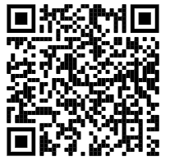 | Learn the dance - Shake It Off- Use the QR code below to learn the dance Shake It Off using fundamental movements.
Science/Social/  Passions  (As much time as needed) | Continue work from Interactions and Interdependence choice board in Set #3  Complete a Science or Social Studies Vocab Puzzle (see below) | Continue work from Interactions and Interdependence choice board in Set #3  Complete a Science or Social Studies Vocab Puzzle (see below) | Continue work from Interactions and Interdependence choice board in Set #3  Complete a Science or Social Studies Vocab Puzzle (see below) | Continue work from Interactions and Interdependence choice board in Set #3  Complete a Science or Social Studies Vocab Puzzle (see below) | Continue work from Interactions and Interdependence choice board in Set #3  Complete a Science or Social Studies Vocab Puzzle (see below)

Movement Specifics
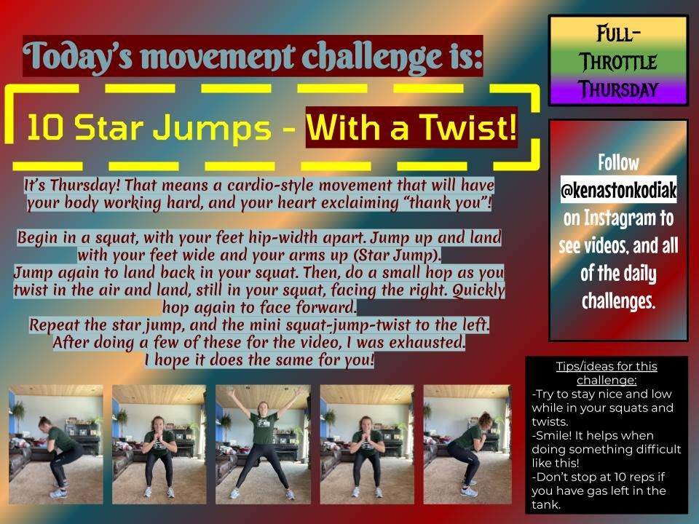
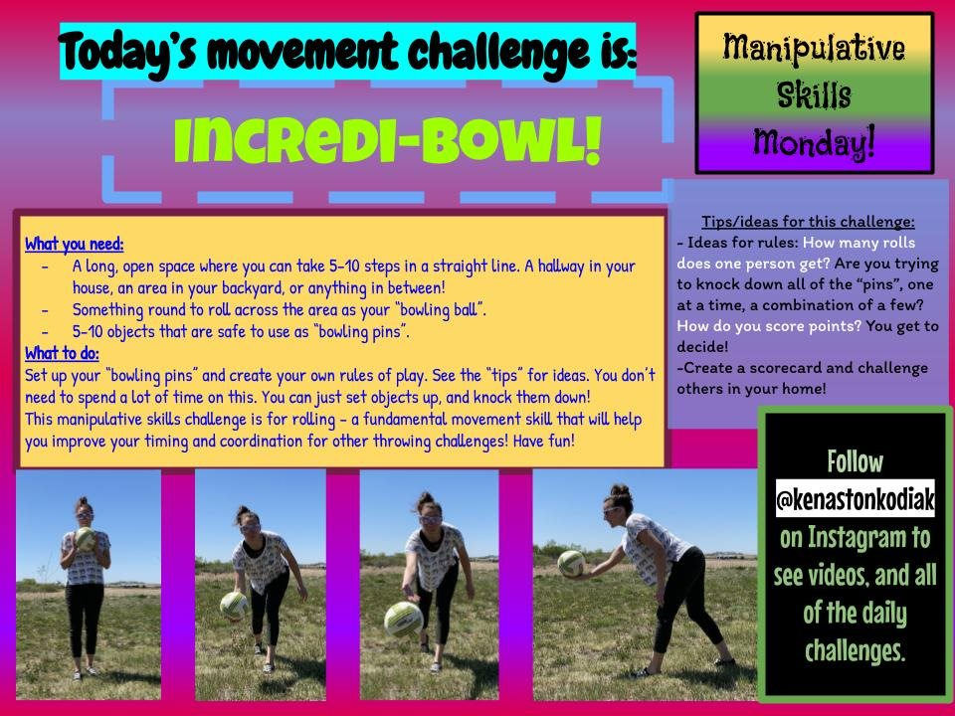

Social Studies Interactions and Interdependence Vocabulary Search

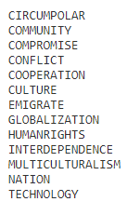
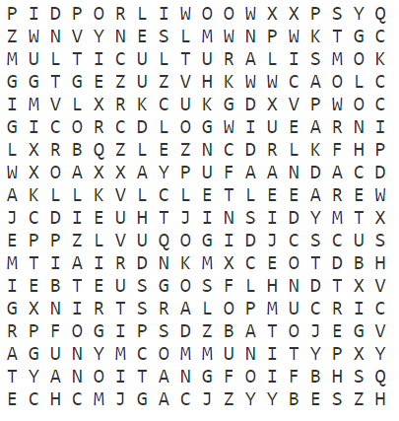
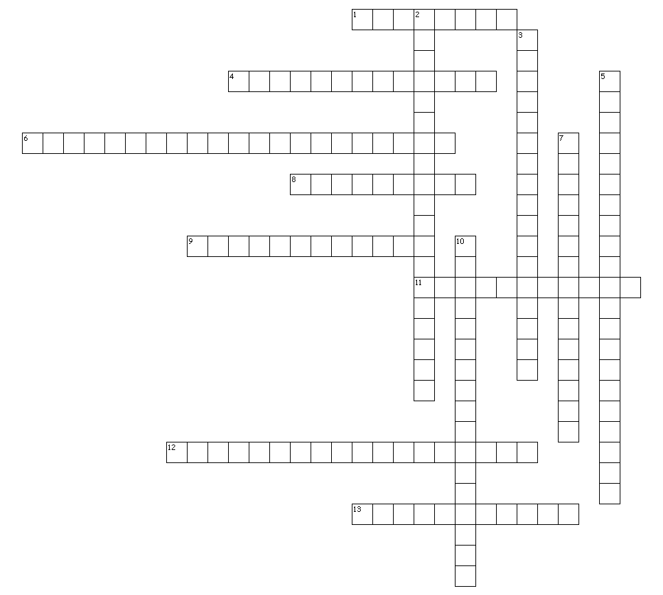
Social Studies Interactions and Interdependence Vocabulary Crossword
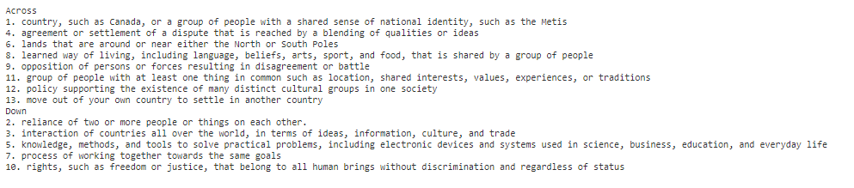
Heat and Temperature Vocabulary Search

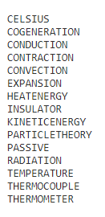
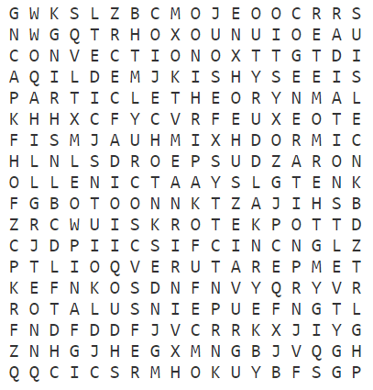

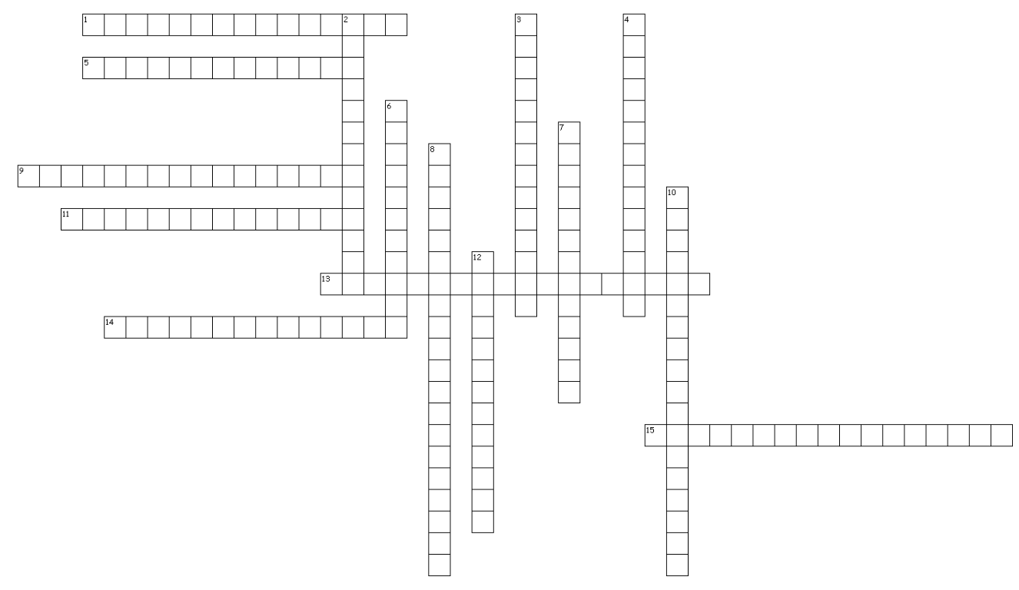
Heat and Temperature Vocabulary Crossword
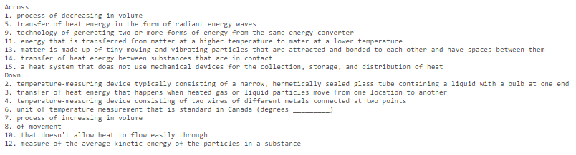
Forces, Fluids, and Density Vocabulary Search
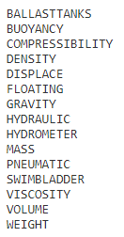
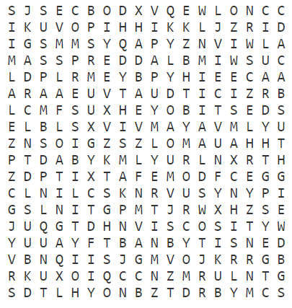
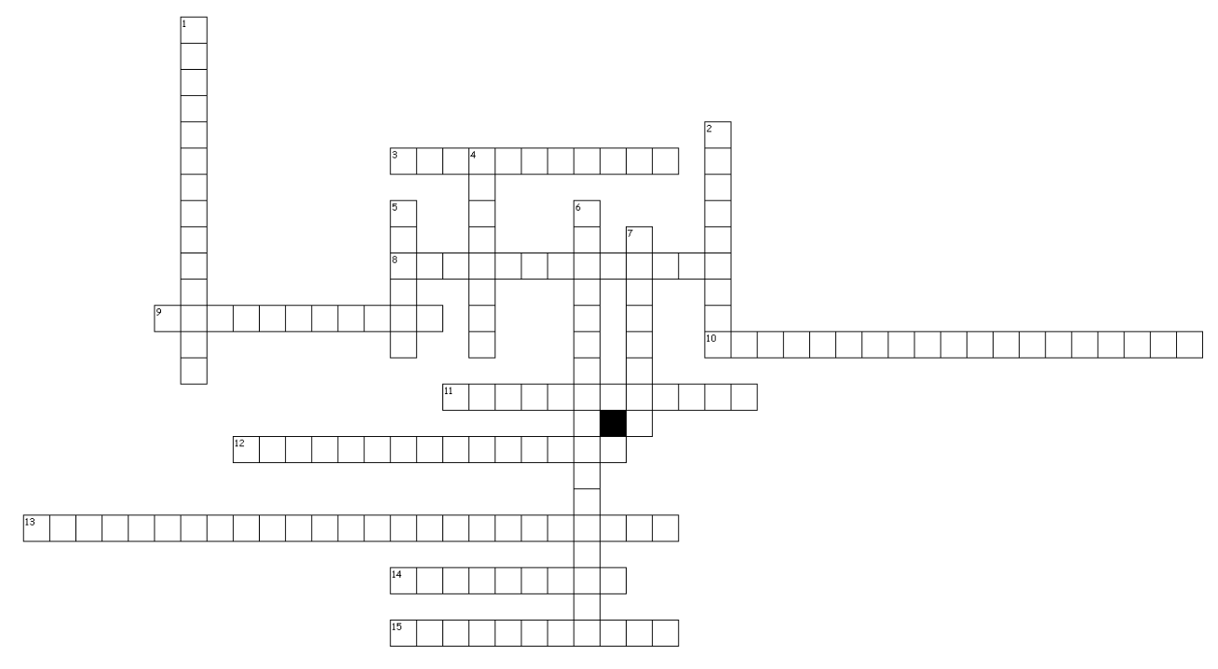
Forces, Fluids, and Density Vocabulary Crossword
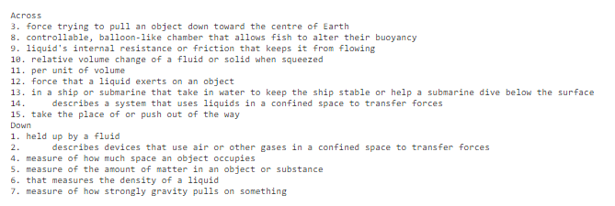
Characteristics of Electricity Vocabulary Search
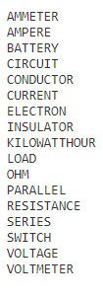
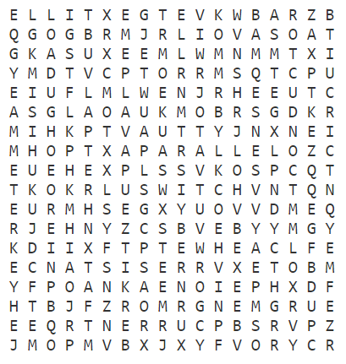
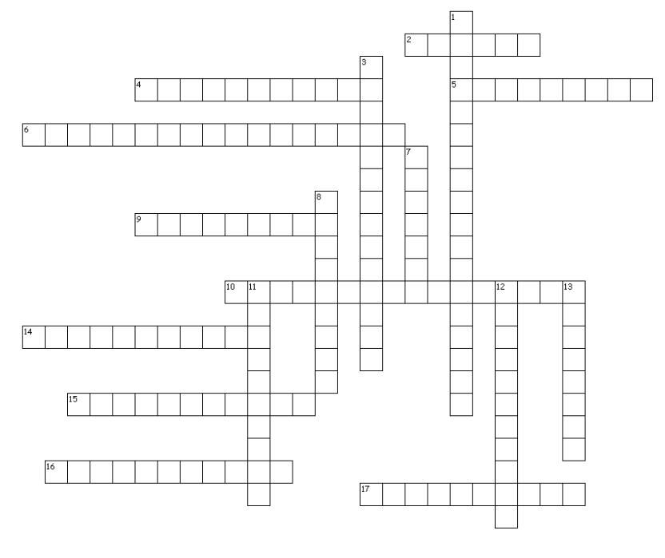
Characteristics of Electricity Vocabulary Crossword

